Statement of Purpose

ROSE LODGE CHILDREN’S HOME
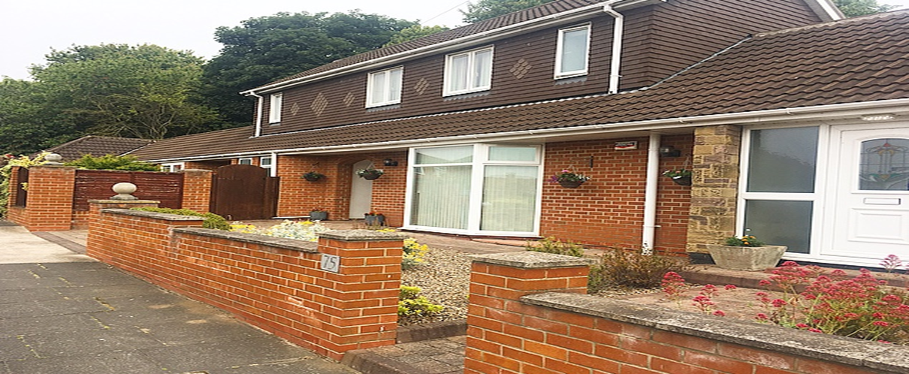
Manager: Lindsey Newbury (Acting manager)
Registered Address:
75 Bosworth Gardens
Heaton
Newcastle Upon Tyne
NE6-5UN
E-mail: Lindsey.newbury@hennessygroup.co.uk
Tel: 0191 2659597
Mob: 0778905644

Unique Registration Number: 1216505
Version: 20
Date of Issue: 18/3/23
Responsible Individual: Chris Goundry
Chris.goundry@hennessygroup.co.uk
Registered Provider Hennessy Living Group.
Rickleton 1B
Bowes Business Park
Lambton Estate
Chester-le-street, DH3 4AN
TEL: 07789056400

Chief Executive: Diane Jones
Registered Provider Hennessy Living Group.
Rickleton 1B
Bowes Business Park
Lambton Estate
Chester-le-street, DH3 4AN
TEL:07868495180

Managing Director: Chris Goundry,
Registered Provider Hennessy Living Group.
Rickleton 1B
Bowes Business Park
Lambton Estate
Chester-le-street, DH3 4AN
TEL:07715200411

OPERATIONAL INSTRUCTIONS

Date of Document: 27.08.2020

All contents must comply with Regulation 16 of the children’s homes (England) Regulation 2015Schedule 1 and company recording standards.

2. Company standards require that this statement shall be kept for at least 15 years from the date on the front page.

3. The Registered Manager must ensure that a copy of this document is on display within the home, copies of this document are made available to any staff working in the home, any child accommodated in the home, the parent of any child in the home and the placing authority of any child accommodated in the home.

Date of Review | Comments | Actions | Acting Managers Signature
 | New staff employed | New staff experience and qualifications added
17.09.2019 | New homes manager in situ  New staff employed | Homes manager and new staff qualifications added | M Jameson
10.11.2019 | Reviewed all contents and staff list | Updated staff information and amended admission criteria and homes layout | M Jameson
02.01.2020 | Updated staffing | Remove staff that has left, and new staff experience added | M Jameson
15.03.20 | Update staffing | Remove staff leaver and add new staff | M Jameson
14.05.20 | Update staffing | Added Deputy Manager | M Jameson
22.06.20 | Update on role change | Updated CG role | M Jameson
22.06.20 | Update staffing | Removed leavers and added starters | M Jameson
27.07.20 | Update staffing | Add new staff | M Jameson
29.07.20 | Update on admission requirement | Send update to social workers/ofsted/responsible individual | M Jameson
21.09.2020 | Update on staff and HQ address | Send update to social worker, alison Fry, ofsted and Chief Operating officer (RI) | M Jameson
01.12.2020 | Update on staff | Added new staff | M Jameson
02.02.2021 | Updated photo of home | New Photo | M Jameson
17.08.2021 | Update on staffing | Removed leavers and added starters | M Jameson
1.9.2021 | Update on staffing | Removed and added starters | S Taylor
24.10.2021 | Update staffing & new commissioner added | Removed former staff added new commissioner | S Taylor
03.11.2021 | Update staffing | Removed former staff added new staff | S Taylor
02.12.2021 | Update staffing | Former staff removed | S Taylor
08.01.22 | Update to staffing | Former staff removed | S Taylor
05.07.22 | New Home Manager | Former staff removed and information updated | P Tillotson
24/10/22 | CCTV | Explanation no operational CCTV  Change of staff Manager left  Deputy, moved to Acting manager | C Harrison
10.1.23 | Update to staffing | Change of staffing details | L Newbury
18/3/23 | Update RI  Update staffing  CPI training | Change of staffing and update of staffing  Change of RI details and manager  CPI | L Newbury

CONTENTS
Introduction | 6
Quality and Purpose of Care
Contextual Information | 7
Our Aims and Objectives at Rose Lodge | 11
At Rose Lodge | 12
Our Specialist Residential Accommodation | 11,
Our Services and Facilities at Rose Lodge | 12, 13, 14
Arrangements for Supporting Cultural, Linguistic and Religious Needs | 14
Arrangements for Dealing with Complaints | 15,16,17
Access to our Policies and Procedures | 17
View’s Wishes and Feelings
View’s Wishes and Feelings | 17,18
Children and Young People’s Rights and Anti-Discriminatory Practice | 18,19,
Education
Educational Arrangements | 19, 20
Enjoyment and Achievement
Enjoyment and Achievement | 20
Health
Health | 21, 22
Positive Relationships
Promoting Contact with Families and Friends | 22, 23
Protection of Children
Monitoring and Surveillance | 23, 24
Behaviour Management | 24,25,26,27
Leadership and Management
Our Senior Leadership Team – Chief Operating Officer & Responsible Individual | 28,29
Rose Lodge Leadership Team – Registered Manager &Team Leaders | 29,30
Rose Lodge Staff Team | 31,32, 33, 34
Experience and Commitment of Staff | 34,35,36,
Arrangements for Supervision | 36, 37
Organisational Structure | 37
Care Planning
Admissions | 38,39, 40
Other Information
Arrangements for Quality-of-Care Reviews | 40
Care Planning and Reviewing | 40, 41
Child Protection | 41,42, 43
Counter Bullying | 43, 44
Missing from Care | 44,45
Fire Precautions | 47, 48
Therapeutic Input | 48
Intensive Interaction | 48
Staff Acknowledgment | 49

Introduction
The Children’s Home Regulations 2015, Regulation 16 (1) requires that we have in place a written Statement of Purpose for our Children’s Home.
In addition, Regulation 16 (2) requires that we provide a copy of this document to Ofsted and that we also make a copy available upon request by:
- Any person working in the home
- Any child accommodated in the home
- The parent of any child accommodated in the home
- The Placing Authority of any child accommodated in the home
- The Placing Authority who is considering placing a child in the home
It is the Registered Managers responsibility to take a positive approach to Regulation 16 (2) by providing a copy of this document to those individuals above rather than this having to be requested.
This Statement of Purpose details all elements of service provision, for example this includes:
- Quality and Purpose of Care
- Views, Wishes and Feelings
- Education
- Enjoyment and Achievement
- Health
- Positive Relationships
- Protection of Children
- Leadership and Management
- Care Planning

In Essence:
- This is a critically important document for Rose Lodge, but more importantly for children and young people who use our services, their families and placing authorities.
- It is the primary foundation for the service that we provide at Rose Lodge and how we deliver the service.
- It is the practise and management template that we aim to adhere to and be measured by.
- It is a stated means of how Rose Lodge will aim to ensure we put children’s and young people’s rights at the forefront of all we do.

Ofsted (The Office for Standards in Education, Children’s Services and Skills) is the regulatory body that registers Rose Lodge as a children’s home. The registration complies with the Care Standards Act 2000 and the Children’s Homes Regulations 2015.
Ofsted is a national body set up under the Care Standards Act for the regulation and inspection of social care services throughout England.
CONTEXTUAL INFORMATION
Rose Lodge is a children’s home which is owned by the Hennessy Group. It is a large, detached bungalow with five bedrooms, based in Heaton; a suburb of Newcastle upon Tyne. It is a specialist home that provides a service to support children and young people aged from 10 to 18 years old of both sexes who present with social, emotional, challenging behaviour, complex needs, and attachment issues.
Rose Lodge provides support for long term accommodation; however, we can accommodate short term placement (6 months) if the referral meets the matching criteria.
Three bedrooms are located on the ground floor. Upstairs there are two bedrooms which have ensuite facility. There is a shared communal area including a spacious open plan living and dining room, and a kitchen overlooking the patio area to the rear of the property.
Children and young people will be deemed suitable to reside together following completion of a comprehensive compatibility risk assessment.

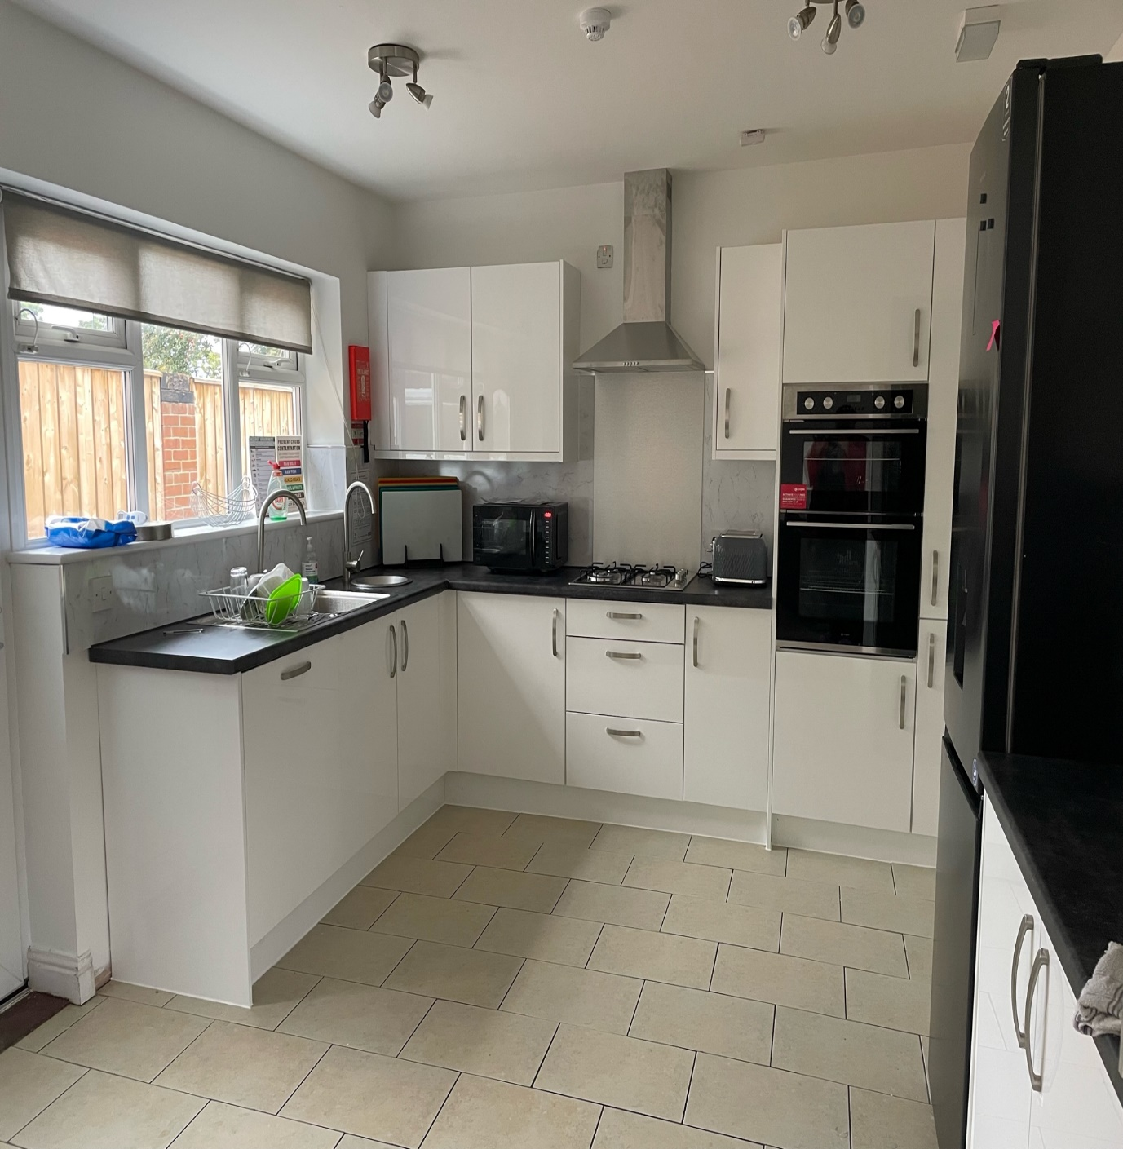

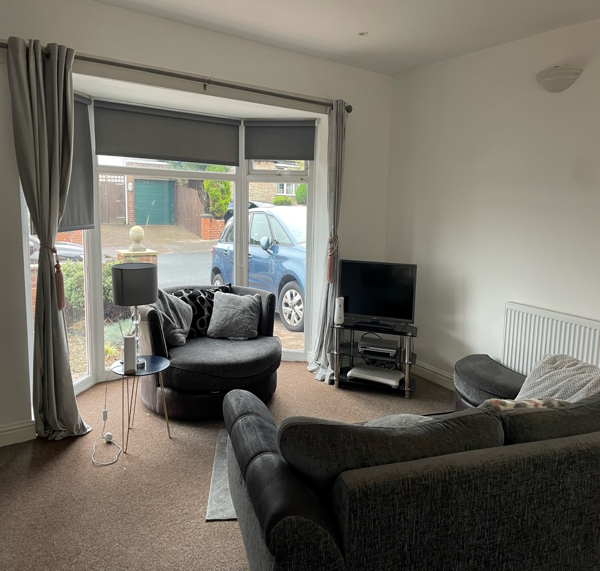

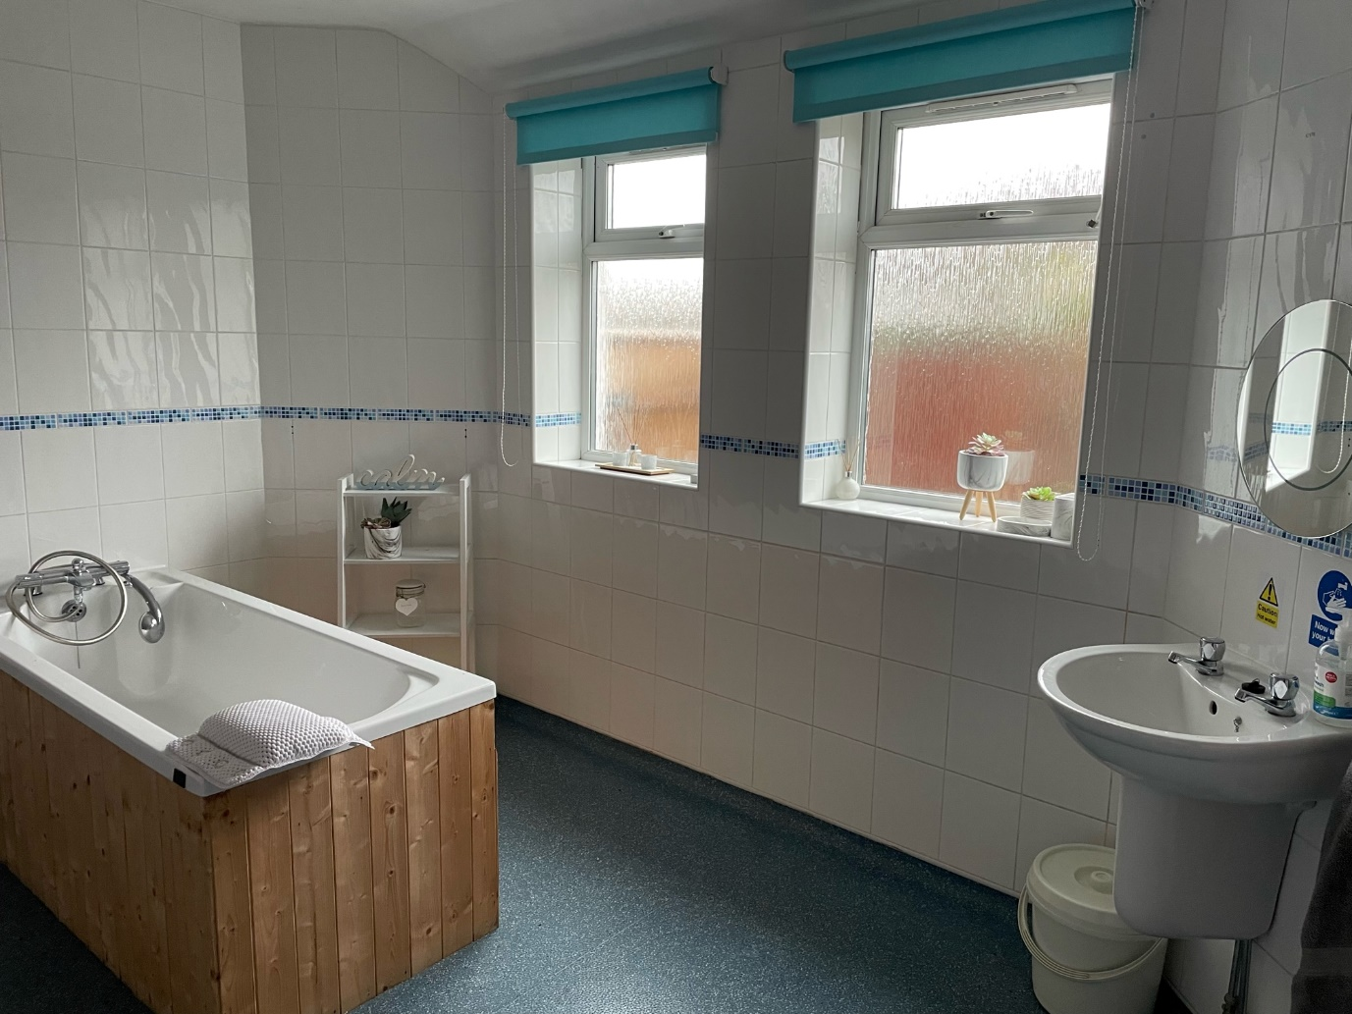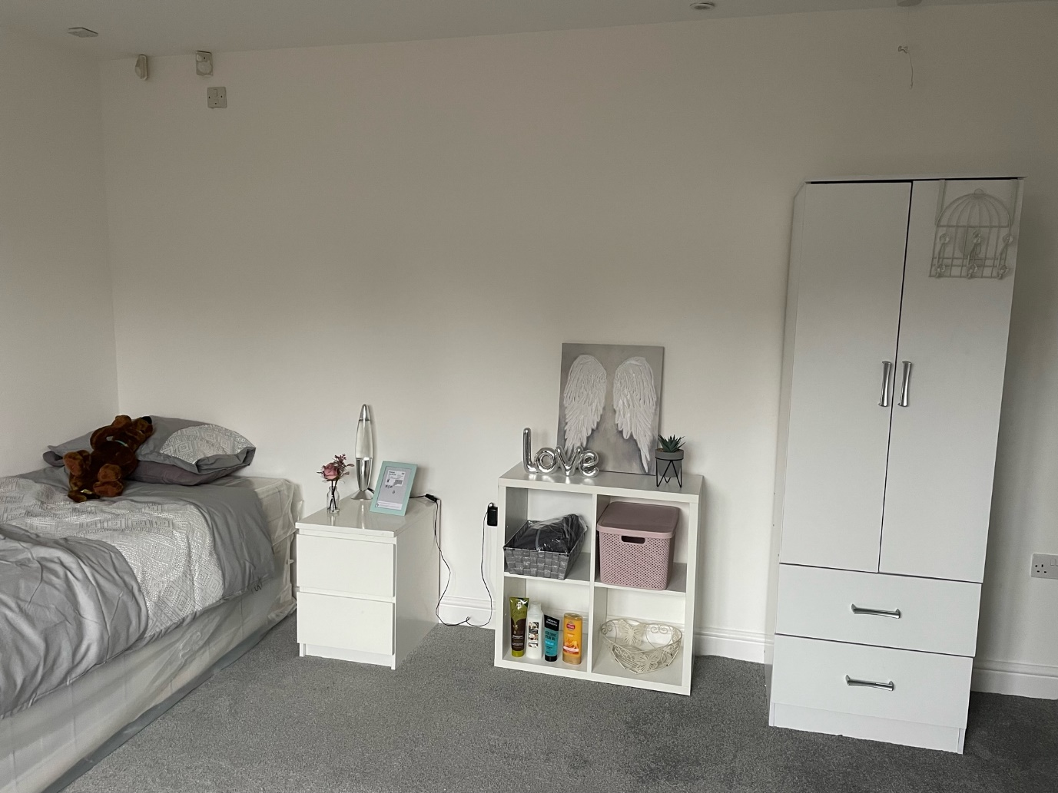
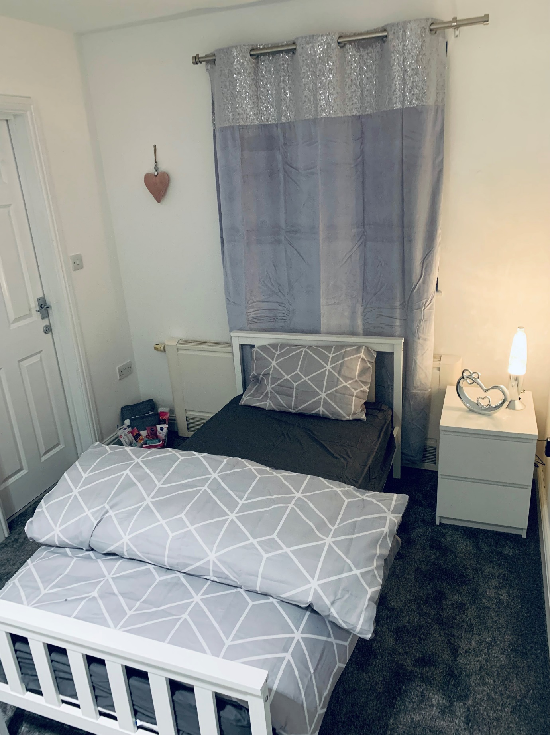
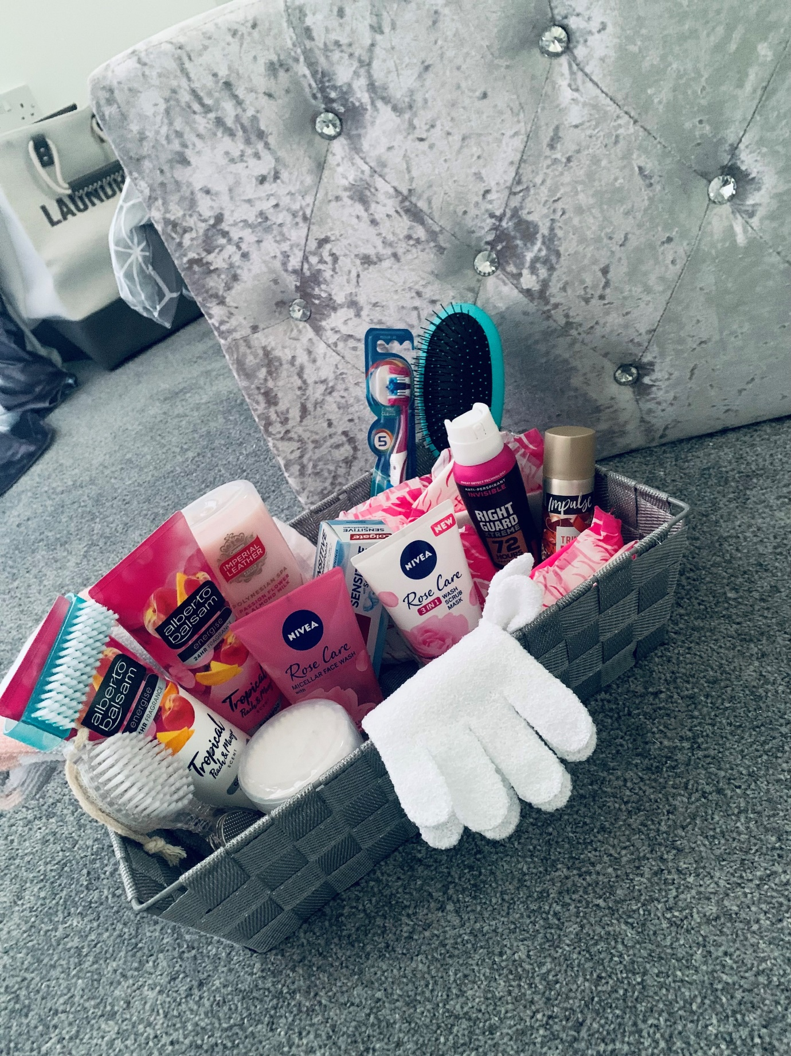

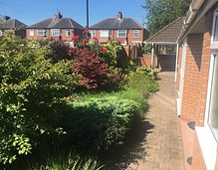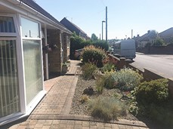

OUR AIMS AND OBJECTIVES AT ROSE LODGE
Our aims and objectives at Rose Lodge are to provide a safe, organic, warm and nurturing environment, tailored to the individual needs of each young person and ensuring excellent delivery of care. Specifically, we at Rose Lodge aim to:
- Provide a physically safe and comfortable place to live and to safeguard and promote the welfare of each child.
- Provide consistent and reliable staff, modelling and ‘good parenting’ to support and encourage children within our care.
- Ensure that all the key developmental areas of health, education, emotional and behavioural development, family and social relationships, identity, self-care and social presentation are addressed in the planning for each child.
- Listen to and respond to children’s concerns and encourage them to express their views and opinions. Ensure each child’s rights and individual needs are respected.
- Facilitate positive experiences and constructive use of free time. Encourage children to participate in social and leisure activities.
- Encourage children to plan and work together towards household decisions regarding activities, decoration of the house, purchase of equipment, house rules and sanctions etc.
- Work towards positive outcomes with children, their parents, carers social workers and relevant others.
- Facilitate contact between the children and their family, friends and other relevant people.
- Welcome visitors to the home.
- Work in accordance with relevant policies and procedures
AT ROSE LODGE
The young people who reside at Rose Lodge are generally placed under Section 31, 20 or a section 17 of the Children’s Act, but may be placed under other sections.
Ownership of the home (property) is owned by Hennessy Living Group.
The accommodation is registered for 5 young people both male and female all aged between 10-18 who have social, emotional, challenging behaviour along with associated conditions i.e., ADHD, ADD, complex needs and attachment issues that affect everyday life.
Any referrals and admissions must be assessed, and plans put in place to ensure the home remains as stable as possible for all young people accommodated.
Due to information received from police that stated residents’ doors had been tampered with in the locality of Rose Lodge it was agreed by senior management that both front and back doors are now locked at Rose Lodge, however the young people residing at Rose Lodge can freely open these doors from the inside using the turn lock system.
The team at Rose Lodge strive to achieve the best outcomes for the young people within our care. We want our young people to feel safe and protected and to grow up in circumstances that are consistent with the provision of safe and effective care. We want our young people to have access to a range of facilities within the local community including good healthcare, activities, and clubs they can join to feel integrated and accepted
OUR SPECIALIST RESIDENTIAL ACCOMODATION
The needs of many children and young people who have social, emotional, challenging behaviour, may impact on how they experience, and cope with, different environments and situations. Staff will be trained and develop a good understanding of young people with these needs and will promote a supportive and functional environment to accommodate these needs.
One of the most effective ways of helping young people with environmental difficulties is to create a well-structured and supportive environment, this supporting and promoting their environmental wellness.
OUR SERVICES AND FACILITIES AT ROSE LODGE
Rose Lodge is in a suburb of Newcastle upon Tyne. The home is conveniently situated near the local community and offers a wide range of facilities which children and young people can access, the home is close to good bus links, a Metro station and is within minutes of major motorways. The home is spacious, light and has a very homely vibe allowing the child/young person to feel relaxed, safe and secure.
Rose Lodge offers a home from home ethos and incorporates all the homely features that would be found in any family home.
There are dummy cameras around the property. These are not operational and act as a deterrent to unwanted visitors or intruders. There is no CCTV in operation at this time internally or externally.

The layout of the home consists of:
Ground Floor:
This provides three single bedrooms. There is a large, shared lounge with a TV, DVD, comfortable sofa’s and a dining area where children can eat and socialise. The kitchen facility is open plan which allows easy access for all. Children and young people are encouraged to participate in making drinks and light snacks and will be supported to develop/enhance their basic activities for daily living in this area. A large patio area is set just off from the kitchen which will be developed in consultation with children and young people and their families, the garden is low maintenance with well-established bushes and trees for all to enjoy, to the rear of the house there is an outdoor decking area which will be developed into an outdoor quiet place for the children to relax and socialise. There are two large communal bathrooms on the ground floor, both have baths and showers to accommodate the child/young person’s personal hygiene needs. Staff office is located on ground floor overlooking the carport.
There are shared laundry facilities on the ground floor within the utility room where children will be encouraged to help with their own laundry.
First Floor:
This provides two single bedroom which has en-suite facility.
The home has a large off-road carpark at the side of the home this is covered to protect young people from adverse weather as much as possible, there are two driveway parking areas at the front of the home.
The home will be fully staffed over a 24-hour period and operates a staff ratio intended to facilitate the development of individual lifestyles and the promotion of appropriate roles and responsibilities both within the home and wider community. The company operates a 24-hour management on-call system to facilitate advice as required. The home has a dedicated, experienced, and suitably qualified staff team to support children and young people to live a fulfilling life. There will also be a waking nightshift each night to support the young people should they need this support.
We support and encourage young people to personalise their bedrooms and have a say on how their home looks. We provide a budget to each young person with staff oversight this allowing them to feel that they are able to choose while also supporting part of their life skills with budgeting.
The home offers an individualised tailored approach to care and a bespoke health and well-being plan tailored to the individual. We work closely with families, NHS staff / PCT’s and other multi agencies involved in the care of each child as well as the young people themselves. We work together to set goals and provide the support and on-going care to help each child reach their full potential at a pace that suits them.
Rooms are well proportioned following health and safety guidelines and regulations. The interior is modern, comfortable, and welcoming. Whilst meeting appropriate standards and legislation, Rose Lodge aims to provide a warm and homely environment.
Televisions are provided in the lounge and bedrooms (depending on child/young person’s desire). A phone is available for young people to maintain contact with family, friends, social workers, IRO’s and Ofsted etc.
Rose Lodge has a dedicated budget for food, housekeeping and outings. Children and young people are encouraged to develop their social and self-care skills and take part in independence training to develop and learn new skills for transition. They are encouraged to be involved in all routine chores within the home as well as the preparation of meals. Where appropriate children and young people will take part in shopping for their own meals and learn about food preparation, food hygiene and budgeting.
Each child/young person will receive regular pocket money and a clothing/activity allowance. They will have opportunities to be part of the community and social inclusion will be encouraged and reinforced. The children have access to a car for them to travel further afield and explore their community.
The home also has an Independent Regulation 44 Visitor in place who will monitor the performance of the home and report back to the Registered Manager, Regional Manager, managing director and Ofsted.
- Community and Extended Service provision for activities and outward bounds courses
- Maintenance Team who supports our home to ensure it is safe and is in good decorative order
- Have trained and dedicated staff who are champions for specific areas.
- Regular inspections by the Regional Manager (RI) to ensure the home is performing to a high standard.
- Independent Reviewing Officer and Social Worker Statutory visits to the home
- 24-hour consistency and continuity of good care practices
- An experienced and dedicated staff team who have been fully trained in a range of disabilities
- Access to advocacy services

ARRANGEMENTS FOR SUPPORTING CULTURAL, LINGUISTIC AND RELIGIOUS NEEDS
Every effort is made to consider the religious and cultural backgrounds of children/young people and their families, and any disabilities that they may have. The opinions and views of children and young people on all matters affecting them, including day to day matters, are ascertained on a regular basis. This will also be displayed on the Equality & Diversity Board, educating children/young people on culture and gender.
Enquiries are made into the religious and cultural background of each child/young person as part of planning their admission into the home. Provisions can then be made to allow the child/young person to practise their religion in a manner appropriate to their age, ability and understanding. Each child/young person is, as far as practicable, to have an opportunity to attend such religious or cultural needs and preferences. To support the individual appropriately, the staff team will seek out advice, knowledge and support from the relevant religious or cultural centres and authorities as necessary. Training and guidance will be given to staff where this is needed.
All staff within the home will receive training on Equality and Diversity to proactively promote rights, choices, beliefs and traditions.
ARRANGEMENTS FOR DEALING WITH COMPLAINTS
On admission to the home the children, young people. Family members, significant others and independent visitors are provided with information on how to complain. Information is available on how an advocate can be accessed and children and young people are supported to action this.
The child/young person or their representative can complain if they are unhappy with any aspect of living in the home. There is a robust complaints policy in place where any complaint will be dealt with informally or through the formal process.
An informal complaint is something which we try to resolve through discussions with the parties involved and these are still recorded. Although we hope to receive very few complaints, we do welcome feedback and see this as a means to continuously improve practice.

The formal complaint process is for independent investigation of complaints that cannot be resolved through the internal informal process or when the parties concerned are not happy with the outcome of the informal investigation.

A child friendly complaint guide is available with appropriate symbols for our children and young people which is in the Children’s Guide. Any complaints are taken seriously and addressed without delay, and a complaint will be fully responded to within a maximum of 28 days. The complainant is kept informed of the progress and offered support as required. Where necessary, a suitably skilled advocate will be sought to aid in making a complaint where the child/young person has a communication impairment or other specific needs which require specialist involvement. The homes complaints procedure enables children, young people, staff and family members and others involved with children and young people living in the home, to make both minor and major complaints. Such complaints will be treated in the strictest confidence.
The children and young people and their families have the right to let staff know when they are not happy with anything relating to the service, they can also make complaints to Ofsted and their Local Authority.

Complaints are also discussed within Children’s Meetings and the option for complaints within the Positive Behaviour Support children and young people’s De-Briefing system. All parents and the Local Authority have access to our policy and procedure. This is in the general office of the home and can be requested at any time.

All children and young people have access to telephone numbers in their Children’s Guide and, for additional contacts, residential staff can provide support.

All complaints are logged within our Compliment, Complaint and Suggestions logbook with the outcome recorded. If the complainant is not satisfied with the outcome then this can be followed through with the appeals process, whereby this will be investigated by Senior Management, the Placing Authority or Ofsted.

We also want to learn from our children and young people, their families, professionals, and staff members so we have developed a suggestion form where individuals can provide us with new and innovative ways or practicing and also ways to improve our service.

Communication is the key to positive relationships; we all have a shared responsibility towards this. We are very proactive is dealing with any complaints and the earlier that we know, the less of a problem it creates.

We want an “open door” policy of working so complaints are dealt with in a professional and reflective manner. Every complaint has the potential to give us quality assurance to improve our service or gain access to a support network like the community police team to ensure we are not being discriminated against.

Below are the relevant contacts for complaints or to make a safeguarding referral/alert:

Name | Designation | Address | Telephone Number | E-Mail Address
Lindsey Newbury | Manager | Rose Lodge  75 Bosworth Gardens  Heaton Newcastle Upon Tyne NE6-5UN | 01912659597  07789056400 | Lindsey.newbury@hennessygroup.co.uk
Diane Jones | Chief Executive | Hennessy Living Group.  Rickleton 1B  Bowes Business Park  Lambton Estate  Chester-le-street  DH3 4AN | 0191 3758229  07868495180 | Diane.jones@hennessygroup.co.uk
Chris Goundry | Managing director/Responsible Individual | Hennessy Living Group.  Rickleton 1B  Bowes Business Park  Lambton Estate  Chester-le-street, DH3 4AN | 0191 3758229  07715200411 | Chris.goundry@hennessygroup.co.uk
Lindsey Newbury | Senior manager | Hennessy Living Group.  Rickleton 1B  Bowes Business Park  Lambton Estate  Chester-le-street, DH3 4AN | 0191 3758229 | Lindsey.newbury@hennessygroup.co.uk
Ofsted | Regulatory Body | Piccadilly Gate, Store Street, Manchester M1 2WD | 03001231231 | www.ofsted.gov.uk
Childline | N/A | N/A | 0800 11 11 | N/A
Dame Rachel Desouza | Children’s Commissioner for England | Sanctuary Buildings, 20 Great Smith Street, London, SW1P 3BT | 02077838330 | Info.request@childrenscommssioner.gsi.gov.uk
On-Call Management | Manager Lindsey Newbury | Rose Lodge  75 Bosworth Gardens  Heaton Newcastle Upon Tyne NE6-5UN | 07789056400  07736162998 | managerroselodge@hennessygroup.co.uk
Barnardo’s | N/A | N/A | 01912404800 | www.barnardos.org.uk

Access to our Policies and Procedures
Parents, social workers, commissioners and other multi-agency partners can access our policies and procedures relating to the care or protection of children residing in Rose Lodge by contacting the Registered Manager.
VIEW’S WISHES AND FEELINGS
At Rose Lodge we believe that the children and young people should be encouraged and supported to make decisions about their lives and to influence the way the home is run. No child/young person is assumed to be unable to communicate his or her views. Therefore, the child/young person’s opinions, and those of their families or significant others are sought. Similarly, each child/young person is appointed a key worker and an advocate can be provided over any additional input regarding key decisions, which are likely to affect the daily life and future of the children and young people.
Children and young people are encouraged to hold resident’s meetings on a monthly basis or requested basis with staff where possible. Staff will take minutes, but it is the children and young people that should be encouraged to take the lead in setting the agenda.
The key worker provides 1:1 support to the child/young person and holds key worker sessions (approx. 10 per month) to gain the child/young person’s views and can advocate on their behalf. We also promote family forums where we can learn from parents and where further support can be given.
Each month the key worker will ensure that the children and young people have been consulted with in their monthly summary which is sent to families and social workers. We learn every day from our children and young people, whom we build into their placement plans and person-centred plans to ensure that they remain consistent.
Every Month children and young people can take place in a Children’s Meeting to express and discuss their views and opinions, this meeting will have an agenda with topics such as, menu, home improvements, activities etc. This uses observations of the child/young person’s mood, body language and behaviour to gain their views on specified activities or situations.
All the children/young people will have care team meetings and looked after children reviews which the children and young people can attend if they wish. Key workers and management also attend these meetings and reviews along with parents and other relevant professionals. These reviews focus on the individual and promoting their voice within the home.
Rose Lodge is also visited by a Regulation 44 visitor. The visitor meets with the young people, parents and staff monthly and submits a Regulation 44 report on findings each month to the Registered Manager, Responsible Individual and Ofsted. All documentation reporting systems ensure that we capture the voice of the child/young person to ensure that we meet our home’s aim of ‘the young person being at the centre of everything we do’.
The children and young people also have statutory visits each month by their relevant social workers, who ensure that the young people are consulted and involved in the home and placement. All current recording systems also feedback and capture the voice of the young person.
CHILDREN’S AND YOUNG PEOPLES RIGHTS AND ANTI-DISCRIMINATORY PRACTICE
Hennessy Group promotes care practices in a non-discriminatory way where all children and young people are valued as individuals regardless of age, race, gender, colour, sexuality, disability, or religious beliefs. We will provide a culturally sensitive service and ensure that all service users, staff and others receive equal access to services and equal access within them, Hennessy Group expect to treat all service users in a fair and respectful manner, and this is positively challenged and discussed with supervision, team meetings and children’s/young person’s meetings.
We uphold the Principles of Care, for promoting anti-discriminatory practice and promotion of children’s rights, respect and dignity as follows:
- Children and young people have the right to live in a home that is safe, warm, happy, nurturing, stable, valuing, affectionate, and secure, free from abuse and recognises the individual needs of the service user.

- Children and young people have the right to have full access to education, health care, social life, community facilities, and could live a full life as possible.

- Children and young people have the right to be listened to, express themselves, take full part in decisions affecting them, have things explained to them and the right to complain.

- Children and young people have the right to privacy, space, time and dignity, have fun and allowed to be a child.

- Children and young people have the right to their religious, cultural, dietary needs and to celebrate their individuality.

Our Responsibilities:
Staff have a duty of care to ensure that children and young people are safe, supported according to their individual needs and abilities and are protected from any act or omission of harm.

- Staff act as role models for young people.

- Staff will act as a chosen key worker for each young person and promote communication and relationships between Rose Lodge and the young person’s family and friends.

- We will ensure effective placement planning, monitoring, and evaluation systems to demonstrate the young person’s development.

- We will liaise with the young person’s education (main stream school, pupil referral unit and tutoring) to ensure continuity of educational programmes.

- We will respond quickly and be flexible in changing needs of the young people and work proactively with other professionals.

- We will ensure the right level of experience and mix of staff are on duty at any one time.

EDUCATIONAL ARRANGEMENTS
Education is viewed as a high priority. The home will work with education authorities to promote and support the delivery of an educational package within an identified educational setting. We offer an integrated model in which teachers and care staff liaise daily providing all children and young people with an individual education plan appropriate to their needs. Education will be provided by Local Education Authority (LEA).
Staff are expected to aid and support with the completion of homework in an appropriate environment to aid learning. Homework is a priority and evening activities will be organised around its completion.
Staff will assist the children and young people with preparation for the next day. Children and young people should be encouraged to refer to the timetable to ensure all needs are met before bedtime, e.g. appropriate clothing for activities, trainers etc.
In special circumstances Rose Lodge can provide in-house education, the aim being to support any young person who is struggling within the school environment to follow an education plan in-house. Rose Lodge will use this opportunity to support the young person back into the school environment. This is only used as a short-term plan.
ENJOYMENT AND ACHIEVEMENT
The daily living experience of the children and young people will be structured and varied providing stimulating opportunities for social, intellectual, vocational, and personal enrichment. They will be encouraged to utilise local community services. The level of supervision required would be subject to ongoing assessment of risk and consultation. Emphasis is placed upon maintaining a normalised experience. The child/young person will be encouraged to invest in their living environment, personalising aspects of it and contributing towards its maintenance.

- Children and young people are encouraged and supported to maintain a proper balance between free and controlled time within the structure of the day. Individual activity plans reflect the needs and choices of the children and young people incorporating periods when they are encouraged to pursue their own interests.

- The children and young people at the home are encouraged and given opportunities to take part in a range of activities both within the home and in the community. Birthdays, name days, cultural and religious festivals will be celebrated where appropriate, themed nights will be organised, and the children/young people will help in the planning. Staff actively encourage family involvement on all occasions planned. The child/young person, where able, is encouraged to participate with staff in planning these events. Children and young people will be able to pursue their interests, develop confidence in their skills, and continually add new activities and experiences to their programme. An activity budget is provided to ensure adequate funds.

- Activities will consider the safety of children and young people. All activities will be risk assessed, recorded, and evaluated, and amended or discontinued as required. Persons holding the relevant qualification to supervise children’s involvement in the activity concerned will supervise any high-risk activity provided or arranged for the young people. All activities will be behaviour dependant.
HEALTH
The physical and mental health of the children and young people will be of paramount importance. We actively promote a healthy lifestyle, and our well-being therapist tailors a person-centred plan to meet the needs of the individual. All dietary needs are discussed with the child/young person and their family and recorded in their placement plan.
The home seeks to ensure that all children and young people live in a healthy environment and their health needs are identified. The management team will be responsible for monitoring and will seek to ensure that specific needs are considered and actively pursued. A range of health care professionals would be approached to identify both initial health care needs, and ongoing input as required.
All children and young people will be registered with the local GP, opticians and dentist on admission the child/young person will have a full health check, the child/young person will also have an annual Looked After Medical Health Check.
The child/young person will be provided with guidance, advice and support on health and personal care issues appropriate to their needs and wishes. Services will be provided to meet all health needs from within the local community. Each child/young person will have a clear written Health Plan covering all medical health needs. These will be developed by involving the child/young person and their parents. We use these when a child/young person needs to access a health service so that we ensure that their appointment has been a successful one.
A written record will document all illnesses, immunisations, ailments, accidents, or injuries to the child/young people during their placement at the home. Children and young people with health needs or disabilities will be provided with appropriate support and help. Key workers at the home will ensure that any support or treatment required are included in the child/young person’s Placement Plan, Contact Plan and Health Plan, is implemented, recorded, and monitored. Relevant parties will be updated with this information as required, and advice sought, as necessary. Serious events will be communicated to the Placing Authority within 24 hours.
We regularly monitor the height and weight of our children and young people and record this information so that we can be proactive in supporting their good health.
Children and young people will receive more formal education on maintaining a healthy lifestyle and learn about nutrition and health management.
The Registered Manager aims to build up a very proactive relationship with the local Consultant Psychiatrist, Community Nursing Team and de-sensitization practitioners who we can call upon if we have a concern about a child/young person’s medication issues or an upcoming medical appointment. The Psychiatrist may visit the service to check on the child/young people’s progress, they may also attend the child/young person’s Looked After Reviews and Annual Statement of Education Reviews.
All staff are trained in First Aid as part of the mandatory training and the home has fully stocked First Aid boxes which are checked weekly. This means that if children and young people have minor injuries that we can actively administer First Aid promptly which limits the need to attend a surgery.
The Registered Manager intends to build up positive relationships with the local NHS primary health centres. Hospitals and Nurses, to provide health support to the child/young person as well as training if required to the staff team.
Some of our children and young people may require medication for various reasons and we aim to work closely with the primary care services to ensure that any medication taken is only for therapeutic reasons.
All our staff will be trained in the Safe Handling of Medicines, and we ensure robust recording and storage procedures are in place. Management also ensures an annual medication audit from Boots as part of our quality assurance medication management. Staff have training on line as well as a competency observation in place as well as face to face training withing 6 months
PROMOTING CONTACT WITH FAMILIES AND FRIENDS
Every effort is made to promote contact between parents and the child/young person residing at the home as outlined in their Placement Plan. The children and young people are provided with practical support for constructive contact with their parents, family and other significant people, and are encouraged to maintain this contact.
Where possible the home will offer support to families who are experiencing difficulties visiting their child in the home.
A telephone will be available for all children and young people to make and receive calls in private. The privacy and dignity of the individuals is respected. The Placement Plan will reflect the arrangements for telephone use and contact and any restrictions on this will be made clear in their Placement Plan and only for the protection of the child/young person. This will be agreed with the placing authority at the point of admission.
We encourage parents and siblings to be fully involved in the child/young person’s life and actively promote activities with their involvement in the home itself and within the community. In some cases, decision making will be delegated to the staff at the home about the child/young person’s health and education. This will be agreed with the placing authority at the point of admission. There are arrangements in place to support all children to develop and sustain friendships and where safe to do so children are welcome to have friends over to stay.
Examples of what we do:

- Key workers maintain regular contact with families
- Family Forums
- Parents evening at school or educational provisions
- Letters and the opportunity of private telephone calls
- Monthly summaries sent to parents to update them on what the children and young people have done during the month
- Involvement in monthly care team meetings
- Family involvement in activities
- Involvement in training sessions, e.g., PBS training
- Consultation and involvement in appointments
- Involvement in monthly theme nights
- Involvement in person centred planning

We do require notice of all visits if these are different to the current recorded arrangements so that we can prepare the child/young person for their visit and also ensure they are at home. All contact arrangements are recorded on the child/young person’s records and visitors are requested to sign in and out of the home for security purposes.
MONITORING AND SURVEILLANCE

Due to the complex needs of the children and young people placed at Rose Lodge, children/young people resident at the home are supported and supervised by staff on a 24-hour basis. Children and young people who live within the residential home may be extremely vulnerable and may demonstrate risk taking behaviours that may cause harm to themselves or others.

Where the need is for this support a safe acre plan will then be put in place for the monitoring of the young person

Children and young people will be assessed regarding their capacity to make choices and decisions about their own safety and will be offered communication support to enable them to move around the building or access outside facilities. These will be considered only after consultation with relevant professionals, parents, and the placing authority when the restricted access of areas is required, and a clear rationale given.

Bedrooms may be fitted with door alarms which can be activated if children and young people demonstrate behaviours that may cause them or others harm or distress e.g. entering another child’s bedroom at night. We will seek consent from all parents regarding the use of mechanical surveillance. Consent forms will be made available within the child’s Placement Plan file.

BEHAVIOUR MANAGEMENT
A child/young person with social, emotional, challenging behaviour may display behaviour that is viewed as inappropriate (challenging behaviour) as they can lack the social understanding of a situation, unable to effectively communicate their needs and lack the imagination of what is expected of them next.

Challenging behaviour is driven by an individual’s needs. The difficulty children and young people experience in addressing their own needs may account for any challenging behaviour they present.

The child/young person’s identified needs and behavioural targets will always remain a central focus of the placement. Issues and information will be discussed openly using a supportive and respectful approach. Our approach is geared towards enhancing motivation to change. Frequent monitoring of behaviour provides valid data to identify patterns, trends, measure progress and change.

We believe our children and young people:

- Have talents and skills
- Are valued members of our society and community
- Have the right to be treated with dignity and understanding
- Have an excellent quality of life through opportunity and learning
- Should be allowed to express themselves individually
- Have responsive and flexible environments that have a positive attitude towards challenging behaviours
- Have strategies that are effective in promoting positive and durable lifestyle changes.
- Builds skills over time
- Should not be restricted in life because of their behaviour

All staff have CPI trained in Positive Behaviour Support including Core Theory, Multi-Element Behavioural Support, PBS Planning, Breakaways and Physical Interventions. We are not working towards BILD Accreditation at this point however are highly passionate about our children and young people and delivering the right services, so this is high on our agenda. The Management Team will eventually all be trained in Train the Trainer therefore have the ability, knowledge and skills to train all staff to a high standard. This process will involve a highly individualised programme that will be developed via a person-centred approach and through a referral system.

Once trained in proactive and reactive behaviour, our instructors (reactive in the use of physical intervention only as a last resort) will develop a training package specific to the needs of our service and the children and young people that we support.

Each child/young person has a positive behaviour support plan that is developed alongside the child/young person, their family and Local Authority representative and is agreed before implementation. All the children/young people will have an individual person centred Positive Behaviour Support plan which they will help to create, this will enable the child/young person to have ownership of their coping strategies. The staff team will follow an in-depth PBS plan for each child/young person which will be developed through functional assessments of behaviours, distress tolerance tools and in consultation with key partners allowing staff to follow the Primary, secondary and Tertiary strategies. Staff will also go through competency assessments so ensure their understanding of PBS and how to deliver this so that it benefits the Child/young person’s development.

Positive Behaviour Support Plans, Behaviour management Plans, and Positive Handling Plans are reviewed regularly through a multi-disciplinary approach and are risk assessed. All staff will be trained in this approach and refresh their skill and knowledge level every 12 months in line with the BILD Code of Practice 2014.

Every child/young person will also have a personal PBS plan, this will enable them and staff to see where the child/young person’s baseline stress is and what things may help to reduce this or impact this which can lead into behaviours escalating.

We do abide by the Mental Capacity Act 2005 and we practice within the following five-person centred principles:

- A person must be assumed to have capacity unless it is established that they lack capacity.

- A person is not to be treated as unable to decide unless all practicable steps to help them to do so have been taken without success.

- A person is not to be treated as unable to decide merely because they make an unwise decision.

- An act done, or decision made, under the Act for or on behalf of a person who lacks capacity must be done, or made, in their best interests.

- Before the act is done, or the decision is made, regard must be had to whether the purpose for which it is needed can be as effectively achieved in a way that is less restrictive of the person's rights and freedom of action.

Promoting good behaviour and respect

Rose Lodge provides supportive and functional environments for all our children and young people and has a caring ethos. We provide several means of celebrating achievements and good behaviour.

We work on a positive approach towards behaviour and will attempt to ignore and diffuse negative behaviours with a view to rewarding and acknowledging as much positive behaviour as possible.

Some examples include

- Sharing and acknowledging good behaviour, through reward charts.
- Having agreed methods of rewarding good behaviour through multi agency meetings.
- Children and young people having opportunities for gaining extra responsibilities.
- Discussion times with the children and young people where they can share their successes and congratulate one another through resident meetings and de-brief sessions.
- Sharing and acknowledging good behaviour with parents and others in the wider community.
- Rewarding certificates of achievements, merits or working towards a person-centred goal.
- Displayed work by children and young people in the residential home and at school.

We will use positive and negative consequences such as removal of privileges or receiving praise and empowerment for positive behaviour. A record of all consequences is kept in the office and these will always be explained to the child/young person.

We never refuse food or drink as a means of consequence, refuse contact with relatives or statutory agencies or refuse medications.

- Reparation – physical reparation, e.g., mending a broken item may also be appropriate

- Curtailment of leisure activities

- Additional household chores – children and young people should be encouraged to help with small household tasks, but they must not be used instead of domestic staff
- A child/young person who is untidy will be encouraged to clear up the mess with supervision and assistance from an adult as necessary
- Aggressive behaviour – it may be appropriate to remove an aggressive child/young person from the immediate situation to another area to diffuse the situation or to withdraw any other children and young people from the area for a short period of time until the child/young person has calmed.

The promotion of good behaviour is supported by multi-disciplinary approach and this is documented in the child/young person’s Positive Behaviour Support Plan.

The Positive Behaviour Support Plans have been designed using the Multi-Element Behaviour Support Model. This model provides a larger emphasis on proactive intervention.

The proactive elements of the plan are overseen by the Registered Manager who will carry out various assessments, e.g., environmental assessments, motivational and functional analysis and behaviour baselines etc. To provide a proactive approach to positive behaviour.

Where children and young people require a reactive assessment to their individual behaviour training will be sought. A Principle Physical Intervention Instructor will assess the need for physical interventions or breakaway techniques. The Instructor will meet with the child/young person, undertake observations and speak with key staff who know the child/young person well. All physical interventions will be risk assessed and are reviewed and evaluated every 12-18 months in line with the BILD Code of Practice 2014.

A Physical Intervention Acknowledgement Form is signed by all parties. Training is then conducted on a bespoke basis and refresher training also takes place every 12-18 months.

The use of physical force is not permitted. Physical force may never be used as punishment or general means of control. However, a person may take the necessary physical action where another course of action may be likely to fail, to avert any immediate danger or personal injury to the child or another person, or to avoid immediate danger to property. The use must be on minimum force for minimum time. Where this is necessary a record will be held in the office and the child/young person will be given the opportunity to discuss their feelings about the situation. Copies of this record will be shared with School, Social Worker and parents where requested.

These policies are in accordance with the D.O.H (Department of Health) guidance on permissible forms of control.

If it becomes necessary, as a last resort, to provide physical intervention to ensure the safety of all, this will be implemented by trained staff who understand the method of these comprehensive therapeutic techniques. In addition to practical demonstration, it provides guidance on recognising and understanding the individual’s behavioural spiral and provides practical strategies to address each level. Reactive strategies will only be used when proactive strategies have been exhausted. Data is collected and analysed. Full incident reports are completed, and staff are de-briefed by the Registered Manager. Individual Behavioural Management Strategies are reviewed to reflect any changing needs and amended as required. Should any therapeutic input be required this will be sourced via external agencies i.e. GP, Community Paediatricians, School Nurses, Physiotherapists, Dieticians, Speech and language Therapists or Placing Authorities.

All parents and the Local Authority have access to our policy and procedure. This is in the general office of the home and can be requested at any time.

OUR SENIOR LEADERSHIP TEAM
Diane Jones
Chief Executive
Diane.jones@hennessygroup.co.uk
Address: Rickleton 1B
Bowes Business Park
Lambton Estate
Chester-le-street, DH3 4AN
TEL: 0191 3758229

Experience of CEO
Diane has over 25 years’ experience in the field of care and support in Children and Adult Services. She has previously been the Registered Manager of 4 children’s services. Before joining the Hennessy Group, Diane was the Head of Children’s Services, Director of Operations and the Responsible Individual for 17 services across the country which specialised in challenging behaviour and complex needs, physical disability and learning disabilities, mental health, autism and sexualised behaviour. She was also Regional Director and Responsible Individual for Adult Services and oversaw 42 services which included Residential and Supported Living. Diane has spent a large amount of time supporting other companies at director level to turn failing regions around.

Qualifications of CEO
NVQ Level 4
Registered Managers Award Level 4
ILM Level 4 Management
D32 and 33 Assessors Award (Upgrade to A1 and A2)
Professional Qualification in Person Centred Counselling and Transactional Analysis

Chris Goundry
Chief Operations Officer & Responsible Individual
Chris.goundry@hennessygroup.co.uk
Address: Rickleton 1B
Bowes Business Park
Lambton Estate
Chester-le-street, DH3 4AN

Mob: 07715200411
Date of Joining Hennessy Group: 9th June 2016
Experience
Chris is a passionate and experienced COO with over 15 years’ experience of strategic management and supporting Children and Adults with Learning Disabilities, SEBD and Mental Health needs. Chris has held all roles within Children’s residential services and understands what is required to lead a team and manage conflict.
Chris is extremely passionate about the rights of children and young people from all walks of life, having helped support lots of young people with learning disabilities and SEBD needs to progress and move on into independence or into adult services with vastly reduced support needs.
Chris has extensive experience and knowledge of working with children’s social care commissioning, planning applications, strategic planning and direction, growth, and marketing strategies.

Qualifications:
CMgr FCMI – Fellow at the Chartered Management Institute
FInstLM – Fellow at the Institute of Leadership and Management
Currently undertaking MBA Leadership at University of Lincoln International Business School
QCF Level 5 in Leadership and Management

Level 2 Handling of Medications
Level 2 Autism Awareness

ROSE LODGE LEADERSHIP TEAM
Lindsey Newbury
Home Manager.
75 Bosworth Gardens, Heaton
Lindsey has a wealth of experience for residential care since 2013, working for a local authority children’s home as support worker then to senior leadership. Lindsey then went on to become a deputy manager for Hennessy Group in 2019 moving to manager of the same year for our Beech Lodge home. Lindsey then went to become the registered manager of Aspen House and during this time became a senior leader of the team supporting new managers in their role. Since December 2022 Lindsey has supported the role of Acting regional manager and Business Development officer. During this time Lindsey has become the manager of Rose Lodge and will start this role permanently in March 2023. Lindsey has cared for Children since leaving school and college in 1992., she first became a nanny is 1992 caring for two children one with server disabilities, Lindsey then had her own children in 1994, and 1997 and in this time became a childminder and also trained at Hartlepool hospital as an auxiliary nurse working with elderly patients and working in emergency care (A and E). Lindsey then went on to become a foster carer and still to this day cares for children in her own home. Caring for more than 26 children for HBC. Lindsey passion for children is still there today and her passion to help others is evident.
Qualifications
Level 3 in children and young people
Level 4 in Management of Residential care
Level 5 in children and young people in residential care and management
Level 5 EPA in the above
Level 2 behaviour management
Level 2 autism
Level 2 counselling
First aid
Level 3 in home childcare settling.
Level 3 in direct care
Safer recruitment
Fire and fire warden
Health and safety
Knife crime
Ligature Training
Medication level 3 ,4, and 5

ROSE LODGE STAFF TEAM

Support Team and management Team
There are 9 residential support workers employed at Rose Lodge and we are excited by what they will bring to the team.

GT – Support worker - Previously worked as a SEND Transport assistant and Lunchtime Supervisory Assistant. Through these roles she was able to gain experience working with children/young people with special educational needs and disabilities.
Whilst working within these roles she was able to gain knowledge and complete both Safeguarding and first aid courses that were undertaken annually.
She also currently holds a level 3 diploma in Counselling skills, which she feel’s will be beneficial in this role.
G has started her level 3 in children and young People

JT -Acting Deputy manager - J has been a support worker with young children who have complex needs and disabilities for 5 years. J has worked with a variety of needs from autism, Learning difficulties, PICA and epilepsy as well as a vast majority of challenging behaviours. J has previously worked with deaf children previously used BSL as a means of communication.

AH – Support worker (currently on maternity leave) A has been working as a support worker supporting clients with mental health issues and/or learning disabilities for the past 4 years she has been providing essential emotional support and intervention (In line with NAPPI - Non-Abusive Psychological and Physical Intervention). A describes herself as a friendly, caring individual with a lot of empathy towards others situations. Having the ability to understand and share the feelings of others has helped in her career working with children from all backgrounds.

CJ – Support worker -Christy Lee has been working as a support worker for over 5 years and over this time she has gained experience of working with challenging behaviour and learning disabilities. Christy Lee is passionate about supporting individuals to support their needs. She describes herself as being a supportive, caring individual who endeavors to make a difference in changing children’s lives and supporting them in the best way possible.
ADH- Support worker A has trained as a social worker at university and although he failed one module, he still had the overall degree in social care studies. A has successfully completed a placement with Cherry Tree support services working with 16–21-year-olds working towards independent living. A has also worked previously worked as a volunteer with 12-16 years olds who were not in mainstem education. A has worked and completed a placement in Rotheram locality safeguarding team as a student social worker where he conducted s47 enquiries, completed initial and core assessments and chaired multi agency meetings.
Staff member: AJ (Support Worker)
Start date: September 2020.
Experience: AJ has a lot of experience with children and young people with LD. AJ has experience with working with LD young people in an equine setting and has qualification to teach YP through equine therapy. AJ has worked in LD settings supporting individual young people in solo placements to ensure the care and quality has been delivered to each individual child.
Qualification: First aid Qualification, MAPA training and A has just started her level 3 in children and young people this is due to finish in January 2022. A has completed all of her online training.
Future within the Service: A would like to move to a new service in the future with Hennessy Group as a support worker in the new setting in the middle 2021 within the equine service.

BD- Support worker -B has a degree in working with children, young people and families. B has been working as a nursery nurse in a children’s nursery she has decided to move to children’s residential to gain experience in residential care. B has her own family also and she does want to progress working in residential care as a key worker as well as progressing over time to become higher in post

LP- Support worker – L has joined the Hennessy group after working over the year is lots of different childcare establishments. L wants to bring something else to the residential setting and wants to experience being an in-house parent to the young people her passion is independent skills, and this is where she want develop her role to support the young people in our care to move from the home with these skills present so they ae able to leave us and be aware of everything that they need to be aware of. L has lots of qualifications working with children.

AE- Team leader -A has experience with working with challenging behaviours in residential care, she aims to change the lives of children in care and so much experience herself in this area. A would like to get the views and wishes for young people and ensure she advocates for them. A is a good role model for children in care and we are looking forward to working with her in the Hennessy Group as part of the team.
A has level three in children and young people.
CS- Support worker – C has experience working with children who have behaviours that challenge, she had LD background of ensuring children’s needs are met and their wishes and feelings are always listened to. C has a very calming nature and is a positive hard working support worker at Rose Lodge
C is qualified in children and young people.

The staffing levels are dependent on the care needs of the children and young people who live at Rose Lodge at any given time. These will be in accordance with staffing requirements as set out in placement plans, risk assessments and contracts with placing authorities. Specific experience and qualifications of staff in post are set out within this document. We recognise that our young people should have appropriate role models both male and female. Our young people and children may also attend education where they will have a diverse range of staff working with them along with regular contact with their family members.
We recognise that children and young people have diverse needs, and their staffing establishment and skill mix has been developed to accommodate our children/young people’s needs and preferences. Where any future admissions are made to the home that involves either gender, management will ensure the gender mix is appropriately balanced.
All appointments are conditional on receipt of the following satisfactory checks:
- Disclosure and Barring Service at the appropriate level, which includes checks of the Protection of Children Act List (POCA) and Protection of Vulnerable Adults List (POVA)
- Occupational Health Check (where necessary)
- Three references, one from a current employer and, where possible a statement from each referee as to their opinion of the person’s suitability to work with children. All references are verbally verified with referees.
- Checks on any breaks in employment history.
- Identity Checks.
- Checks of any required and relevant qualifications.
- Checks to confirm the right to work in the UK; and
- Where the person has lived outside of the UK, further checks are considered appropriate.

The whole process is carried out in line with Hennessy Group Equal Opportunities and Recruitment and Selection Policy’s. The Responsible Individual has the final review and sign off of the applications and files before the candidate is offered a contract and start date.

Training
We are committed to ensuring that our staff team have been given the necessary skills to meet the individual needs of our young people through an extensive programme of in-house and external training. This is not only about competencies of staff but is also based on having positive values and attitudes towards their work. We all share a commitment to our core principles which all training is based upon. Staff training needs are identified through the on-going process of statutory obligations and the internal process of supervision, team meetings and appraisals. Staff may be required to undertake more specialised training in Physical, Learning, Dual and Complex Disabilities and aim to work closely with Therapists who will undertake bespoke training for the staff team so that we can relate as much as possible to the young people that we support.
Staff of the Hennessy Group work towards providing a service in which children and young people are encouraged to develop opportunities and support as set out in Every Child Matters. All staff complete a comprehensive induction when joining Rose Lodge and have to complete a probationary that is monitored by the Registered Manager through the supervisions and mentoring process.
All staff undertakes the following training (this is not an exhaustive list):
Course Title
Introduction to The Hennessy Group
Emergency First Aid at Work
Health and Safety
Manual Handling
Fire Safety
Food Hygiene
Behaviour that challenges
Safe Handling of Medicines Certificate
Positive Behaviour Support Planning
Mental Health Awareness
Learning Disabilities and Communication
Safeguarding of Children (Local Authority Level 3)
Whistle Blowing and Child Protection
Physical Intervention and Breakaways
Caring for children and young people
Children and young people’s mental health
Level 3 Children and Young People’s Workforce Diploma / Level 3 Diploma for Residential Childcare (From 05/01/2015)
We are also hoping to develop a management programme for existing and aspiring managers who are provided with a coach or mentor to support them through the programme. This will support our strategic succession planning:
Management Course Title
Supervision and Appraisal
Managing Finance
Introduction to Children’s Act and Regulations
CPD Registered Managers Workbook
CPD Team Leader Workbook
How to Manage a Team
Coaching and Mentoring
Leadership and Management Development Programme
Transitions
Designated Child Protection
Child Protection Conferences
Restraint Training
Mental Capacity and Deprivation of Liberty and Safeguards
Level 5 Leadership and Management in Health and Social Care / Level 5 Diploma in Leadership and Management for Residential Childcare
We provide in-house training allowing new staff to shadow more experienced staff. We have experienced staff members working alongside new staff to develop their understanding and skills further. This has proved beneficial as it has increased the competencies, attitudes and confidences which the young people benefit from.
All staff will be given a personal development plan which sets out training needs and opportunities.
ARRANGEMENTS FOR SUPERVISION
Rose Lodge is fully committed to meeting supervision standards as set out in Regulation 33 (4b) of the Children’s Homes Regulations 2015.
We ensure all staff receive 1:1 professional supervision, or group or observational supervision and appraisal in line with Company Policy and Children’s Homes Regulations 2015. The purpose of supervision is to create a forum in which staff can be held accountable for their work, receive advice and support on work-based practice, and allow an opportunity to explore personal and professional development. Additional supervision will be provided as required or requested. We believe it is essential to ensure best practice is promoted and achieved through staff development and education. Rose Lodge aims to encourage and maintain high motivation and morale amongst individuals and the staff team. The company has a robust policy on staff supervision and records held by the Registered Manager.
Performance frameworks are embedded into each staff member’s supervision, to ensure a high standard of service is provided. We ensure at Rose Lodge that there are regular weekly staff meetings to keep staff up to date with the young people’s development, to share information regarding the reviews of young people, company developments etc. We recognise the value in a joined-up supervision system that provides the opportunity of bottom up and top-down communication. We also expect high supervisory standards from our management team therefore the Registered Manager deputy and staff receive training on managing teams, supervision and appraisal.
The Registered Manager also receives a formal monthly supervision with the Regional Manager where a discussion will take place about young people’s welfare, planning, reviewing, monitoring and evaluation of placement plans and practices.
The Chief Executive Officer (CEO) meets regularly with the Regional Manager to report on practice and operational issues. Board meetings take place quarterly so that the board of Directors can then ensure that there is an effective and efficient application of resources to each young person.

OUR ORGANISATIONAL & Rose Lodge Management Structure
Patrick Hennessy
Managing Director

Diane Jones
Chief Executive

Chris Goundry
Managing Director/RI
R

Lindsey Newbury
Acting Regional Manager
BDM

Lindsey Newbury
Home Manger

ADMISSIONS
Admissions
Admission to the home is carefully planned and organised, both for the child/young person moving in and for other young people in residence. Once we have received a letter from the Local Authority requesting permission for an assessment, we work together with the child/young person, their family, social worker, and any other professionals who are able to provide information. Assessments prior to admission provide invaluable holistic, person-centred information which enables us to make an informed decision, this will be based upon the individual needs of the child and the impact to the local area, i.e. drug and alcohol usage. We also request and review updated copies of the child’s Local Authority Placement Plan, Risk Assessments, Core Assessments and Annual Statement of Education from the social worker, Individual Education Plan and most recent LAC review minutes, this information will provide us with the educational and care needs information required so that we know exactly what the child/young person’s needs are and how to support them consistently and appropriately to their preferences. Before any child/young person or their family visit the Registered Manager will assess information, which includes potential and actual risks relevant to the specific needs of the individual. This information will be considered alongside the knowledge of any child/young person already residing. Physical aspects of the home, staffing levels, skills of the staff etc. will also be considered.
The assessment team is normally comprising of the Responsible Individual, Registered Manager, Deputy Mangers, support workers. We will work together to consider the most appropriate placement and complete a compatibility risk assessment.
We will endeavour to state from the outset any additional resources necessary to meet individual needs. Similarly, professionals and family will be made aware of the general philosophy of the home and its relationship to the rights and needs of the individual. If a trial period is felt to be appropriate, then the home must be aware of its timescale to meet the specific needs of the other children/young people and their reactions may also be closely monitored.
Emergency/accelerated admissions to the home will be considered if there is suitable space in the home to accommodate the child/young person and the placement appears appropriate in terms of compatibility, meeting needs etc. An initial assessment would be completed, and risks considered prior to agreement and accommodation.
We will write back to the Local Authority outlining the service that can be offered to the child/young person. Once this has been approved, we work alongside the child/young person, their family and any other professional to develop a person-centred passport prior to admission. We also provide the child/young person with an accessible format of the Children’s Guide, and we provide families and social workers with a copy of the homes Statement of Purpose.
Children, young people, and families are also offered the opportunity to take part in social activities, e.g., having a meal with the other children/young people or attend an activity. This is helpful to develop social relationships and build familiarity and predictability. Some children/young people may have difficulty with this so discussion will take place to ensure the right transition is taken for each individual person.
On admission the child/young person will be registered with the local GP, and a health check will be completed. The child/young person will also be registered with the local Dentist and Optician. Where distance permits children and young people and their families may prefer to maintain existing relationships with their own GP and Rose Lodge will support such choices.
To ensure that we are providing the right care, and our aims are in line with the needs of the individual young people, we will draw together a placement plan prior to admission wherever possible. These plans will look at the needs of the child/young person and how they are to be met. This plan will be looked at during the placement stay and will be reviewed at each statutory review, one month, three months and six months into placement.
Children and young people will have the opportunity of a key worker who will be suitably chosen to reflect the child/young person’s abilities and preferences. The key worker will become the link person between education and with the family. Sometimes the child/young person or the family might just want to ask practical questions which the keyworker can offer advice and reassurance. The child/young person will be given the choice of their key worker at Rose Lodge. The Registered Manager ensures that all staff are trained and aware of their duties in operating keyworker responsibilities.
The complaints procedure is explained to the child and their family and information providing access to an Independent Advocate is made available.
ARRANGEMENTS FOR QUALITY-OF-CARE REVIEWS
In addition to monitoring and inspection from statutory bodies, Hennessy has a Regulation 44 External Visitor that monitors the running of the home in line with relevant legislation and good practice. Reports are regularly forwarded to the Directors and the Responsible Individual. The home is supported to develop their own personal development and action plan from the report outcome and findings. In addition to spending time with young people, staff and management, a comprehensive checklist enables a thorough insight of how the home is functioning. The home is audited against a range of criteria including how children and young people are effectively safeguarded and how the conduct of the home promotes children’s and young people’s well-being. An action log for improvement or development is provided together with details of timescales for action required and who is responsible for this. The Registered Manager monitors the home’s provision through monthly checks as is required under Regulation 45 of the Children’s Homes Regulations 2015.

CARE PLANNING AND REVIEWING
On admission each child/young person will have a Placement Plan, which sets out clearly the assessed needs of the child/young person and how these will be met on a day-to-day basis.
The Plan includes the key elements of the L.A.C. system, health, education, physical and emotional needs. Safeguarding and promoting welfare, cultural, religious language, racial needs and leisure needs. Also contact arrangements with family, friends and significant others.
The child/young person’s needs and how best they are being met will be monitored by the child/young person’s key worker. The key worker is responsible for maintenance of the Plan and co-ordinating the guidance, advice and support for the child/young person.
The Registered Manager and the Responsible Individual regularly seeks the views of children and young people, parents (where appropriate), social workers and teachers and considers in initiating and making changes to the plan.
Children and young people are encouraged to participate in meetings designed especially for them; minutes are taken of their views, opinions, and ideas. These meetings: held monthly or when requested, are tailor made to consider the age range and level of understanding, they have an open agenda and cover all aspects of daily life within the residential home.
All children and young people receive a copy of these minutes on their working files, with copies also provided to the multi-disciplinary team.
The child/young person will be encouraged to participate as far as is practicable in the review process however staff will support and encourage the children and young people who wish to make a less formal “one-to-one” approach with staff and the placement plan is an evolving plan that is discussed during these events.
All children and young people are made aware of the context of their overall plans and Placement Plan according to their level of understanding and support received by the Therapy Team where appropriate.
Who is involved in reviews?
Placement plans are reviewed under a multi-disciplinary team approach including:
- Child/Young person
- Registered Manager
- Responsible Individual
- Key workers
- Family
- Education staff
- Therapy staff
- Social Worker
CHILD PROTECTION
Our children and young people have the right to feel safe in their home and we are committed to ensuring that this is achieved. We do this in many ways:

- All staff have Enhanced DBS checks with full references prior to commencing employment
- All visitors to the home are vetted before entering
- Security is maintained within the property
- The home meets environmental health standards
- All staff receive safeguarding training which is refreshed every two years
- Designated child protection officer poster available for all children, staff, parents and Local Authority representatives

The safety and well-being of the children and young people is paramount and is underpinned in all care provided within the home. This is fully supported in the Hennessy Group policy of safeguarding children where its procedures clearly are a key to keeping children safe.

All children and young people have individual risk assessments which are regularly reviewed and monitored. We are careful to ensure that these risk assessments do not infringe the rights of the child/young person and allow them to take an element of risk to grow and learn.

Staff are familiar with and adhere to child protection protocol and will be prompt in raising a child protection concern. They are familiar with and will refer to:

- Hennessy Group Safeguarding Policy
- Local Safeguarding Children Policy
- Children’s Homes Regulations 2015
- Hennessy Group Representations, Complaints and Compliments Policy

A hard copy of the above policies is readily available to staff and can be located within the office.

Safeguarding children and young people is part of statutory induction training for all new staff to become familiar with and gain an understanding on child protection issues and protocol.

All staff will attend appropriate inter-agency training in Safeguarding Level 3 NSCB and complete the NSCB e-learning training course. The Registered Manager and team leaders also attend higher level training in making child protection referrals and child protection conferences.

Rose Lodge has regular unannounced inspections, undertaken by Chris Goundry and Diane Jones , CEO and Responsible Individual.

These focus on staff’s knowledge around safeguarding as well as inspecting key documentation, such as accident/injury logs, and incident recording logs, to ensure that safeguarding is maintained within the service. An action plan is provided following each inspection of areas where progress is required, and this is followed up within 2 weeks of the actions made where necessary.

The named person and Designated Safeguarding Officer responsible for Child Protection at Rose Lodge and the Hennessy Group is Chris Goundry Managing director and RI for Rose Lodge

All parents and the Local Authority have access to our policy and procedure. This is in the general office of the home and can be requested at any time.

COUNTER BULLYING
Bullying is a persistent and personal abuse of power to an individual. Bullying is defined as the unjustified, unprovoked and repeated display of aggressive, verbal or physical behaviour on the part of one individual or group to torment, inflict pain or humiliate, to the extent that the victims lose the power of will defend.
Bullying is recognised as a serious problem that can affect a person’s mental and physical health and well-being. Bullying and any other form of intimidation is not acceptable. Internet bullying will be monitored by all staff ensuring that children and young people access appropriate safe sites. Each child/young person will have a risk assessment on the use of computers. Staff use many forms of alternative and augmented communication to help children and young people to divulge their feelings including things such as feeling bullied. Staff are also observant and alert to any patterns of behaviour that may indicate a child/young person is bullying or being bullied. The child/young person’s Positive Behaviour Support Plan will address aspects of behaviour that may be causing harm or distress to another child/young person.
Any form of intimidation that increases the risk of significant harm to a child/young person will be dealt with accordingly. The home has a zero-tolerance policy towards any form of bullying of children and young people by staff or others and has a robust anti bullying policy to support this. Any instances of such behaviour will be investigated, responded to and outcomes monitored.
The challenging behaviour presented by some children and young people can sometimes be directed at others and could be interpreted as “bullying”. Because of the combined learning difficulties, the children and young people often do not understand the concept of bullying and it is therefore very difficult to address the behaviour by applying “normal measures” used to counter bullying.
Rose Lodge also has a bullying plan, individualised to the home, which outlines potential “hotspots” within the home where bullying may occur, and actions to reduce the likelihood of bullying.
How we protect our children and young people:
- To teach how to socialise and respect people particularly their dignity and privacy.

- Children’s Guide is in accessible format informing them of what bullying is and how to respond to it or make a complaint.

- Advocate and key worker support is available to all children and young people.

- Detailed Placement Plans and Positive Behaviour Support Plans for children and young people.

- Children’s/Young people’s meetings so that they have an opportunity to air their feelings.

- High level of support and supervision.

- Indicators of Well-being which helps to spot the subtle signs of bullying.

MISSING FROM CARE
At Rose Lodge we ensure that all children and young people are supervised both during the day and at night according to their assessment needs. If a child/young person has been known to go Missing, a Missing Person’s Risk Assessment is created along with a recent photograph to assess the risk of absconding/going missing and provide a history of outcomes of past experiences of absconding. The Registered Manager will put into place all reasonable measures to prevent a child/young person from absconding. These procedures may include physical modification to the home, behavioural and/or therapeutic approaches to change the child/young person’s behaviour or agreed physical intervention. Any such measures will be used as agreed in the child/young person’s Placement Plan. The front door will be locked on a night-time due to keeping the children safe. In the event of a young person going missing then the protocol will be adhered to
In the event a child/young person does go missing the police are notified immediately whilst staff conduct a localised search based on all known information and knowledge of the child/young person. The safety of the children and young people are paramount. All relevant authorities will be informed, on their return the child/young person will be supported and monitored, a full investigation would be initiated as this would be a serious event and reported to Ofsted.
If the child/young person wanted to speak to an independent advocate, then this can be arranged. Parents and professionals would be kept fully informed of any action taken to prevent reoccurrence. At Rose Lodge we have a comprehensive Missing from Care policy which is linked to the Safeguarding Children’s Missing from Care Policy and Northumbrian Police’s Missing Children and Young People Protocol.

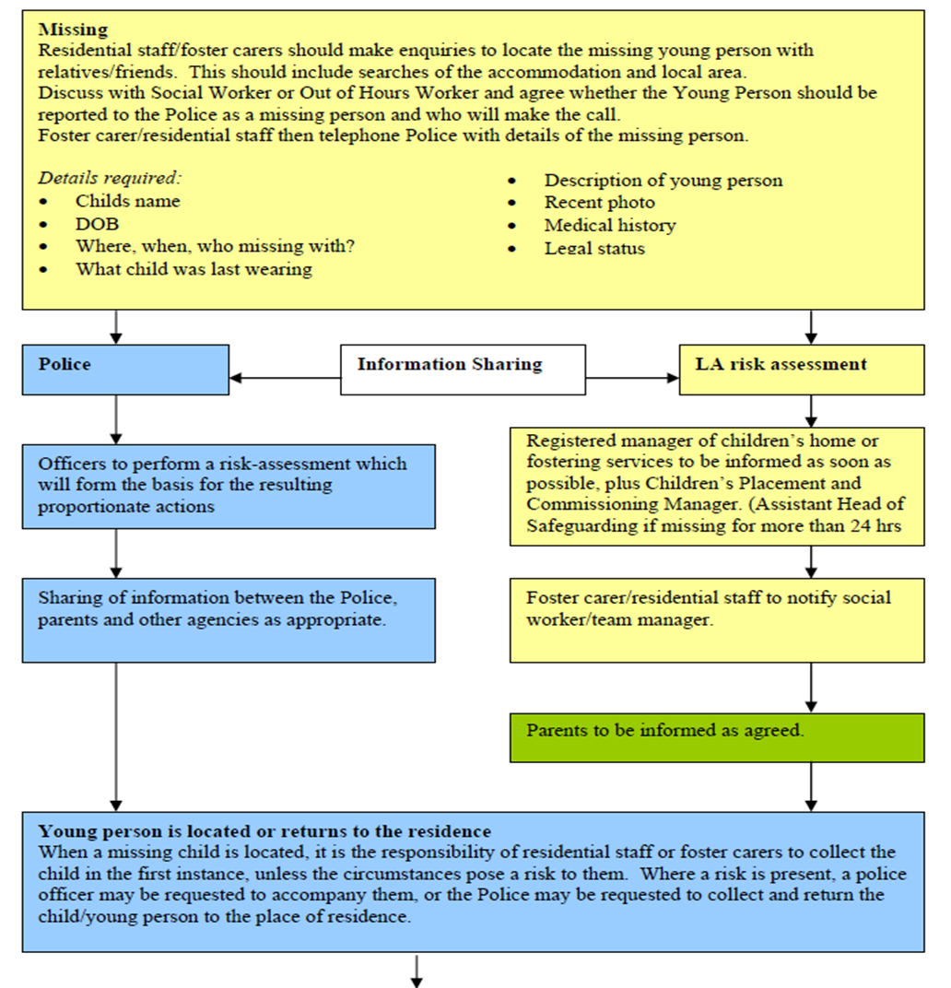

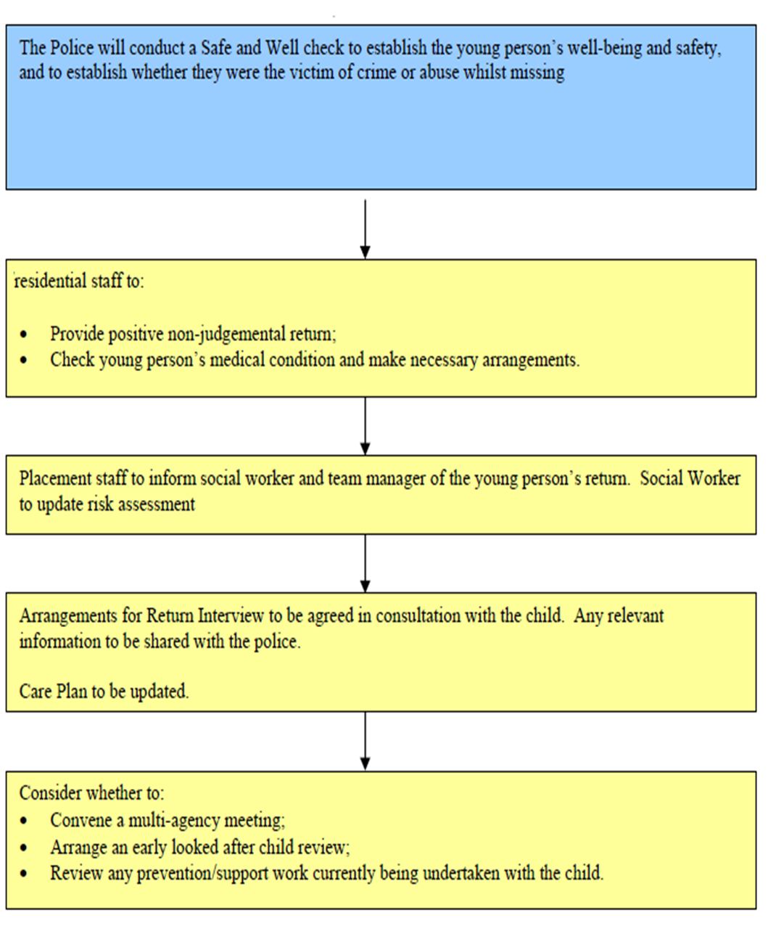

FIRE PRECAUTIONS
Fire Procedure
The home operates robust fire and emergency procedures. The home has a fire policy which is rigorously applied. An appropriately qualified external agent services equipment on a regular basis. Fire equipment and alarms are tested at regular intervals and tests are recorded in the fire log book, testing takes place in line with the fire safety policy and legislation and staff and service users take place in regular evacuations as required and we actively support children and young people in understanding fire safety. We do this through picture/symbol fire procedures, talking about fire safety and through fire drill simulations. Records are kept and include children’s and young people’s comments and scenarios used; any issues noted are addressed immediately. All exits are clearly marked and with emergency windows and fire equipment in place that is checked regularly we provide a safe home to children and young people.
The team receives regular fire training from a qualified consultant and in-house instruction takes place as part of the induction process for new staff and regular thereafter. The implications of a fire within the home are discussed with the children and young people if practicable. In addition, each child/young person has a specific risk assessment related to fire safety and details of any evacuation plans are kept in the fire file.
We participate in three monthlies night-time simulation drills to raise staff awareness on fire safety. We have an evacuation plan which highlights the procedure for staff to follow in the event of a day or night-time fire and accommodation required for the children and young people if the building is unsafe. This has been done in agreement with citation.
The staff team will carry out weekly checks on all fire equipment, record and report any actions required to their line manager.
All our staff have been trained in first aid so that there is a first aider on duty at any one time. All staff are trained in fire safety and complete weekly fire safety checks that are recorded in the fire safety check book.
Health and medical emergencies are also planned for within the general running of the home. An ambulance will be called by the home in the event of any accident or seizure requiring attention and it is deemed appropriated to await the arrival of a GP. A staff member will accompany the child/young person to hospital and remain with them as required. Night cover will be provided if it is felt that this would be in the best interests of the child/young person or at the request of the placing authority.
Other emergencies such as gas or water leaks or electrical failures, will receive immediate attention from appropriate external agencies, the home has a Business Continuity Plan which can be found in the office.
Fire precautions and emergency procedures are inspected during monthly statutory Regulation 44 visits and during the Registered Managers Regulation 45 reporting. The Registered Manager also ensures that portable appliance testing (PAT) is carried out on a yearly basis. The boilers are serviced annually to ensure that they are safe for use.
THERAPEUTIC INPUT INTO THE HOME

The changing needs of a child or young person can make it difficult to make predictions about the on-going and future needs of the individual. Hennessy Group see this as part of the on-going review system and accepts that the home may no longer be suitable for the changing needs of the individual. This can include an increase in independence and development.

Emergency incidents notwithstanding, any decisions or changes will be made through multidisciplinary reviews and would only happen if agreed that it is in the best interests of the child or young person, or where a failure to act is likely to put the home in breach of registration requirements.

There are several therapeutic approaches used within our home and these are individualised to each child/young person. Some children and young people may use a form of visual planning which is individualised for their level of understanding, for example some children and young people will use photographs and other symbols or the written word.

Staff attend regular training which enables them to implement therapeutic strategies and approaches effectively. Within our home there will also be a support staff with the role of ‘Communication Champion’.

Communication takes a lead in promoting communication and sensory stimulation within the environment and ensuring communication strategies and sensory approaches are used.

INTENSIVE INTERACTION

The home will identify a support worker to take the lead as an ‘Intensive Interaction Champion’

STAFF ACKNOWLEDMENT

I confirm I have read the contents of the Statement of Purpose.

I confirm I will carry out all instructions as detailed in this document.

I can confirm I know this document is kept within the office Should Ofsted request me to locate the Statement of Purpose during an inspection I can do this immediately.

I am aware that the Statement of Purpose is a document that all Children’s Residential Homes must have as stated in Regulation 16 of the Children’s Homes Regulations 2015 which instructs who the Statement of Purpose should be available to. Schedule 1 of the Children’s Homes Regulations sets out a detailed list of criteria which is the minimum contents contained in the Statement of Purpose.

I agree to follow the guidelines in the Statement of Purpose.
Name | Signature | Date
Paul Tillotson | P Tillotson | 5/7/2022
Carol Harrison | C Harrison | 06/07/2022
Zoe Barker | Z Barker | 05/09/2022
Lindsey Newbury |  | 16.1.23
Lindsey Newbury |  | 20/3/23

Review Date: | 18/3/23
Version: | 20
Acting Regional Manager | Lindsey Newbury
Date Sent to Ofsted: | 20/3/23
Date Sent to Social Workers (all young people): | 20/3/23
Date Sent to Parents (all young people):

