Statement of Purpose
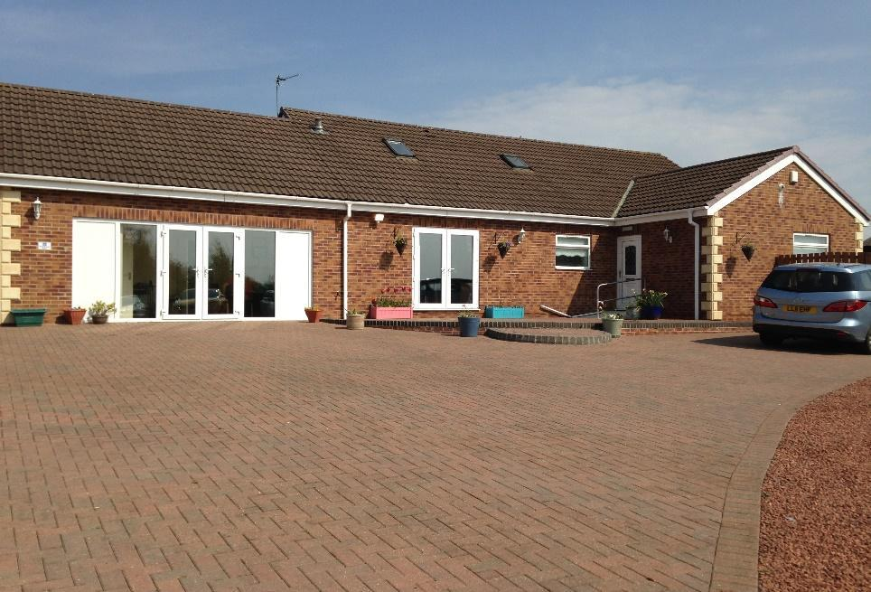

Donna Coulthard
Homes Manager

Willow Lodge
Children’s Home

Homes Manager: Donna Coulthard
Registered Address:
25 Cumberland Terrace
Willington
County Durham
DL15 0PB
E-mail: managerwillowlodge@hennessygroup.co.uk
Tel: 01388746906
Mob: 07834586398

Unique Registration Number: SC482418
Date Registered:
Version:19
Date of Issue: November 2021

Registered Provider:
Hennessy Living Group
Rickleton 1b
Bowes Business Park
Lambton Estate
Chester Le Street
DH3 4AN
TEL: 01913758229
Responsible Individual & Chief Executive Officer: Diane Jones (Details Above)
Regional Manager: Chris Goundry

Operational Instructions

Date of Original Document: 5/10/15

1. All contents must comply with Regulation 16 of the children’s homes (England) Regulation 2015 Schedule 1 and company recording standards.

2. Company standards require that this statement shall be kept for at least 15 years from the date on the front page.

3. The Registered Manager must ensure that a copy of this document is on display within the home, copies of this document are made available to any staff working in the home, any child accommodated in the home, the parent of any child in the home and the placing authority of any child accommodated in the home.

Introduction
The Children’s Home Regulations 2015, Regulation 16 (1) requires that we have in place a written Statement of Purpose for our Children’s Home.
In addition, Regulation 16 (2) requires that we provide a copy of this document to Ofsted and that we also make a copy available upon request by:
- Any person working in the home
- Any child accommodated in the home
- The parent of any child accommodated in the home
- The Placing Authority of any child accommodated in the home
- The Placing Authority who is considering placing a child in the home

It is the Registered Managers responsibility to take a positive approach to Regulation 16 (2) by providing a copy of this document to those individuals above rather than this having to be requested.
This Statement of Purpose details all elements of service provision, for example this includes:
- Quality and Purpose of Care
- Views, Wishes and Feelings
- Education
- Enjoyment and Achievement
- Health
- Positive Relationships
- Protection of Children
- Leadership and Management
- Care Planning
In essence.
- This is a critically important document for Willow Lodge, but more importantly for children and young people who use our services, their families and placing authorities.
- It is the primary foundation for the service that we provide at Willow Lodge and how we deliver the service.
- It is the practise and management template that we aim to adhere to and be measured by.
- It is a stated means of how Willow Lodge will aim to ensure we put children’s and young people’s rights at the forefront of all we do.
Ofsted (The Office for Standards in Education, Children’s Services and Skills) is the regulatory body that registers Willow Lodge as a children’s home. The registration complies with the Care Standards Act 2000 and the Children’s Homes Regulations 2015.
Ofsted is a national body set up under the Care Standards Act for the regulation and inspection of social care services throughout England.
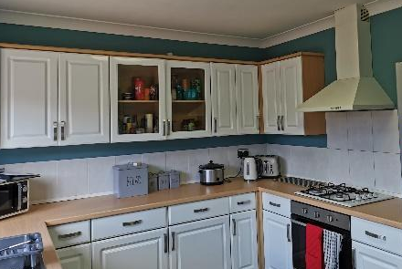
Contextual Information
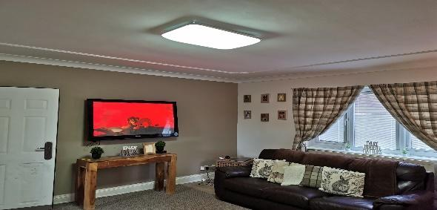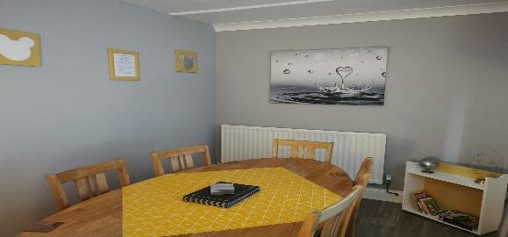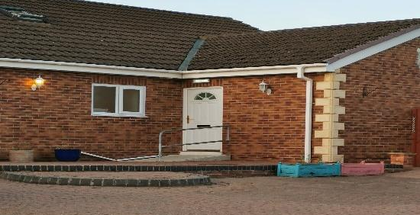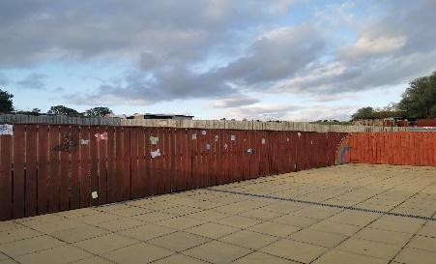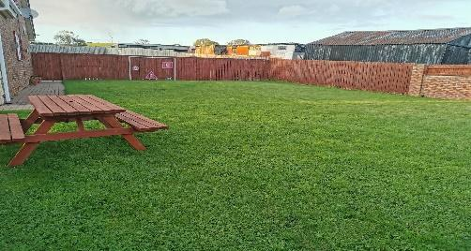
Willow Lodge is a children’s home which is owned by the Hennessy Group. It is a large, detached bungalow with Four bedrooms, based in Willington; a suburb of Durham. It is a specialist home that provides a service to support children and young people aged from 3 to 19 years old of both sexes who present Physical and Learning Difficulties. It has 2-bedrooms downstairs and 2-bedroom with en-suite bathroom upstairs.
Willow Lodge provides support for long term, short break care, outreach (in some cases) and emergency/accelerated admissions dependent upon compatibility and suitable space within the home.
Two bedrooms are located on the ground floor, and these are accessible by wheelchair users. There are shared communal areas downstairs including a spacious Living and dining room, and a kitchen overlooking the patio area to the rear of the property. Upstairs there are two bedrooms which have an en-suite facility and a snug space.
Children and young people will be deemed suitable to reside together following completion of a comprehensive group dynamic risk assessment. Willow Lodge’s staff team have an excellent reputation in the development and progress of complex children who have challenged services previously.
Our Aims and Objectives at Willow Lodge
Our aims and objectives at Willow Lodge are to provide a safe, warm, and nurturing environment with a high standard of care and accommodation for children. Ensuring excellent delivery of care. Specifically, we at Willow Lodge aim to:
- Provide a physically safe and comfortable place to live and to safeguard and promote the welfare of each child.
- Provide consistent and reliable staff, modelling and ‘good parenting’ to support and encourage children within our care.
- Ensure that all the key developmental areas of health, education, emotional and behavioural development, family and social relationships, identity, self-care, and social presentation are addressed in the planning for each child.
- Listen to and respond to children’s concerns and encourage them to express their views and opinions. Ensure each child’s rights and individual needs are respected.
- Facilitate positive experiences and constructive use of free time. Encourage children to participate in social and leisure activities.
- Encourage children to plan and work together towards household decisions regarding activities, decoration of the house, purchase of equipment, house rules and sanctions etc.
- Work towards positive outcomes with children, their parents, carers, social workers and relevant others.
- Facilitate contact between the children and their family, friends, and other relevant people.
- Welcome visitors to the home and ensure we promote a culture of positive professional relationships.
- Work in accordance with relevant policies and procedures

At Willow Lodge
The property is owned by Hennessy Living Group.
The accommodation is registered for 4 young people, aged between 3-19, who have learning disabilities and physical disabilities.
Any referrals and admissions are assessed with plans and relevant training undertaken by staff prior to placement commencing to ensure the home can offer a stable placement for each Young Person admitted.
Young people who reach the age of 18 years may remain in the home until they have completed their education at 19, however the home must remain wholly or mainly a children’s home (Care Standards Act 2000).
The team at Willow Lodge strive to achieve the best outcomes for the young people within our care. We want our young people to feel safe and protected and to grow up in circumstances that are consistent with the provision of safe and effective care. We want our young people to have access to a range of facilities within the local community including good healthcare, activities, and clubs they can join to feel integrated and accepted.
Children who stay within the home short term will benefit from well-established routines and procedures that meet their needs. It is important that children living in the home long term who need boundaries and clear routines are not unsettled by the combination of Short Break and Permanent Placements.

Our Specialist Residential Accommodation
Many people who have Physical/Learning Disabilities or Difficulties and life limiting illnesses have sensory sensitivity. This can affect one or more of the five senses: sight, sound, smell, touch, and taste.
A young person’s senses can be over- developed (hypersensitive) or under-developed (hyposensitive): both can impact on how young people experience, and cope with, different environments. Staff have a good understanding of the sensory needs of young people and will promote a supportive and functional environment to accommodate these needs, e.g., neutral décor, uncluttered environments etc.
One of the most effective ways of helping young people with environmental difficulties is to create a well-structured and supportive environment. This need does not necessarily involve physically changing the environment, but by making minor changes e.g., focus on putting in place structure, routine, and useful support strategies for the young people, we find this to be extremely beneficial.

Our Services and Facilities at Willow Lodge
The Home Layout
Willow Lodge is set in a secluded and quiet part of Willington that is surrounded by tranquil countryside. The home is conveniently situated near the local community and offers a wide range of facilities which children and young people can access, the home is close to good bus links, a train station and within 15 minutes of motorways. The home is spacious and light to support the child/young person’s Disability in a person-centred way and supports any sensory issues with noise and overcrowding, which creates a more calming atmosphere within the home.
Willow Lodge offers a home from home ethos and incorporates all the homely features that would be found in any family home.
The layout of the home consists of:
Two single bedrooms on the ground floor which meets the requirements of physical disability access. Next to these bedrooms is a sensory room, which all Young people can access. This leads into a spacious reception room/ Lounge and onto a staircase up to the first floor, at the top of the stairs is a snug where young people can relax and have some space away from the main areas of the home should they wish.
There are two rooms in parallel with the snug. Both are spacious single en-suite bedrooms,
There is a large attic room on the first floor which is accessible via the stairs just off the utility room and from the bedroom area. We have developed this into a staff room.
There is a large, shared lounge with a TV, DVD, and modern and comfortable sofas, a dining area where children can eat and socialise. The kitchen facility is next to the dining area. Children and young people are encouraged to participate in making meals, drinks and light snacks and will be supported to develop/enhance their skills in this area. A large patio area and garden is set just off from the kitchen which will be developed in consultation with children and young people and their families, there is a large garden for children and young people to play in. In the summer months the children and young people have access to a paddling pool and various garden games. We have plans to develop our own vegetable patch, herb garden, barbeque and seating area.
There is a large, shared bathroom on the ground floor, which has a WC, bath, and walk-in shower facilities.
There are shared laundry facilities on the ground floor within the utility room where children are encouraged to help with their own laundry.
There is an office and a staff sleep-in room. There will also be a waking night shift each night to support the young people should they get up.
The home has a large off-road car park.
The home is fully staffed over a 24-hour period and operates a high staff ratio intended to facilitate the development of individual lifestyles and the promotion of appropriate roles and responsibilities both within the home and wider community. The company operates a 24-hour management on-call system to facilitate authorisation of PRN medication, advice, or rapid response as required. The home has a dedicated, experienced, and suitably qualified staff team in order to support children and young people to live a fulfilling life.
We support and encourage young people to personalise their bedrooms and have a say on how their home looks.
The home offers a completely individual, tailored approach to care. We work closely with families, NHS staff / PCT’s, YOT and other organisations involved in the care of each child as well as the young people themselves. We work together to set goals and provide the support and on-going care to help each child reach their full potential at a pace that suits them.
Rooms are well proportioned following health and safety guidelines and regulations. The interior is modern, comfortable, and welcoming. Whilst meeting appropriate standards and legislation, Willow Lodge aims to provide a warm and homely environment.
Televisions are provided in the lounge and bedrooms (depending on child/young person’s desire). A telephone is available for young people to maintain contact with family, friends, social workers, IRO’s and Ofsted etc.
Willow Lodge has a dedicated budget for food, housekeeping, and outings. Children and young people are encouraged to develop their social and self-care skills and take part in independence training to develop and learn new skills for transition. They are encouraged to be involved in all routine chores within the home as well as the preparation of meals. Where appropriate children and young people will take part in shopping for their own meals and learn about food preparation, food hygiene and budgeting.
Each child/young person will receive regular pocket money and a clothing/activity allowance. They will have opportunities to be part of the community and social inclusion will be encouraged and reinforced. The children have access to a car for them to travel further afield and explore their community.
The home also has an Independent Regulation 44 Visitor in place who will monitor the performance of the home and report back to the Registered Manager, Chief Executive Officer and Ofsted.
The Hennessy Group will also develop the following services:
- Dedicated Therapy Team including Occupational Therapy, Speech and Language Therapy etc.
- Access to Psychology and Psychiatry teams
- Positive Behaviour Support Team
- Community and Extended Service provision for activities and outward bounds courses
- Maintenance Team who supports our home to ensure it is safe and is in good decorative order.
- Have trained and dedicated staff who are champions for specific areas i.e. Communication, Equality and Diversity etc.
- Regular inspections by the Regional Manager to ensure the home is performing to a high standard.
- Independent Reviewing Officer and Social Worker Statutory visits to the home
- 24-hour consistency and continuity of good care practices
- An experienced and dedicated staff team who have been fully trained in a range of disabilities.
- Access to advocacy services

Arrangements for Supporting Cultural, Linguistic and Religious Needs
Every effort is made to consider the religious and cultural backgrounds of children/young people and their families, and any disabilities that they may have. The opinions and views of children and young people on all matters affecting them, including day to day matters, are ascertained on a regular basis.
Enquiries are made into the religious and cultural background of each child/young person as part of planning their admission into the home. Provisions can then be made to allow the child/young person to practise their religion in a manner appropriate to their age, ability and understanding. Each child/young person is, as far as practicable, to have an opportunity to attend such religious or cultural needs and preferences. In order to support the individual appropriately, the staff team will seek out advice, knowledge and support from the relevant religious or cultural centres and authorities as necessary. Training and guidance will be given to staff where this is needed.
All staff within the home will receive training on Equality and Diversity to proactively promote rights, choices, beliefs, and traditions.

Arrangements for Dealing with Complaints
On admission to the home the children and young people and their families, significant others and independent visitors are provided with information on how to complain. Information is available on how an advocate can be accessed and children and young people are supported to action this.
The child/young person or their representative can complain if they are unhappy with any aspect of living in the home. There is a robust complaints policy in place where any complaint will be dealt with informally or through the formal process.
An informal complaint is something which we try to resolve through discussions with the parties involved and these are still recorded. Although we hope to receive very few complaints, we do welcome feedback and see this to continuously improve practice.

The formal complaint process is for independent investigation of complaints that cannot be resolved through the internal informal process or when the parties concerned are not happy with the outcome of the informal investigation.

A child friendly complaint guide is available with appropriate symbols for our children and young people which is in the Children’s Guide. Any complaints are taken seriously and addressed without delay, and a complaint will be fully responded to within a maximum of 28 days. The complainant is kept informed of the progress and offered support as required.
Where necessary, a suitably skilled advocate from our advocacy agency NYAS will be sought to aid in making a complaint where the child/young person has a communication impairment or other specific needs which require specialist involvement. We are currently accessing this service for a young person, and it has been a positive experience for all concerned.
The home's complaints procedure enables children, young people, staff and family members and others involved with children and young people living in the home, to make both minor and major complaints. Such complaints will be treated in the strictest confidence.
The children and young people and their families have the right to let staff know when they are not happy with anything relating to the service.

Complaints are also discussed within Children’s Meetings and the option for complaints within the Positive Behaviour Support children and young people’s Debriefing system. All parents and the Local Authority have access to our policy and procedure. This is located in the general office of the home and can be requested at any time.

All children and young people have access to telephone numbers in their Children’s Guide and for additional support residential staff can provide support.

All complaints are logged within our Compliment, Complaint and Suggestions logbook with the outcome recorded. If the complainant is not satisfied with the outcome then this can be followed through with the appeals process, whereby this will be investigated by Senior Management, the Placing Authority or Ofsted.

We also want to learn from our children and young people, their families, professionals, and staff members so we have developed a suggestion form where individuals can provide us with new and innovative ways of practicing and also ways to improve our service.

Communication is the key to positive relationships, and we all have a shared responsibility towards this. We are very proactive in dealing with any complaints and the earlier that we know, the less of a problem it creates.

We want an “open door” policy of working so complaints are dealt with in a professional and reflective manner. Every complaint has the potential to give us quality assurance to improve our service or gain access to a support network like the community police team to ensure we are not being discriminated against.

Below are the relevant contacts for complaints or to make a safeguarding referral/alert:

Name | Designation | Address | Telephone Number | E-Mail Address
Rebecca Donnelly | Homes Manager | Willow Lodge  25 Cumberland Terrace  Willington, DL15 0PB | 01388746906  07834586398 | managerwillowlodge@hennessygroup.co.uk
Diane Jones | Chief Executive Officer & Responsible Individual | Hennessy Living Group  Rickleton 1b  Bowes Business Park  Lambton Estate  Chester Le Street  DH3 4AN | 01484 850165  07868 495180 | Diane.jones@hennessygroup.co.uk
Chris Goundry | Chief Operating Officer & Regional Manager | Hennessy Living Group  Rickleton 1b  Bowes Business Park  Lambton Estate  Chester Le Street  DH3 4AN | 07715200411 | Chris.goundry@hennessygroup.co.uk
Ofsted | Regulatory Body | Piccadilly Gate, Store Street, Manchester M1 2WD | 0300 123 1231 | www.ofsted.gov.uk
Childline | N/A | N/A | 0800 11 11 | N/A
Dame Rachel de Souza | Children’s Commissioner for England | Sanctuary Buildings, 20 Great Smith Street, London, SW1P 3BT | 020 7783 8330 | Info.request@childrenscommssioner.gsi.gov.uk
On-Call Management Advice Line | Registered Manager’s & Deputy | N/A | 07834586398  07824638933 | N/A
Barnardo’s | N/A | N/A | 0191 240 4800 | www.barnardos.org.uk

Access to our Policies and Procedures
Parents, Social Workers, Commissioners, and other Multi-Agency Partners can access our Policies and Procedures relating to the care or protection of children residing in Willow Lodge by contacting the Registered Manager.

Views, Wishes and Feelings
At Willow Lodge, we believe that the children and young people should be encouraged and supported to make decisions about their lives and to influence the way the home is run. No child/young person is assumed to be unable to communicate his or her views. Therefore, the child/young person’s opinions, and those of their families or significant others are sought. Similarly, each child/young person is appointed a key worker and an advocate can be provided over any additional input regarding key decisions, which are likely to affect the daily life and future of the children and young people.
Children and young people are encouraged to take part in Children’s Meetings on a weekly basis or requested basis with staff where possible. Staff will take minutes, but it is the children and young people that should be encouraged to take the lead in setting the agenda.
The key worker provides 1:1 support to the child/young person and holds key worker sessions in order to gain the child/young person’s views and is able to advocate on their behalf. We also promote family forums where we can learn from parents and where further support can be given.
Each month the key worker will ensure that the children and young people have been consulted with in their monthly summary which is sent to families and social workers. We learn every day from our children and young people, whom we build into their placement plans and person-centred plans to ensure that they remain consistent.
Each week children and young people have the opportunity to take part in a Children’s Meeting in order to express their views and opinions. These will be worked on in consultation with the child/young person and any other professionals involved within their care in order to ensure these are meaningful to the young person through the use of symbol support and their indicators of well-being. This uses observations of the child/young person’s mood, body language and behaviour to gain their views on specified activities or situations.
All the young people will have Annual Statement of Special Education Reviews and Person-Centred Planning Reviews which the children and young people are encouraged to attend if they wish. Key workers and management also attend these meetings and reviews along with parents and other relevant professionals. These reviews focus on the individual and promote their voice within the home.
Willow Lodge is also visited by an External Regulation 44 Visitor. The visitor meets with the young people, parents, and staff monthly and submits a Regulation 44 report on findings each month to the Registered Manager and Ofsted. All documentation reporting systems ensure that we capture the voice of the child/young person to ensure that we meet our home’s aim of ‘the young person being at the centre of everything we do’.
The children and young people also have statutory visits each month by their relevant social workers, who ensure that the young people are consulted and involved in the home and placement. All current recording systems also feedback and capture the voice of the young person.

Children’s and Young People’s Rights, and Anti-Discriminatory Practice
Hennessy Group promotes care practices in a non-discriminatory way where all children and young people are valued as individuals regardless of age, race, gender, colour, sexuality, disability, or religious beliefs. We will provide a culturally sensitive service and ensure that all service users, staff and others receive equal access to services and equal access within them, Hennessy Group expect to treat all service users in a fair and respectful manner, and this is positively challenged and discussed with supervision, team meetings and children’s/young person’s meetings.
We uphold the Principles of Care, for promoting anti-discriminatory practice and promotion of children’s rights, respect and dignity as follows:

- Children and young people have the right to live in a home that is safe, warm, happy, nurturing, stable, valuing, affectionate, and secure, free from abuse and recognises the individual needs of the service user.

- Children and young people have the right to have full access to education, health care, social life, community facilities, and have the opportunity to live a full life as possible.

- Children and young people have the right to be listened to, express themselves, take full part in decisions affecting them, have things explained to them and the right to complain.

- Children and young people have the right to privacy, space, time, and dignity, have fun and be allowed to be a child.

- Children and young people have the right to their religious, cultural, dietary needs and to celebrate their individuality.

Our Responsibilities
Staff have a duty of care to ensure that children and young people are safe, supported according to their individual needs and abilities and are protected from any act or omission of harm.

- Staff act as role models for young people.

- Staff will act as a chosen key worker for each young person and promote communication and relationships between Willow Lodge and the young person’s family and friends.

- We will ensure effective placement planning, monitoring, and evaluation systems to demonstrate the young person’s development.

- We will liaise with the young person’s School to ensure continuity of educational programmes.

- We will respond quickly and be flexible in changing the needs of the young people and work proactively with other professionals.

- We will ensure the right level of experience and mix of staff are on duty at any one time.

Positive Outcomes
During their time at Willow Lodge, each child/ young person will be assigned keyworkers to work directly with them, providing them with three priority areas, short-term goals, long-term goals, and evaluations for reflective practice. These will all be documented in their keyworker file and care plan in the respective sections for progress and outcomes.

Keyworker meetings
Each child/ young person’s keyworkers will also discuss on a regular basis via keyworker meetings and children’s meetings, about their progress and achievements, as well as Child/ young person’s individual goals that they would like to work towards, and any concerns they may have with these or the service.
Short term targets will be put in place and agreed with the Child/ young person at the beginning of each week, giving them an incentive for good behaviour and making progress with priority areas.
Long term targets will be put in place and agreed with the Child/ young person at the beginning of the month, again giving them incentive to work towards, and their progress visible for them to follow.

Reflective Practice
Each child/ young person will be offered a quick discussion with staff when they arrive back from school, to discuss their day, what they have learned, what lessons they did and who they interacted with. Using their evaluation, it ensures each Child/ young person is aware that staff are working with the school to promote their education, and the Child/ young person can reflect on the day they had.
Every child/ young person will also be offered activity choices on evenings, weekends, and holidays, but these may also be organised for them due to concerns around their disabilities, such as anxieties. After each activity, staff will complete an evaluation of the activity from their perspective of supporting the Child/ young person, to determine whether they enjoyed the activity or not, and reflect on any potential changes or prospects. Staff will also complete an evaluation with the Child/ young person for their reflection of the activity, where they can voice their opinion, and discuss any achievements that have been made (such as positive social interaction, good behaviour etc.)

Behaviours that challenge.
If the Child/ young person displays behaviours that challenge that result in intervention or physical intervention, they will be offered a debrief for reflection on the scenario (this will be dependent on the incident and whether the Child/ young person will be deemed to not escalate or react negatively). If the Child/ young person completes these debriefs with staff and can vocalise their reaction appropriately (such as learning about consequences of actions), then it can be documented towards their positive outcomes.

Educational Arrangements
Education is viewed as a high priority. The home will work with education authorities to promote and support the delivery of an educational package within an identified educational setting. We offer an integrated model in which teachers and care staff liaise daily providing all children and young people with an individual education plan appropriate to their needs. Education will be provided by the Local Education Authority (LEA).
Staff are expected to help and support with the completion of homework in an appropriate environment to aid learning. Homework (when provided) is a priority, and evening activities will be organised around its completion.
Staff will assist the children and young people with preparation for the next day. Children and young people should be encouraged to refer to the timetable to ensure all needs are met before bedtime, e.g., appropriate clothing for activities, trainers etc.
In special circumstances Willow Lodge can provide in-house education, the aim being to support any young person who is struggling within the school environment to follow an education plan in-house. Willow Lodge will use this opportunity to support the young person back into the school environment. This is only used as a short-term plan.

Enjoying and Achieving
The daily living experience of the children and young people will be structured and varied providing stimulating opportunities for social, intellectual, vocational and personal enrichment. They will be encouraged to utilise local community services. The level of supervision required would be subject to ongoing assessment of risk and consultation. Emphasis is placed upon maintaining a normalised experience. The child/young person will be encouraged to invest in their living environment, personalising aspects of it and contributing towards its maintenance.

- Children and young people are encouraged and supported to maintain a proper balance between free and controlled time within the structure of the day. Individual activity plans reflect the needs and choices of the children and young people incorporating periods when they are encouraged to pursue their own interests.

- The children and young people at the home are encouraged and given opportunities to take part in a range of activities both within the home and in the community. Birthdays, name days, cultural and religious festivals will be celebrated where appropriate, themed nights will be organised, and the children/young people will help in the planning. Staff actively encourage family involvement in all occasions planned. The child/young person, where able, is encouraged to participate with staff in planning these events. Children and young people will be able to pursue their interests, develop confidence in their skills, and continually add new activities and experiences to their programme. An activity budget is provided to ensure adequate funds.

- Activities will consider the safety of children and young people. All activities will be risk assessed, recorded, and evaluated, and amended or discontinued as required. Persons holding the relevant qualification to supervise children’s involvement in the activity concerned will supervise any high-risk activity provided or arranged for the young people.

Health
The physical and mental health of the children and young people are of paramount importance. We actively promote a healthy lifestyle, which is applied to planning diets, exercise, and relaxation specific to the child/young person’s needs to ensure a balanced and varied lifestyle. All dietary needs are discussed with the child/young person and their family and recorded in their placement plan.
The home seeks to ensure that all children and young people live in a healthy environment and their health needs are identified. The management team will be responsible for monitoring and will seek to ensure that specific needs are considered and actively pursued. A range of health care professionals would be approached to identify both initial health care needs, and ongoing input as required.
All our children and young people will be registered with the local GP, the Registered Manager will ensure she meets with the Practise Manager to build up effective relationships. On admission, the child/young person will have a full health check, the child/young person will also have an annual Looked After Medical Health Check.
The child/young person will be provided with guidance, advice and support on health and personal care issues appropriate to their needs and wishes. Services will be provided to meet all health needs from within the local community. Each child/young person will have a clear written Health Plan covering all medical health needs. These will be developed by involving the child/young person and their parents. We use these when a child/young person needs to access a health service so that we ensure that their appointment has been a successful one.
A written record will document all illnesses, ailments, accidents, or injuries to the child/young people during their placement at the home. Children and young people with health needs or disabilities will be provided with appropriate support and help. Key workers at the home will ensure that any support or treatment required are included in the child/young person’s Placement Plan and Health Plan, is implemented, recorded, and monitored. Relevant parties will be updated with this information as required, and advice sought, as necessary. Serious events will be communicated to the Placing Authority within 24 hours.
We monitor the height and weight of our children and young people monthly unless otherwise stated in individual needs and record this information so that we can be proactive in supporting their good health.
Children and young people will receive more formal education on maintaining a healthy lifestyle and learn about nutrition and health management.
The Registered Manager aims to build up a very proactive relationship with the local Consultant Psychiatrist, Community Nursing Team and de-sensitization practitioners who we can call upon if we have a concern about a child/young person’s medication issues or an upcoming medical appointment. The Psychiatrist may visit the service to check on the child/young people’s progress, they may also attend the child/young person’s Looked after Reviews and Annual Statement of Education Reviews.
All staff are trained in First Aid as part of the mandatory training and the home has fully stocked First Aid boxes which are checked weekly. This means that if children and young people have minor injuries that we can actively administer First Aid promptly which limits the need to attend a surgery.
The Registered Manager intends to build up positive relationships with the local NHS primary health centres. Hospitals and PALS Nurses, to provide health support to the child/young person as well as training if required to the staff team.
Some of our children and young people may require medication for various reasons and we aim to work closely with the primary care services to ensure that any medication taken is only for therapeutic reasons.
All of our staff will be trained in the Safe Handling of Medicines, and we ensure robust recording and storage procedures are in place.

Promoting Contact with Families and Friends
Every effort is made to promote contact between parents and the child/young person residing at the home as outlined in their Placement Plan. The children and young people are provided with practical support for constructive contact with their parents, family and other significant people, and are encouraged to maintain this contact. Where possible the home will offer support to families who are experiencing difficulties visiting their child in the home. A telephone will be available for all children and young people to make and receive calls in private. The privacy and dignity of the individuals is respected. The Placement Plan will reflect the arrangements for telephone use and contact and any restrictions on this will be made clear in their Placement Plan and only for the protection of the child/young person. This will be agreed with the placing authority at the point of admission. We encourage parents and siblings to be fully involved in the child/young person’s life and actively promote activities with their involvement in the home itself and also within the community. In some cases, decision making will be delegated to the staff at the home with regard to the child/young person’s health and education. This will be agreed with the placing authority at the point of admission. There are arrangements in place to support all children to develop and sustain friendships and where safe to do so children are welcome to have friends over to stay.
Examples of what we do:
- Key workers maintain regular contact with families.
- Family Forums
- Parents evening at school
- Letters, and the opportunity of private telephone calls
- Monthly summaries, keyworker meetings, and children’s meetings, and a summary sent to parents to update them on what the children and young people have done during the month.
- Involvement in monthly care team meetings
- Monthly newsletters
- Family involvement in activities
- Involvement in training sessions, e.g., PBS training
- Consultation and involvement in appointments
- Involvement in monthly theme nights
- Involvement in person centred planning

We do require notice of all visits if these are different to the current recorded arrangements, so that we can prepare the child/young person for their visit, and also ensure they are at home. All contact arrangements are recorded on the child/young person’s records and visitors are requested to sign in and out of the home for security purposes.
Monitoring and Surveillance

Due to the nature of the learning disabilities and other complex needs of the children and young people placed at Willow Lodge, children/young people resident at the home are supported and supervised by staff on a 24-hour basis. Children and young people who live within the residential home may be extremely vulnerable and may demonstrate risk taking behaviours that may cause harm to themselves or others.

Where the need has been highlighted, listening monitors may be used during the night to promote well-being of the children and young people. These will be considered only after consultation with relevant professionals, parents, and the placing authority when the restricted access of areas is required, and a clear rationale given.

Children and young people will be assessed regarding their capacity to make choices and decisions about their own safety and will be offered communication support to enable them to move around the building or access outside facilities. These will be considered only after consultation with relevant professionals, parents, and the placing authority when the restricted access of areas is required, and a clear rationale given.

Willow Lodge operates a locked door policy to ensure that no unauthorised visitors have access to the premises or children and young people and to ensure that children and young people will not be able to leave the premises without staff’s knowledge.

Any restriction of liberty will be the subject of a multi-agency meeting with placing authority prior to placement; this must demonstrate that these measures are not punitive, or in any way contravening the rights of the child directive.

Bedrooms may be fitted with door alarms which can be activated if children and young people demonstrate behaviours that may cause them or others harm or distress e.g. entering another child’s bedroom at night. We will seek consent from all parents regarding the use of mechanical surveillance. Consent forms will be made available within the child’s Placement Plan file.

Behaviour Management
A child/young person with a Learning Disability may display behaviours that are challenging as they can/may lack the social understanding of a situation, which could lead to them being unable to effectively communicate their needs and lack the imagination of what is expected of them next.
Behaviour that challenges is often driven by individual needs. The difficulty children and young people experience in addressing their own needs may account for any challenging behaviour they present.

The child/young person’s identified needs and behavioural targets will always remain a
central focus of the placement. Issues and information will be discussed openly using a supportive and respectful approach. Our approach is geared towards enhancing motivation to change. Frequent monitoring of behaviour provides valid data to identify patterns, trends, measure progress and change.

We believe our children and young people:

- Have talents and skills.
- Are valued members of our society and community.
- Have the right to be treated with dignity and understanding.
- Have an excellent quality of life through opportunity and learning.
- Should be allowed to express themselves individually.
- Have responsive and flexible environments that have a positive attitude towards challenging behaviours.
- Have strategies that are effective in promoting positive and durable lifestyle changes.
- Builds skills over time.
- Should not be restricted in life because of their behaviour.

All staff have a good understanding of Positive Behaviour Support including Core Theory, Multi-Element Behaviour Support, PBS Planning, PMVA Restraint Training. We are not working towards BILD Accreditation at this point however are highly passionate about our children and young people and delivering the right services, so this is high on our agenda. The Management Team will eventually all be trained in Train the Trainer therefore have the ability, knowledge, and skills to train all staff to a high standard. This process will involve a highly individualised programme that will be developed via a person-centred approach and through a referral system.

Once trained our instructors in proactive and reactive behaviour (reactive in the use of physical intervention only as a last resort) will develop a training package specific to the needs of our service and the children and young people that we support.

Each child/young person has a positive behaviour support plan that is developed alongside the child/young person, their family and Local Authority representative and is agreed before implementation.

Positive Behaviour Support Plans are reviewed regularly through a multi-disciplinary approach and are risk assessed. All staff will be trained in this approach and refresh their skill and knowledge level every 12 months in line with the BILD Code of Practice 2014.

This service does operate a locked door procedure which is only operated due to young people being at risk of either absconding or having a lack of awareness of the dangers within the community and because of their individual vulnerabilities. A consent for this is signed by the placing authority for this prior to placing a Child at Willow Lodge.

We do abide by the Mental Capacity Act 2005, and we practice within the following five-person centred principles:

- A person must be assumed to have capacity unless it is established that they lack capacity.
- A person is not to be treated as unable to make a decision unless all practicable steps to help them to do so have been taken without success.
- A person is not to be treated as unable to make a decision merely because they make an unwise decision.
- An act done, or decision made, under the Act for or on behalf of a person who lacks capacity must be done, or made, in their best interests.
- Before the act is done, or the decision is made, regard must be had to whether the purpose for which it is needed can be as effectively achieved in a way that is less restrictive of the person's rights and freedom of action.

A decision to have a locked door procedure fully complies with the Mental Capacity Act and Deprivation of Liberty Safeguards. This assessment process is fully communicated to the individual's Local Authority and parent and a consent form must be signed prior to admission. If the placing authority feels a DOL’s is needed, then they must communicate this prior to placement commencing and ensure these measures are put in place.
Promoting Positive behaviour, Respect, and Positive Outcomes

Willow Lodge provides supportive and functional environments for all our children and young people and has a caring ethos. We provide several means of celebrating achievements and positive behaviour.

We work on a positive and proactive approach towards behaviour and will attempt to ignore and diffuse negative behaviours with a view to rewarding and acknowledging as much positive behaviour as possible.

Some examples include.

- Sharing and acknowledging good behaviour.
- Having agreed methods of rewarding good behaviour through multi agency meetings.
- Children and young people have opportunities for gaining extra responsibilities.
- Discussion times with the children and young people where they can share their successes and congratulate one another through resident meetings and debrief sessions.
- Sharing and acknowledging good behaviour with parents and others in the wider community.
- Rewarding certificates of achievements, merits or working towards a person-centred goal.
- Displayed work by children and young people in the residential home and at school.

We may use sanctions such as removal of privileges, fines, groundings etc. A record of all sanctions is kept in the office, and these will always be explained to the child/young person. We never refuse food or drink as a means of sanction, refuse contact with relatives or statutory agencies or refuse medications. We prefer to work with a restorative approach and promote the Young People to earn their privileges rather than taking them away.

- Reparation – physical reparation, e.g., mending a broken item may also be appropriate.

- Curtailment of leisure activities

- Additional household chores – children and young people should be encouraged to help with small household tasks, but they must not be used instead of domestic staff.
- A child/young person who is untidy will be encouraged to clear up the mess with supervision and assistance from an adult as necessary.
- Aggressive behaviour – it may be appropriate to remove an aggressive child/young person from the immediate situation to another area to diffuse the situation or to withdraw any other children and young people from the area for a short period of time until the child/young person has calmed.
The promotion of good behaviour is supported by a multi-disciplinary approach, and this is documented in the child/young person’s Positive Behaviour Support Plan. The proactive elements of the plan are overseen by the Registered Manager who will carry out various assessments, e.g., environmental assessments, motivational and functional analysis and behaviour baselines etc. To provide a proactive approach to positive behaviour.

Where children and young people require a reactive assessment to their individual behaviour training will be sought. A Principal Physical Intervention Instructor will assess the need for physical interventions or breakaway techniques. The instructor will meet with the child/young person, undertake observations, and speak with key staff who know the child/young person well.

All physical interventions will be risk assessed and are reviewed and evaluated every 12-18 months in line with the BILD Code of Practice 2010. A Physical Intervention Acknowledgement Form is signed by all parties. Training is then conducted on a bespoke basis and refresher training also takes place every 12-18 months.

The use of physical force is not permitted. Physical force may never be used as punishment or general means of control. However, a person may take the necessary physical action where another course of action may be likely to fail, to avert any immediate danger or personal injury to the child or another person, or to avoid immediate danger to property. The use must be as little but necessary force, in the least restrictive way, and for a minimum amount of time. Where this is necessary a record will be held in the office and the child/young person will be given the opportunity to discuss their feelings about the situation. Staff are also offered debrief sessions following all incidents to discuss the positive outcomes and any concerns regarding the scenario. Copies of this record will be shared with School, Social Worker and parents where requested. These policies are in accordance with the D.O.H (Department of Health) guidance on permissible forms of control.

In the event it becomes necessary, as a last resort, to provide physical intervention in order to ensure the safety of all, this will be implemented by trained staff who understand the method of these comprehensive therapeutic techniques. In addition to practical demonstration, it provides guidance on recognising and understanding the individual’s behavioural spiral and provides practical strategies to address each level. Reactive strategies will only be used when proactive strategies have been exhausted. Data is collected and analysed. Full incident reports are completed, and staff are de-briefed by the Registered Manager. Individual Behavioural Management Strategies are reviewed to reflect any changing needs and amended as required.

Should any therapeutic input be required this will be sourced via external agencies i.e. GP, Community Paediatricians, School Nurses, Physiotherapists, Dieticians, Speech and language Therapists or Placing Authorities.

All parents and the Local Authority have access to our policy and procedure. These are stored in the general office of the home and can be requested at any time.
Our Senior Leadership Team
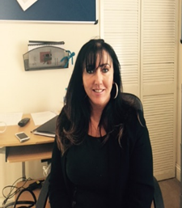
Diane Jones
Chief Executive Officer and Responsible Individual
Email: Diane.jones@hennessygroup.co.uk
Address: Rickleton 1b, Bowes Business Park, Lambton Estate,
Chester le Street, DH3 4AN

Experience of CEO: Diane has over 25 years’ experience in the field of care and support in Children and Adult Services. She has previously been the Registered Manager of 4 children’s services. Before joining the Hennessy Group, Diane was the Head of Children’s Services, Director of Operations, and the Responsible Individual for 17 services across the country which specialised in challenging behaviour and complex needs, physical disability and learning disabilities, mental health, autism and sexualised behaviour. She was also Regional Director and Responsible Individual for Adult Services and oversaw 42 services which included Residential and Supported Living. Diane has spent a large amount of time supporting other companies at director level to turn failing regions around.
Qualifications:
- NVQ Level 4
- Registered Managers Award Level 4
- ILM Level 4 Management
- D32 and 33 Assessors Award (Upgrade to A1 and A2)
- Professional Qualification in Person Centred Counselling and Transactional Analysis
- Enrolled on NVQ Level 5 Children and Young People

Our Senior Leadership Team

Chris Goundry
Regional Manager and COO

Email: chris.goundry@hennessygroup.co.uk

Address: Rickleton 1b, Bowes Business Park, Lambton Estate, Chester le Street, DH3 4AN
Tel: 07715200411

Date of Joining Hennessy Group: 9th June 2016.
Experience:
Chris has worked in Children’s services for over 7 years, 4 of which have been at senior level supporting children with autism, learning disabilities and physical disabilities. Chris has over 10 years’ experience with Adults with Learning disabilities and Autism.
Chris spent 3 years as a Senior Custody Officer responsible for 21 prison custody officers and up to 50 prisoners. He has 3 years’ experience of Control and restraint, physical intervention, and de-escalation within a custodial setting for adults and young offenders.
Qualifications:
- Level 5 Leadership and Management in Residential Children and Young People
- NVQ Care Level 3
- Level 2 Handling of Medications
- Level 2 Autism Awareness
- No Fear RPI
- Control and Restraint

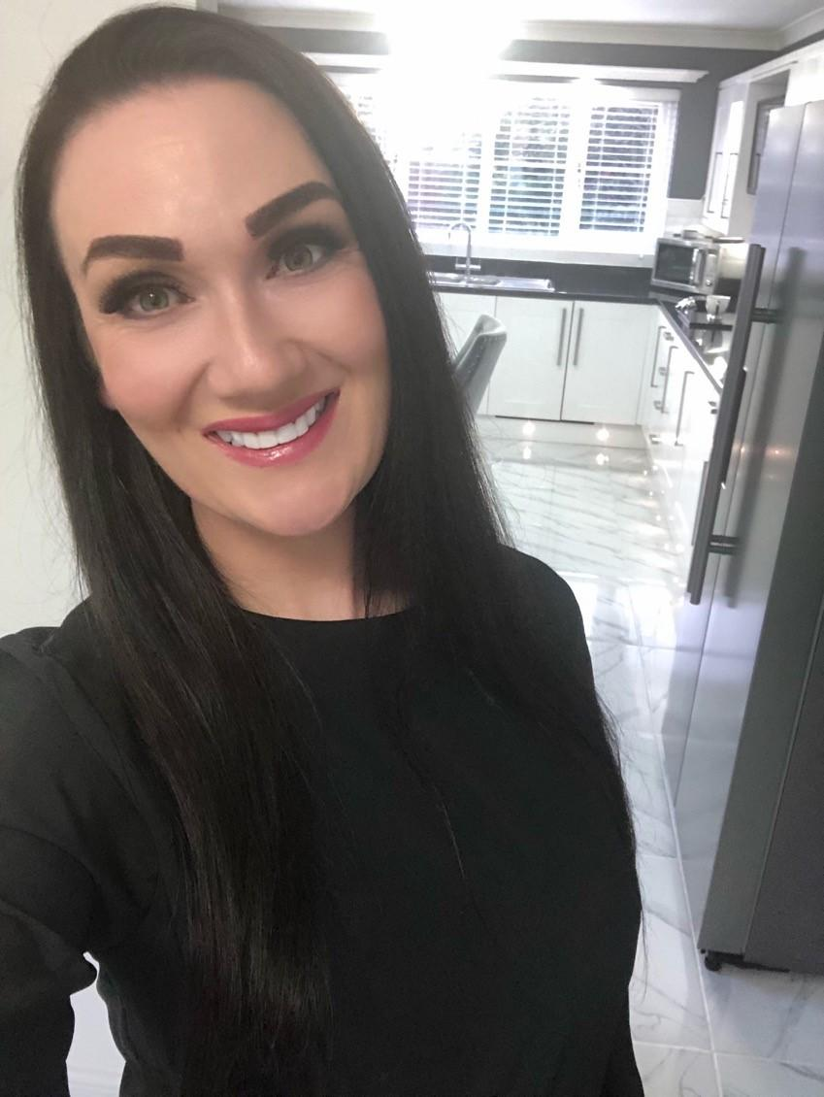
Donna Coulthard
Acting Manager
Email: managerwillowlodge@hennessygroup.co.uk

Tel: 01388 746906

Date of joining Hennessy: March 2021
Experience: Donna has committed to over 21 years in the care industry, 10 of which have been spent in a management role in private services for ages 16+ supporting individuals with complex and challenging behaviours. During this time Donna set up a new resource centre and successfully managed two other units in order to bring them to a high standard. Donna then transitioned over to children's services as part of the management team, supporting young people from the age of 8-18 with EBD and LD, from the areas of Gateshead, Stockton, Middlesbrough, and Darlington.

Qualifications:

- NVQ level 2 and 3 in children’s and adult’s social care
- NVQ level 4 in Leadership and Management
- Level 2 Autism
- Level 5 Leadership and Management Children's Services
- Level 3 Designated Safeguarding Officer
- Responsible Individual

Willow Lodge Staff Team
At Willow Lodge, we currently have a staff team of 14 core staff. We do not use agency workers unless necessary. This means that our children and young people know the staff team very well.
The staff levels are of course dependent on the care needs of the children and young people who live at Willow Lodge at any given time. Our staffing levels are well planned to take account of the differing needs of children who come to stay at the home for a Short Break and those living permanently in the home. These will be in accordance with staffing requirements as set out in placement plans, risk assessments and contracts with placing authorities. Specific experience and qualifications of staff in post are set out within this document. We recognise that our young people should have appropriate role models both male and female. Our young people may also attend School where they will have a diverse range of staff working with them along with regular contact with their family members.
We recognise that our children and young people have diverse needs, and their staffing establishment and skill mix has been developed to accommodate our children/young people’s needs and preferences. Where any future admissions are made to the home that involves either gender, management will ensure the gender mix is appropriately balanced.
All appointments are conditional on receipt of the following satisfactory checks:
- Disclosure and Barring Service at the appropriate level, which includes checks of the Protection of Children Act List (POCA) and Protection of Vulnerable Adults List (POVA)
- Occupational Health Check (where necessary)
- At least two references, preferably one from a current employer and, where possible a statement from each referee as to their opinion of the person’s suitability to work with children. All references are verbally verified with referees.
- Checks on any breaks in employment history.
- Identity Checks.
- Checks of any required and relevant qualifications.
- Checks to confirm the right to work in the UK; and
- Where the person has lived outside of the UK, further checks are considered appropriate.

The whole process is carried out in line with Hennessy Group Equal Opportunities and Recruitment and Selection Policies.

Willow Lodge has an experienced team of support workers who all bring their own skills and experiences to improve the service provided to our young people.
DP, Support worker
Experience – DP has previous experience in the care sector which involves working with Children and Young people who have been subject to CSE. DP also has experience in working with Learning Disabilities, SEBD and behaviours that challenge.
Qualifications:
Level 3 Children and Young People's Residential Care.
Level 2 Safe handling of medication
Adverse Childhood Experiences, Autism, and communication
LA CSE and Safeguarding
MAPPA RPI Control and Restraint
First Aid, Health and Safety and Fire Marshall Trained.

DL, Support worker
Experience: DL has over 4 years’ experience in the care sector which involves working with Children and Young people who have been subject to CSE. DL has experience in working with Learning Disabilities, SEBD and behaviours that challenge.
Qualifications:
Danni has a Level 3 in Children and Young People
PMVA Restraint Training
LA CSE and Safeguarding
First Aid, Health and Safety and Fire Marshall Trained.

JHe, Support worker
Experience: JHe was a care coordinator for adult services. JHe has worked in Health and Social care since leaving school. JHe joined us as she wants to progress into working with children and young people
Qualifications:
Jade is currently enrolled on to a Level 3 in Children and Young People
LA CSE and Safeguarding
PMVA Restraint Training
First Aid, Health and Safety and Fire Marshall Trained.

DG, Support worker
Experience – DG joined us in September 2019 she has precious experience of working in care although this was with the elderly, she did not have previous experience of managing challenging behaviour.
Qualifications:
Working towards Level 3 Children and Young People's Residential Care.
LA CSE and Safeguarding
MAPPA RPI Control and Restraint
First Aid, Health and Safety and Fire Marshall Trained.

HH, Team Leader
Experience – HH has worked with Children and Young People in a school setting, delivering Art Therapy. HH is keen to develop her career in Children and Young People's Residential care.
Qualifications:
Working towards Level 3 Children and Young People's Residential Care.
LA CSE and Safeguarding
PMVA Restraint training
First Aid, Health and Safety and Fire Marshall Trained.

JC, Support worker, Team Leader
Experience – JC is currently undertaking her level 3 in Residential care. Jordyn has 5 years plus experience of working in Childcare, JC is very patient and creative and has quickly built-up positive relationships with the Children and Young People.
Qualifications:
Level 3 Health and Social Care.
LA CSE and Safeguarding
PMVA Restraint Training
First Aid, Health and Safety and Fire Marshall Trained.

VH, Support worker
Experience – VH has previous experience in a residential setting and dealing with challenging behaviour and has personal experience of working with young people with various complex syndromes, as well as caring for dementia patients. VH is able to build a positive rapport with the Children and Young people as she is easy going and good to talk to.
Qualifications:
Level 2 child Care
Working towards Level 3 Children and Young People's Residential Care.
LA CSE and Safeguarding
PMVA Restraint Training
First Aid, Health and Safety and Fire Marshall Trained.

CJW, Support worker
Experience – CJW has previous experience in a residential setting. She has dealt with challenging behaviours, Autism and LD. CJW is able to build a positive rapport with the Children and Young people as friendly and a good listener.
Qualifications:
Working towards Level 3 Children and Young People's Residential Care.
LA CSE and Safeguarding
PMVA Restraint Training
First Aid, Health and Safety and Fire Marshall Trained.

ET, Support Worker
Experience – ET has previous experience in a residential setting. She has dealt with challenging behaviours, Autism and LD. ET is able to build a positive rapport with the Children and Young people as friendly and a good listener.
Qualifications:
Working towards Level 3 Children and Young People's Residential Care.
LA CSE and Safeguarding
First Aid, Health and Safety and Fire Marshall Trained.

LS, Support Worker
Experience – LS has previous experience in other residential settings, including secure. LS has also worked with SEND as both a teacher and teaching assistant within a college. She has dealt with challenging behaviours, Autism and LD. LS is able to build a positive rapport with the Children and Young people as friendly and a good listener.
Qualifications:
Working towards Level 3 Children and Young People's Residential Care.
LA CSE and Safeguarding
First Aid, Health and Safety and Fire Marshall Trained.

CW, Support Worker
Experience – CW has precious experience of working in the care of children and young people although not directly as a support worker, she did not have previous experience of managing challenging behaviour.
Qualifications:
Working towards Level 3 Children and Young People's Residential Care.
LA CSE and Safeguarding
PMVA Restraint Training
First Aid, Health and Safety and Fire Marshall Trained.

SC, Support Worker
Experience – SC has previous experience of working in care in many different settings including residential, day and secure. He has extensive experience of working with challenging behaviours. He has developed a positive relationship with the Children and Young people as a supportive and good listener.
Qualifications:
NVQ Level 3 Children health and social care.
LA CSE and Safeguarding
MAPPA RPI Control and Restraint
Emergency First Aid and defibrillation
Health and Safety and Fire Marshall Trained.

RF, Support Worker
Experience- RF has worked in the care industry for five years, she initially supported adults before transitioning to children’s services in 2017. RF is also a foster carer and has recently cared for two siblings aged 3 and 9, one of which had extremely challenging behaviours. RF has only recently joined us in July and has already built strong professional relationships with those we support and has had a great impact on the support of our activities and improvements to the home.
Qualifications: RF is keen to start her NVQ 3 once she has completed her probationary period. FR has an extensive portfolio of training in support of her role in children’s services, all which has recently been completed.
ME- Support Worker
Experience- ME has recently joined Hennessy Group, and although he has no previous experience, he found himself in supportive situations through the pandemic, where he supported those, he trained as a personal coach, through group chats, offering emotional support. ME decided that he wanted to take this support to another level and join children’s services so that he could make a difference to the lives of young people. ME is a very caring individual who has already built good relationships with those we support, demonstrating confidence in his role and is a very keen, active learner.
Qualifications: ME is keen to start his NVQ 3 once he has completed his probationary period. ME has completed all mandatory training within Hennessy Group.

Training
We are committed to ensuring that our staff team have been given the necessary skills to meet the individual needs of our young people through an extensive programme of in-house and external training. This is not only about competencies of staff but is also concerned with having positive values and attitudes towards their work. We all share a commitment to our core principles which all training is based upon. Staff training needs are also identified through the on-going process of statutory obligations and the internal process of supervision, team meetings and appraisals. We also undertake more specialised training in Physical, Learning, Dual and Complex Disabilities and aim to work closely with Therapists who will undertake bespoke training for our staff team so that we can relate as much as possible to the young people that we support. The admission of a child/young person with specific care needs might highlight the necessity for additional training as required, for example: PEG feeding, Mi-Key Button Replacement, Suctioning, use of Standing Frames, Colostomy Bag changing/ care etc.
Staff of the Hennessy Group work towards providing a service in which children and young people are encouraged to develop through the mediums of opportunity and support as set out in Every Child Matters. All staff complete a comprehensive induction when joining and must complete a probationary period that is monitored by the Registered Manager through the supervisions and mentoring process.

All staff undertakes the following training (this is not an exhaustive list):
Course Title
Introduction to The Hennessy Group
Emergency First Aid at Work
Health and Safety
Manual Handling
Fire Safety
Food Hygiene
Infection Control
Safe Handling of Medicines Certificate
Positive Behaviour Support Planning
Mental Health Awareness
Learning Disabilities and Communication
Safeguarding of Children
Whistle Blowing and Child Protection
Physical Intervention and Breakaways
Sensory
Epilepsy
Level 3 Children and Young People’s Workforce Diploma / Level 3 Diploma for Residential Childcare (From 05/01/2015)
Level 5 Children and young people Diploma residential management/advanced practice in childcare.

We are also hoping to develop a management programme for existing and aspiring managers who are provided with a coach or mentor to support them through the programme. This will support our strategic succession planning:
Management Course Title
Supervision and Appraisal
Managing Finance
Introduction to Children’s Act and Regulations
CPD Registered Managers Workbook
CPD Team Leader Workbook
How to Manage a Team
Coaching and Mentoring
Leadership and Management Development Programme
Transitions
Designated Child Protection
Child Protection Conferences
Adult Protection and MAPPA
Mental Capacity and Deprivation of Liberty and Safeguards
Level 5 Leadership and Management in Health and Social Care / Level 5 Diploma in Leadership and Management for Residential Childcare (From 05/01/2015)

We also provide in-house training so that new staff can shadow more experienced staff. We have experienced staff members who can work alongside new staff or staff who wish to develop their understanding and skill level further. This has proved beneficial as it has increased the competencies, attitudes, and confidences which the young people benefit from.
All staff will be given a personal development plan which sets out training needs and opportunities.
Arrangements for Supervision
Willow Lodge is fully committed to meeting supervision standards as set out in Regulation 33 (4b) of the Children’s Homes Regulations 2015.
We will ensure that all staff receive 1:1 professional supervision, group or observational supervisions, and appraisal in line with Company Policy and Children’s Homes Regulations 2015. The purpose of supervision is to create a forum in which staff can be held accountable for their work, receive advice and support on work-based practice, and allow an opportunity to explore personal and professional development. Additional supervision will be provided as required or requested. We believe that it is essential to ensure best practice is promoted and achieved through staff development and education. Willow Lodge aims to encourage and maintain high motivation and morale amongst individuals and the whole staff team. The company has a robust policy on staff supervision and records held by the Registered Manager.
Performance frameworks are also embedded into each staff member’s supervision, to ensure a high standard of service is provided. We also ensure at Willow Lodge that there are daily handovers, and regular monthly staff meetings in order to keep the staff up to date with the young people’s development or to share information regarding the reviews of young people, company developments etc. We recognise the value in a joined-up supervision system that provides the opportunity of bottom up and top-down communication. We also expect high supervisory standards from our management team therefore the Registered Manager and Deputy Managers receive training on managing teams and supervision and appraisal.
The Registered Manager also receives a formal monthly supervision with the regional manager where a discussion will take place about young people’s welfare, planning, review, monitoring and evaluation of placement plans and practices.
Our Organisational & Willow Lodge Structure
Patrick Hennessy
Director

Diane Jones
Chief Executive Officer

Chris Goundry
COO

Donna Coulthard
Acting Homes Manager

Craig Bolton
Deputy Manager

Support Workers
Danni Lapworth, Danielle Graham, Jade Henderson, Hannah Harbron, Vicky Hardy, Johannah Hackworth, Jordyn Campbell, Darren Place, Caitlyn Woodall, Emma Thirkell, Lisa Spenceley, Chloe Workman, Stuart Campbell, Rachel Forrest, Mark Eldrett
Admissions
Admission to the home is carefully planned and organised, both for the child/young person moving in and for other young people in residence. Once we have received a letter from the Local Authority requesting permission for an assessment, we work together with the child/young person, their family, social worker and any other professionals who are able to provide information. Assessments prior to admission provide invaluable holistic, person-centred information which enables us to make an informed decision. We also request an updated copy of the child’s Local Authority Placement Plan and Annual Statement of Education from the social worker and Individual Education Plan, this information will provide us with the educational and care needs information required so that we know exactly what the child/young person’s needs are and how to support them consistently and appropriately to their preferences. Before any child/young person or their family visit the Registered Manager will assess information, which includes potential and actual risks relevant to the specific needs of the individual. This information will be considered alongside the knowledge of any child/young person already residing. Physical aspects of the home, staffing levels, skills of the staff etc. will also be considered.
The assessment team is normally composed of the Chief Executive Officer, Regional Manager, Registered Manager, Deputy Managers, support workers, auxiliary staff, Teacher and Therapist from outside agencies will be utilised where possible. We will work together to consider the most appropriate placement and complete a compatibility risk assessment.
We will endeavour to state from the outset any additional resources necessary to meet individual needs. Similarly, professionals and family will be made aware of the general philosophy of the home and its relationship to the rights and needs of the individual. If a trial period is felt to be appropriate, then the home must be aware of its timescale in order to meet the specific needs of the other children/young people and their reactions may also be closely monitored.
Emergency/accelerated admissions to the home will be considered if there is suitable space in the home to accommodate the child/young person and the placement appears appropriate in terms of compatibility, meeting needs etc. An initial assessment would be completed, and risks considered prior to agreement and accommodation.
We will write back to the Local Authority outlining the service that can be offered to the child/young person. Once this has been approved, we work alongside the child/young person, their family and any other professional to develop a person-centred passport prior to admission. We also provide the child/young person with an accessible format of the Children’s Guide, and we provide families and social workers with a copy of the homes Statement of Purpose.
Children, young people and families are also offered the opportunity to take part in social activities, e.g., having a meal with the other children/young people or attend an activity. This is helpful to develop social relationships and build familiarity and predictability. Some children/young people may have difficulty with this so discussion will take place to ensure the right transition is taken for each individual person.
On admission the child/young person will be registered with the local GP and a health check will be completed. The child/young person will also be registered with the local Dentist and Optician. Where distance permits children and young people and their families may prefer to maintain existing relationships with their own GP and Willow Lodge will support such choices.
In order to ensure that we are providing the right care, and our aims are in line with the needs of the individual young people, we will draw together a placement plan prior to admission wherever possible. These plans will look at the needs of the child/young person and how they are to be met. This plan will be looked at during the placement stay and will be reviewed at each statutory review, one month, three months and six months into placement.
Children and young people will have the opportunity of a key worker who will be suitably chosen to reflect the child/young person’s abilities and preferences. The key worker will become the link person between School and with the family. Sometimes the child/young person or the family might just want to ask practical questions which the keyworker can offer advice and reassurance. The child/young person will be given the choice of their key worker at Willow Lodge. The Registered Manager ensures that all staff are trained and aware of their duties in operating keyworker responsibilities.
The complaints procedure is explained to the child and their family and information providing access to an Independent Advocate is made available

Arrangements for Quality-of-Care Reviews
In addition to monitoring and inspection from statutory bodies, Hennessy has a Regulation 44 External Visitor that monitors the running of the home in line with relevant legislation and good practice. Reports are regularly forwarded to the Directors and the Registered Manager. The home is supported to develop their own personal development and action plan from the report outcome and findings.

In addition to spending time with young people, staff and management, a comprehensive checklist enables a thorough insight of how the home is functioning. The home is audited against a range of criteria including how children and young people are effectively safeguarded and how the conduct of the home promotes children’s and young people’s well-being.

An action log for improvement or development is provided together with details of timescales for action required and who is responsible for this. The Registered Manager monitors the home’s provision through monthly checks as is required under Regulation 45 of the Children’s Homes Regulations 2015.

Care Planning and Reviewing
Upon admission, each child/young person will have a Placement Plan, which sets out clearly the assessed needs of the child/young person and how these will be met on a day-to-day basis.
The Plan includes the key elements of the L.A.C. system, health, education, physical and emotional needs. Safeguarding and promoting welfare, cultural, religious language, racial needs and leisure needs. Also, contact arrangements with family, friends and significant others.
The child/young person’s needs and how best they are being met will be monitored by the child/young person’s key worker. The key worker is responsible for maintenance of the Plan and co-ordinating the guidance, advice and support for the child/young person.
The Registered Manager regularly seeks the views of children and young people, parents (where appropriate), social workers and teachers and takes into account in initiating and making changes to the plan.
Children and young people are encouraged to participate in meetings designed especially for them; minutes are taken of their views, opinions and ideas. These meetings: held monthly or when requested, are tailor made to take into account the age range and level of understanding, they have an open agenda and cover all aspects of daily life within the residential home. All children and young people receive a copy of these minutes on their working files, with copies also provided to the multi-disciplinary team.
The child/young person will be encouraged to participate as far as is practicable in the review process however staff will support and encourage the children and young people who wish to make a less formal “one-to-one” approach with staff and the placement plan is an evolving plan that is discussed during these events.
All children and young people are made aware of the context of their overall plans and Placement Plan according to their level of understanding and support received by the Therapy Team where appropriate.
Placement plans are reviewed under a multi-disciplinary team approach including:
- Child/Young person
- Registered Manager
- Key workers
- Family
- Education staff
- Therapy staff
- Social Worker
- SENCO

Child Protection

Our children and young people have the right to feel safe in their home and we are committed to ensuring that this is achieved. We do this in many ways:

- All staff have Enhanced DBS checks with full references prior to commencing employment
- All visitors to the home are vetted before entering
- Security is maintained within the property
- The home meets environmental health standards
- All staff receive safeguarding training which is refreshed every two years
- Designated child protection officer poster available for all children, staff, parents and Local Authority representatives

The safety and well-being of the children and young people is paramount and is underpinned in all care provided within the home. This is fully supported in the Hennessy Group policy of safeguarding children where its procedures clearly are a key to keeping children safe.

All children and young people have individual risk assessments which are regularly reviewed and monitored. We are careful to ensure that these risk assessments do not

infringe the rights of the child/young person and allow them to take an element of risk in order to grow and learn.

Staff are familiar with and adhere to child protection protocol and will be prompt in raising a child protection concern. They are familiar with and will refer to:

- Hennessy Group Safeguarding Policy
- Local Safeguarding Children Policy
- Children’s Homes Regulations 2015
- Hennessy Group Representations, Complaints and Compliments Policy

A hard copy of the above policies is readily available to staff and can be located within the office.

Safeguarding vulnerable children

Safeguarding children and young people is part of statutory induction training for all new staff to become familiar with and gain an understanding on child protection issues and protocol.

All staff will attend appropriate inter-agency training in Safeguarding and also complete the LSCB e-learning training course. The Registered Manager and team leaders also attend higher level training in making child protection referrals and child protection conferences.

Willow Lodge has regular unannounced inspections, undertaken by Diane Jones, Chief Executive Officer.

These focus on staff’s knowledge around safeguarding as well as inspecting key documentation, such as accident/injury logs, and incident recording logs, to ensure that safeguarding is maintained within the service. An action plan is provided following each inspection of areas where progress is required, and this is followed up within 2 weeks of the actions made where necessary.

The named person and Designated Safeguarding Officer responsible for Child Protection at Willow Lodge is Chris Goundry, Regional Manager. The Designated Safeguarding Officer within Hennessy Group is Diane Jones, Chief Executive Officer.

All parents and the Local Authority have access to our policy and procedure. This is in the general office of the home and can be requested at any time.

Missing from Care
At Willow Lodge, we ensure that all children and young people are supervised both during the day and at night according to their assessment needs. If a child/young person has been known to abscond, a Missing Person’s Risk Assessment is created along with a recent photograph to assess the risk of absconding/going missing and provide a history of outcomes of past experiences of absconding. The Registered Manager will put into place all reasonable measures to prevent a child/young person from absconding. These procedures may include physical modification to the home, behavioural and/or therapeutic approaches to change the child/young person’s behaviour or agreed physical intervention. Any such measures will be used as agreed in the child/young person’s Placement Plan. The front door is kept locked due to the complex needs of the children and young people. In the event of a child/young person regularly absconding a copy of the missing from care risk assessment and photograph would be placed at the local police station.
In the event a child/young person does go missing, the police are notified immediately whilst staff conduct a localised search based on all known information and knowledge of the child/young person. The safety of the children and young people is paramount. All relevant authorities will be informed, on their return the child/young person will be supported and monitored, a full investigation would be initiated as this would be seen as a serious event and reported to Ofsted.
If the child/young person wants to speak to an independent advocate, then this can be arranged. Parents and professionals would be kept fully informed of any action taken to prevent reoccurrence. At Rose Lodge we have a comprehensive Missing from Care policy which is linked to the Safeguarding Children’s Missing from Care Policy and Durham Police’s Missing Children and Young People Protocol.

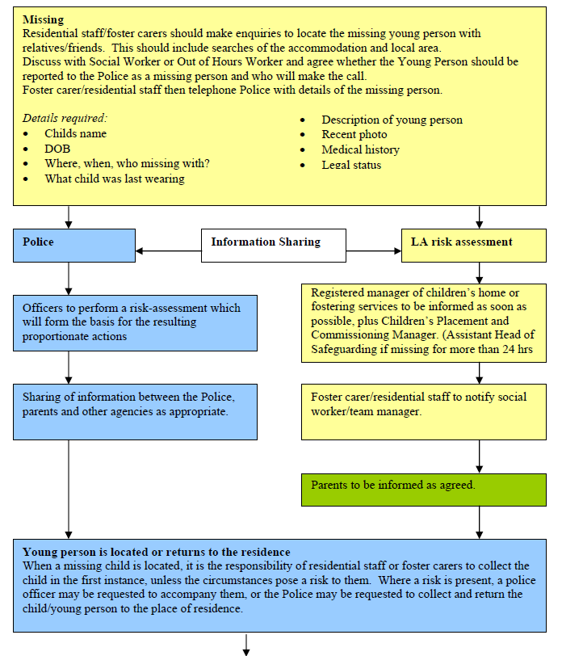

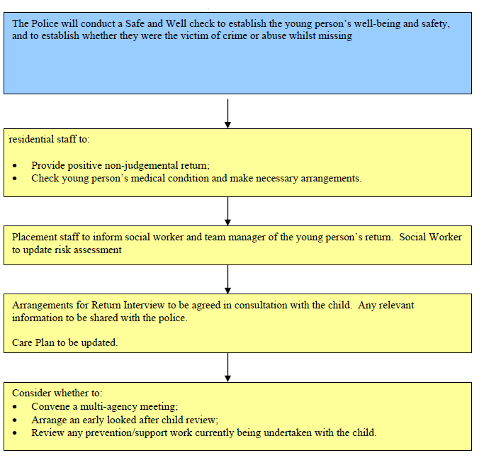

Fire Precautions
The home operates robust fire and emergency procedures. The home has a fire policy which is rigorously applied. An appropriately qualified external agent services equipment on a regular basis.

Fire Precautions
The home operates robust fire and emergency procedures. The home has a fire policy which is rigorously applied. An appropriately qualified external agent services equipment on a regular basis.
Fire equipment and alarms are tested at regular intervals and tests are recorded in the fire logbook, testing takes place in line with the fire safety policy and legislation and staff and service users take place in regular evacuations as required and we actively support children and young people in understanding fire safety. We do this through picture/symbol fire procedures, talking about fire safety and through fire drill simulations. Records are kept and include children’s and young people’s comments and scenarios used; any issues noted are addressed immediately.
All exits are clearly marked and with emergency windows and fire equipment in place that is checked regularly we provide a safe home to children and young people.
The team receives regular fire training from a qualified consultant and in-house instruction takes place as part of the induction process for new staff and regular thereafter. The implications of a fire within the home are discussed with the children and young people if practicable. In addition, each child/young person has a specific risk assessment related to fire safety and details of any evacuation plans are kept in the fire file.
We also participate in three monthly night-time simulation drills to raise staff awareness on fire safety. We also have an evacuation plan which highlights the procedure for staff to follow in the event of a day or night-time fire and accommodation required for the children and young people in the event that the building is unsafe. This has been done in agreement with Northumbria Fire Service.
The staff team will carry out weekly checks on all fire equipment, record and report any actions required to their line manager.
All our staff have been trained in first aid so that there is a first aider on duty at any one time. All staff are trained in fire safety and complete weekly fire safety checks that are recorded in the fire safety check book.
Health and medical emergencies are also planned for within the general running of the home. An ambulance will be called by the home in the event of any accident or seizure requiring attention and it is deemed appropriate to await the arrival of a GP. A staff member will accompany the child/young person to hospital and remain with them as required. Night cover will be provided if it is felt that this would be in the best interests of the child/young person or at the request of the placing authority.

Other emergencies such as gas or water leaks or electrical failures, will receive immediate attention from appropriate external agencies, the home has a Business Continuity Plan which can be found in the office.
Fire precautions and emergency procedures are inspected during monthly statutory Regulation 44 visits and during the Registered Managers Regulation 45 reporting. The Registered Manager also ensures that portable appliance testing (PAT) is carried out on a yearly basis. The boilers are serviced annually to ensure that they are safe for use.
Therapeutic Input into the Home
The changing needs of a child or young person can make it difficult to make predictions about the on-going and future needs of the individual. Hennessy Group see this as part of the on-going review system and accepts that the home may no longer be suitable for the changing needs of the individual. This can include an increase in independence and development.
Emergency incidents notwithstanding, any decisions or changes will be made through multidisciplinary reviews and would only happen if agreed that it is in the best interests of the child or young person, or where a failure to act is likely to put the home in breach of registration requirements.

There are several therapeutic approaches used within our home and these are individualised to each child/young person. Some children and young people may use a form of visual planning which is individualised for their level of understanding, for example some children and young people will use photographs and other symbols or the written word.
Some children and young people use the Picture Exchange Communication System (PECS) to communicate their wants and needs.
Staff attend regular training which enables them to implement therapeutic strategies and approaches effectively.
Infection Control

The home observes high standards of hygiene and adheres to strict guidelines on infection control to ensure children/young people and staff are as safe as possible from acquiring infections from any source. Staff are required to make infection control a key priority and to act in a way that is compatible with safe, modern, and effective infection control practice.
Staff are trained in infection prevention and control measures during their induction and annual infection control refresher training as part of the company’s mandatory training programme. Staff with specific infection control link responsibilities are provided with the relevant training for their role, duties, and levels of responsibility. Training is updated as required by changes of legislation, policy, and guidance.
The following steps are taken by staff to minimise the spread of infection at the home.

Good Personal hygiene
One of the main sources of transfer from one person to another is via bodily fluids. This includes nasal discharges, coughing, sneezing and open wounds, so appropriate precautions must be taken. Towels, flannels, toothbrushes etc. must not be shared. Open wounds must be covered appropriately. Staff with skin conditions e.g. eczema, must wear household/disposable gloves before starting work on household tasks/personal care. Washing of hands is imperative after using the toilet, following handling bed linen, on entering the kitchen, prior to preparing food or before and after performing personal care tasks.

Waste disposal
Bin liners must be used in bins and must be emptied regularly. Bins are also disinfected each night.
Clinical waste is disposed of in sealed yellow plastic sacks and each sack is clearly labelled with the home’s details. Non-clinical waste is disposed of in normal black plastic bags. When no more than three-quarters full, yellow sacks are sealed and stored safely to await collection by an authorised collector. Yellow bags are used only in pedal-type bins in clinical areas.

Household duties
Staff are expected to assist with household duties when necessary. As a general rule, cross-contamination is reduced if separate staff perform kitchen duties to other household duties e.g. bathroom or laundry duties. This is not always practicable but should be adhered to whenever possible.

Hand washing
Most of the cross-infection is caused by unwashed or poorly washed hands and environmental contamination, which provide an effective transfer route for micro-organisms. Effective hand washing and drying, when done correctly, is the single most effective way to prevent the spread of communicable diseases such as hepatitis, tuberculosis, MRSA, food poisoning, legionnaires’ disease, AIDS, and E. coli. Hands should be washed thoroughly according to the guidelines from the World Health Organisation.
PPE
Staff performing personal care must use disposable aprons. Disposable gloves must be worn when coming into direct contact with bodily fluids. Any member of staff who suspects that they or a child/young person might be suffering from an allergic reaction to the gloves provided should stop using them immediately and inform their line manager. They should then consult their GP.

Food hygiene
Staff should ensure food prepared for children/young people is prepared, cooked, stored and presented in line with the high standards required by the Food Safety Act 1990 and the Food Hygiene (England) Regulations 2005. Any member of staff who becomes ill while handling food should report to their line manager or supervisor. Staff must follow food storage recommendations and observe sell-by dates scrupulously.

RIDDOR
The Reporting of Injuries, Diseases and Dangerous Occurrences Regulations 2013 (RIDDOR) requires an organisation to report the outbreak of notifiable diseases to the Health and Safety Executive. Records of any such outbreak must be kept, specifying dates and times and a completed disease report form must be sent to the Health and Safety Executive. In the event of an incident, the manager is responsible for informing the Health and Safety Executive.

Staff Acknowledgement
I confirm I have read the contents of the Statement of Purpose.
I confirm I will carry out all instructions as detailed in this document.
I can confirm I know this document is kept within the office Should Ofsted request me to locate the Statement of Purpose during an inspection I can do this immediately.
I am aware that the Statement of Purpose is a document that all Children’s Residential Homes must have as stated in Regulation 16 of the Children’s Homes Regulations 2015 which instructs who the Statement of Purpose should be available to. Schedule 1 of the Children’s Homes Regulations sets out a detailed list of criteria which is the minimum contents contained in the Statement of Purpose.

Name | Signature | Date
Donna Coulthard | D Coulthard
Danni Lapworth | D Lapworth
Danielle Graham | D Graham
Jordyn Campbell | J Campbell
Jade Henderson | J Henderson
Hannah Harbron | H Harbron
Darren place | D Place
Johannah Hackworth | J Hackworth
Caitlyn Woodall | K Woodall
Lisa Spenceley | L Spenceley
Stuart Campbell | S Campbell
Rachel Forrest | R Forrest
Mark Elderett | M Elderett
Jordan Tomlinson | J Tomlinson
I agree to follow the guidelines in the Statement of Purpose.

Review Date: | 21.11.2021
Version: | 19
Date Sent to Ofsted: | 21.11.2021
Date Sent to Social Workers (all young people):
Date Sent to Parents (all young people):

Contact Details:

Address Protected.

Tel: 01388 746906
Email: managerwillowlodge@hennessygroup.co.uk

Hennessy Group

Hennessy Living Group
Rickleton 1b
Bowes Business Park
Lambton Estate
Chester Le Street
DH3 4AN
TEL: 01913758229

Email: info@hennessygroup.co.uk

