Statement of Purpose

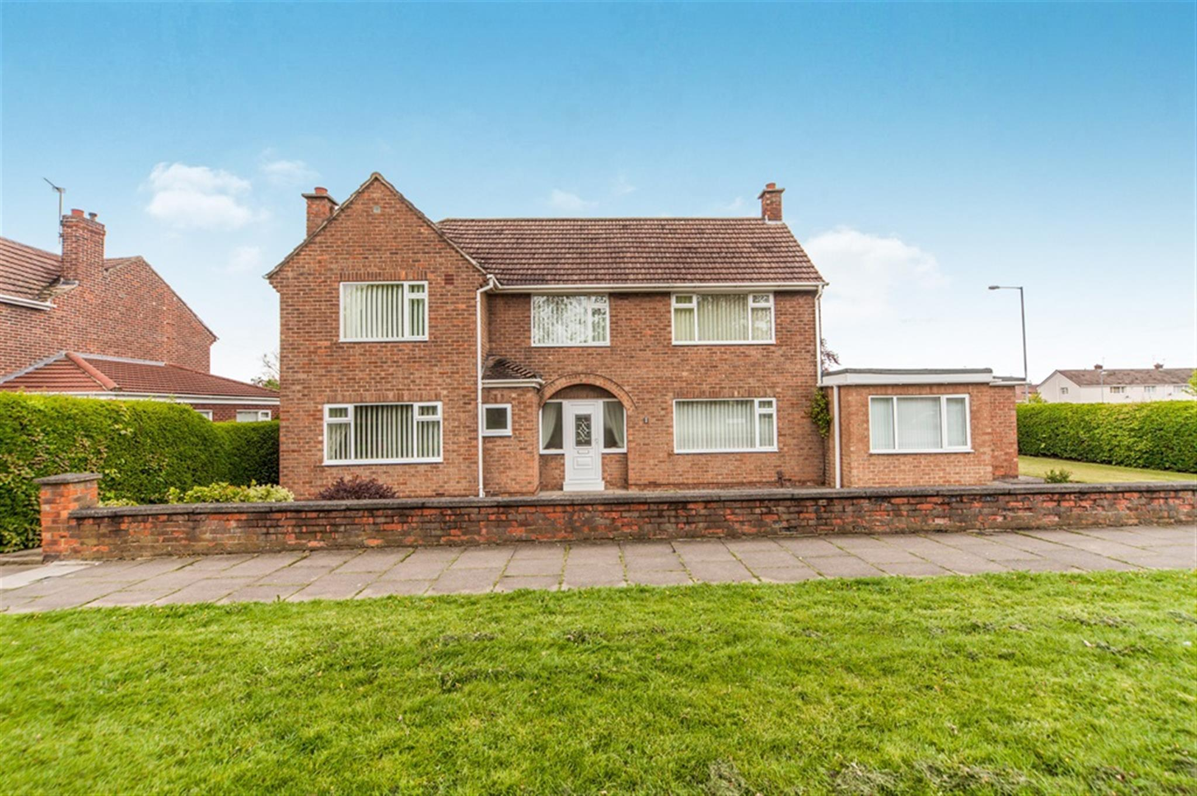

Beech Lodge
Children’s Home

December 15th 2022

Manager:
Sarah Smith
Registered Address:
Beech Lodge
1-3 Melrose Avenue,
Billingham
Stockton on Tees

E-mail: managerbeechlodge@hennessygroup.co.uk

Unique Registration Number: 2520922
Date Registered: 6.7.19
Version: 9
Date of update: 15/12/.21

Registered Provider:
Hennessy Group
Rickleton 1B
Bowes Business Park
Lambton Estate
Chester le Street
DH3 4AN
TEL: 0191 3758229

Responsible Individual: Chris Goundry
Chief Executive Officer: Diane Jones

Operational Instructions

Date of Original Document: 14/5/18

1. All contents must comply with Regulation 16 of the children’s homes (England) Regulation 2015 Schedule 1 and company recording standards.

2. Company standards require that this statement be kept for at least 15 years from the date on the front page.

3. The Registered Manager must ensure a copy of this document is on display within the home, copies of this document are made available to any staff working in the home, any child accommodated in the home, the parent of any child in the home and the placing authority of any child accommodated in the home.

Date of Review | Comments | Actions | Managers Signature
February 2019 | Changes to age range supported and a full review of the document. | Changes made to age range supported | C Goundry
December  2019 | Changes to manager  Registered manager let post due to illness and Deputy manager Lindsey Newbury as manager at present | Changes made to registered manager | L Newbury
February  2020 | Changes made to include MAPA (Restraint training) as guided by Reg 44 | Changes added re MAPA | L Newbury
March 2020 | Changes to staffing including Deputy Manager | Changes made to staffing documentation including Deputy manager status | L Newbury
January 2021 | Changed to staffing and updates throughout the document | Changed to staffing deputy and added more information of the running of the home | L Newbury
February 6th 2021 | Added staff section with more detailed information | Changed names to initials and added al staff qualifications, experience, and dates | L Newbury
April 7th 2021 | Checked and updated document | Added new staff members and added training and qualifications | L Newbury
August 8th 2021 | Manager moved to another service within company, Deputy promoted to manager | New managers details and new staff added. | S.Smith
15th December 2021 | Staffing changes updated | Leavers removed, new starters added. New pictures added | S.Smith

Contents
Introduction
Quality and Purpose of Care
Contextual Information
Our Aims and Objectives at Beech Lodge
At Beech Lodge
Our Specialist Residential Accommodation
Our Services and Facilities at Beech Lodge
Arrangements for Supporting Cultural, Linguistic and Religious Needs
Arrangements for Dealing with Complaints
Access to our Policies and Procedures
View’s, Wishes and Feelings
View’s, Wishes and Feelings
Children and Young People’s Rights and Anti-Discriminatory Practice
Positive Outcomes
Positive Outcomes
Educational Arrangements
Enjoyment and Achievement
Health
Promoting Contact with Families and Friends
Monitoring and Surveillance
Behaviour Management
Leadership and Management
Our Senior Leadership Team – Chief Executive Officer & Responsible Individual
Beech Lodge Leadership Team – Registered Manager & Deputy Managers
Beech Lodge Staff Team
Experience and Commitment of Staff
Arrangements for Supervision
Organisational Structure
Admissions
Arrangements for Quality of Care Reviews
Care Planning and Reviewing
Child Protection
Counter Bullying
Missing from Care
Fire Precautions
Therapeutic Input
Intensive Interaction
Staff Acknowledgment
Contact Details

Introduction
The Children’s Home Regulations 2015, Regulation 16 (1) requires that we have in place a written Statement of Purpose for our Children’s Home.
In addition, Regulation 16 (2) requires that we provide a copy of this document to Ofsted and that we also make a copy available upon request by:
- Any person working in the home.
- Any child accommodated in the home.
- The parent of any child accommodated in the home.
- The Placing Authority of any child accommodated in the home.
- The Placing Authority who is considering placing a child in the home

It is the Registered Managers responsibility to take a positive approach to Regulation 16 (2) by providing a copy of this document to those individuals above rather than this having to be requested.
This Statement of Purpose details all elements of service provision, for example this includes:
- Quality and Purpose of Care
- Views, Wishes and Feelings
- Education
- Enjoyment and Achievement
- Health
- Positive Relationships
- Protection of Children
- Leadership and Management
- Care Planning
In Essence:
- This is a critically important document for Beech Lodge, but more importantly for children and young people who use our services, their families and placing authorities.
- It is the primary foundation for the service that we provide at Beech Lodge and how we deliver the service.
- It is the practice and management template that we aim to adhere to and be measured by.
- It is a stated means of how Beech Lodge will aim to ensure we put children’s and young people’s rights at the forefront of all we do.
Ofsted (The Office for Standards in Education, Children’s Services and Skills) is the regulatory body that registers Beech Lodge as a children’s home. The registration complies with the Care Standards Act 2000 and the Children’s Homes Regulations 2015.
Ofsted is a national body set up under the Care Standards Act for the regulation and inspection of social care services throughout England.
Contextual Information
Beech Lodge is a children’s home which is owned by the Hennessy Group. It is a large, detached House with 4 bedrooms and a two bedroomed bungalow which is attached, based in Billingham. It is a specialist home that provides a service to support children and young people aged from 8 to 18 years old of both sexes who experience emotional and behavioural difficulties, including mental health difficulties and associated conditions.
Beech Lodge provides support for long term outreach care (in some cases) and emergency/accelerated admissions dependent upon compatibility and suitable space within the home.
Two bedrooms are located on the ground floor. Upstairs there are four further bedrooms. There are shared communal areas including a spacious open plan living room. There is also a large spacious kitchen and dining room.
Children and young people will be deemed suitable to reside together following completion of a comprehensive compatibility risk assessment. Beech Lodge’s Management have an excellent reputation in the development and progress of complex children who have challenged the service previously.

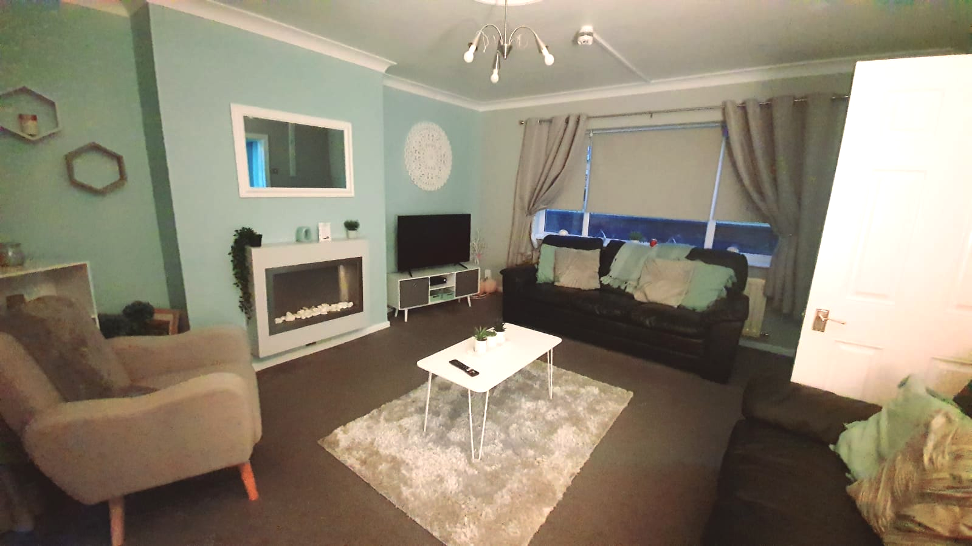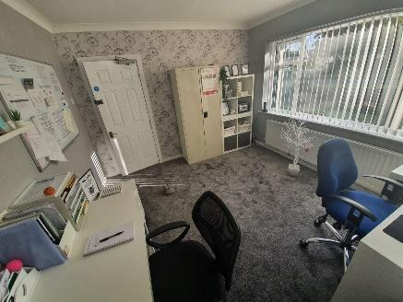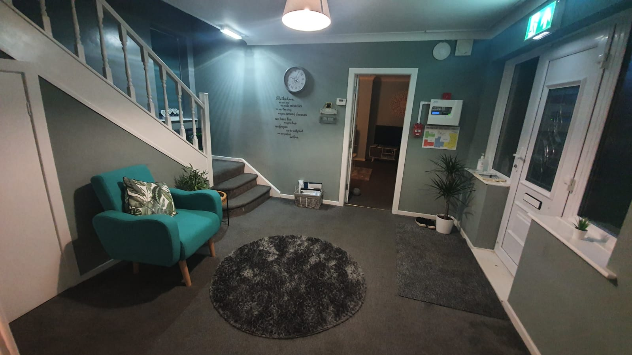

Our Aims and
Objectives at Beech Lodge
Our aims and objectives at Beech Lodge are to provide a safe, warm, and nurturing environment with a high standard of care and accommodation for children. Ensuring excellent delivery of care. Specifically, we at Beech Lodge aim to:
- Provide a physically safe and comfortable place to live and to safeguard and promote the welfare of each child.
- Provide consistent and reliable staff, modelling and ‘good parenting’ to support and encourage children within our care.
- Ensure that all the key developmental areas of health, education, emotional and behavioural development, family and social relationships, identity, self-care, and social presentation are addressed in the planning for each child.
- Listen to and respond to children’s concerns and encourage them to express their views and opinions. Ensure each child’s rights and individual needs are respected.
- Facilitate positive experiences and constructive use of free time. Encourage children to participate in social and leisure activities.
- Encourage children to plan and work together towards household decisions regarding activities, decoration of the house, purchase of equipment, house rules and sanctions etc.
- Work towards positive outcomes with children, their parents, carers, social workers and relevant others.
- Facilitate contact between the children and their family, friends and other relevant people.
- Welcome visitors to the home.
- Work in accordance with relevant policies and procedures
At Beech Lodge
Most of the young people who stay long term are placed under Section 20 of the Children’s Act, so parents retain full parental control and responsibility.
Ownership of the home (property) is owned by Hennessy Living Group.
The accommodation is registered for 6 young people both male and female, aged 8-18.
Any referrals and admissions must be assessed, and plans put in place to ensure the home remains as stable as possible for all young people accommodated.
The team at Beech Lodge strives to achieve the best outcomes for the young people within our care. We want our young people to feel safe and protected and to grow up in circumstances that are consistent with the provision of safe and effective care. We want our young people to have access to a range of facilities within the local community including good healthcare, activities, and clubs they can join to feel integrated and accepted.
Our Services and Facilities at Beech Lodge
Beech Lodge is in a suburb of Billingham. The home is conveniently situated near the local community and offers a wide range of facilities which children and young people can access, the home is close to good bus links, and within minutes of major motorways.
The Home Layout
Beech Lodge offers a home from home ethos and incorporates all of the homely features that would be found in any family home.
The layout of the home consists of:
Ground Floor:
This provides two single bedrooms. There is a large, shared lounge with a TV, DVD, and modern and comfortable sofas and an office area. The kitchen facilities either side of the office. Children and young people are encouraged to participate in making drinks and light snacks and will be supported to develop/enhance their skills in this area. A large patio area and garden is set just off from the main lounge which will be developed in consultation with children and young people and their families. The garden is private and well maintained. In the summer months the children and young people have access to a BBQ, paddling pool and seated area. In the future we are looking at building a conservatory in the garden attached to the home and this will provide and extra room for the young people (around the Summer of 2022)
There are shared laundry facilities on the ground floor within the utility room where children will be encouraged to help with their own laundry.
The main office is near the main entrance.
First Floor:
There is a large landing leading to 4 bedrooms and a bathroom.
The home is fully staffed over a 24-hour period and operates a high staff ratio intended to facilitate the development of individual lifestyles and the promotion of appropriate roles and responsibilities both within the home and wider community. The company operates a 24-hour management on-call system to facilitate advice or rapid response as required. The home has a dedicated, experienced, and suitably qualified staff team to support children and young people to live a fulfilling life.
We support and encourage young people to personalise their bedrooms and have a say on how their home looks through discussions and young people’s meetings that are carried out once a month (or more if requested)
The home offers a completely individual, tailored approach to care. We work closely with families, NHS staff / PCT’s and other organisations involved in the care of each child as well as the young people themselves. We work together to set goals and provide the support and on-going care to help each child reach their full potential at a pace that suits them.
Rooms are well proportioned following health and safety guidelines and regulations. The interior is modern, comfortable, and welcoming. Whilst meeting appropriate standards and legislation, Beech Lodge aims to provide a warm and homely environment.
Televisions are provided in the lounge and bedrooms (depending on child/young person’s wishes). A telephone is available for young people to maintain contact with family, friends, social workers, IRO’s and Ofsted etc.
Beech Lodge has a dedicated budget for food, housekeeping, and outings. Children and young people are encouraged to develop their social and self-care skills and take part in independence training to develop and learn new skills for transition. They are encouraged to be involved in all routine chores within the home as well as the preparation of meals. Where appropriate children and young people will take part in shopping for their own meals and learn about food preparation, food hygiene and budgeting.
Each child/young person will receive regular pocket money and a clothing/activity allowance. Those young people working towards independence will have a separate allowance to purchase food and budget for utility bills etc. The children will have opportunities to be part of the community and social inclusion will be encouraged and reinforced. The children have access to a car in order for them to travel further afield and explore their community. Again, those working towards dependence will be encouraged to use public transport.
The home also has an Independent Regulation 44 Visitor in place who will monitor the performance of the home and report back to the Registered Manager, Regional Manager, Chief Operations Officer, the CEO and Ofsted.

The Hennessy Group will also develop the following services:
- Dedicated Therapy Team including Occupational Therapy, Speech and Language Therapy etc.
- Access to Psychology and Psychiatry teams
- Positive Behaviour Support Team
- Community and Extended Service provision for activities and outward bounds courses
- Maintenance Team who supports our home to ensure it is safe and is in good decorative order.
- Have trained and dedicated staff who are champions for specific areas i.e. Equality and Diversity, anti-bullying etc.
- Regular inspections by the Regional Manager to ensure the home is performing to a high standard.
- Independent Reviewing Officer and Social Worker Statutory visits to the home
- 24 hour consistency and continuity of good care practices
- An experienced and dedicated staff team who have been fully trained in a range of interventions for young people.
- Access to advocacy services
- Trained staff in focused area of care

Arrangements for Supporting Cultural, Linguistic and Religious Needs
Every effort is made to consider the religious and cultural backgrounds of children/young people and their families. The opinions and views of children and young people on all matters affecting them, including day to day matters, are ascertained on a regular basis.
Enquiries are made into the religious and cultural background of each child/young person as part of planning their admission into the home. Provisions can then be made to allow the child/young person to practise their religion in a manner appropriate to their age, ability and understanding. Each child/young person is, as far as practicable, to have an opportunity to attend such religious or cultural needs and preferences. In order to support the individual appropriately, the staff team will seek out advice, knowledge and support from the relevant religious or cultural centres and authorities as necessary. Training and guidance will be given to staff where this is needed.
All staff within the home will receive training on Equality and Diversity to proactively promote rights, choices, beliefs, and traditions.

Arrangements for Dealing with Complaints
On admission to the home the children and young people and their families, significant others and independent visitors are provided with information on how to complain. Information is available on how an advocate can be accessed and children and young people are supported to action this.
The child/young person or their representative can complain if they are unhappy with any aspect of living in the home. There is a robust complaints policy in place where any complaint will be dealt with informally or through the formal process.
An informal complaint is something which we try to resolve through discussions with the parties involved and these are still recorded. Although we hope to receive very few complaints, we do welcome feedback and see this as a way to continuously improve practice.

The formal complaint process is for independent investigation of complaints that cannot be resolved through the internal informal process or when the parties concerned are not happy with the outcome of the informal investigation.

A child friendly complaint guide is available for young people who need additional support. Any complaints are taken seriously and addressed without delay, and a complaint will be fully responded to within a maximum of 28 days. The complainant is kept informed of the progress and offered support as required.
Where necessary, a suitably skilled advocate from our advocacy agency NYAS will be sought to aid in making a complaint where the child/young person has a communication impairment or other specific needs which require specialist involvement.
The home's complaints procedure enables children, young people, staff and family members and others involved with children and young people living in the home, to make both minor and major complaints. Such complaints will be treated in the strictest confidence.
The children and young people and their families have the right to let staff know when they are not happy with anything relating to the service.

Complaints are also discussed within Children’s Meetings and the option for complaints within the Positive Behaviour Support children and young people’s Debriefing system. All parents and the Local Authority have access to our policy and procedure. This is located in the general office of the home and can be requested at any time.

All complaints are logged within our Compliment and Complaint logbook with the outcome recorded. If the complainant is not satisfied with the outcome then this can be followed through with the appeals process, whereby this will be investigated by Senior Management, the Placing Authority or Ofsted.

We also want to learn from our children and young people, their families, professionals, and staff members so we have developed a suggestion form where individuals can provide us with new and innovative ways of practicing and also ways to improve our service.

Communication is the key to positive relationships, and we all have a shared responsibility towards this. We are very proactive in dealing with any complaints and the earlier that we know, the less of a problem it creates.

We want an “open door” policy of working so complaints are dealt with in a professional and reflective manner. Every complaint has the potential to give us quality assurance to improve our service or gain access to a support network, like the community police team to ensure we are not being discriminated against.

Below are the relevant contacts for complaints or to make a safeguarding referral/alert:

Name | Designation | Address | Telephone Number | E-Mail Address
Sarah Smith | Residential Home Manager | Beech Lodge  1-3 Melrose Avenue,  Billingham  TS23 2JJ | 01642555320  07710714250 | managerbeechlodge@hennessygroup.co.uk
Diane Jones | Chief Executive Officer | Rickleton 1B  Bowes business park  Lambton estate  Chester le street  DH3 4AN | 01484 850165  07868 495180 | Diane.jones@hennessygroup.co.uk
Chris Goundry | Chief operations officer  and Responsible Individual | Rickleton 1B  Bowes business park  Lambton estate  Chester le street  DH3 4AN | 07715200411 | Chris.goundry@hennessygroup.co.uk
Ofsted | Regulatory Body | Piccadilly Gate, Store Street, Manchester M1 2WD | 0300 123 1231 | www.ofsted.gov.uk
Childline | N/A | N/A | 0800 11 11 | N/A
Anne Longfield | Children’s Commissioner for England | Sanctuary Buildings, 20 Great Smith Street, London, SW1P 3BT | 020 7783 8330 | Info.request@childrenscommssioner.gsi.gov.uk
On-Call Management Advice Line | Registered Managers | N/A |  | N/A
Barnardos | N/A | N/A | 0191 240 4800 | www.barnardos.org.uk

Access to our Policies and Procedures
Parents, Social Workers, Commissioners, and other Multi-Agency Partners can access our Policies and Procedures relating to the care or protection of children residing in Beech Lodge by contacting the Registered Manager.
Views, Wishes and Feelings
At Beech Lodge, we believe that the children and young people should be encouraged and supported to make decisions about their lives and to influence the way the home is run. No child/young person is assumed to be unable to communicate his or her views. Therefore, the child/young person’s opinions, and those of their families or significant others are sought. Similarly, each child/young person is appointed a key worker and an advocate can be provided over any additional input regarding key decisions, which are likely to affect the daily life and future of the children and young people.
Children and young people are encouraged to hold resident’s meetings on a monthly or requested basis with staff where possible. Staff will take minutes, but it is the children and young people who should be encouraged to take the lead in setting the agenda.
The key worker provides 1:1 support to the child/young person and holds key worker sessions in order to gain the child/young person’s views and is able to advocate on their behalf. We also promote family forums where we can learn from parents and where further support can be given.
Each month the key worker will ensure that the children and young people have been consulted with in their monthly summary which is sent to families and social workers. We learn every day from our children and young people, whom we build into their placement plans and person-centred plans to ensure that they remain consistent.
Beech Lodge is also visited by an External Regulation 44 Visitor. The visitor meets with the young people, parents and staff on a monthly basis and submits a Regulation 44 report on findings each month to the Registered Manager and Ofsted. All documentation reporting systems ensure that we capture the voice of the child/young person to ensure that we meet our home’s aim of ‘the young person being at the centre of everything we do’.
The children and young people also have statutory visits each month by their relevant social workers, who ensure that the young people are consulted and involved in the home and placement. All current recording systems also feedback and capture the voice of the young person.

Children’s and Young People’s Rights, and Anti-Discriminatory Practice
Hennessy Group promotes care practices in a non-discriminatory way where all children and young people are valued as individuals regardless of age, race, gender, colour, sexuality, disability, or religious beliefs. We will provide a culturally sensitive service and ensure that all service users, staff and others receive equal access to services and equal access within them, Hennessy Group expect to treat all service users in a fair and respectful manner, and this is positively challenged and discussed with supervision, team meetings and children’s/young person’s meetings.
We uphold the Principles of Care, for promoting anti-discriminatory practice and promotion of children’s rights, respect and dignity as follows:

- Children and young people have the right to live in a home that is safe, warm, happy, nurturing, stable, valuing, affectionate, and secure, free from abuse and recognises the individual needs of the service user.

- Children and young people have the right to have full access to education, health care, social life, community facilities, and have the opportunity to live a full life as possible.

- Children and young people have the right to be listened to, express themselves, take full part in decisions affecting them, have things explained to them and the right to complain.

- Children and young people have the right to privacy, space, time and dignity, have fun and be allowed to be a child.

- Children and young people have the right to their religious, cultural, dietary needs and to celebrate their individuality.
Our Responsibilities

Staff have a duty of care to ensure that children and young people are safe, supported according to their individual needs and abilities and are protected from any act or omission of harm.

- Staff act as role models for young people.

- Staff will act as a chosen key worker for each young person and promote communication and relationships between Beech Lodge and the young person’s family and friends.

- We will ensure effective placement planning, monitoring, and evaluation systems to demonstrate the young person’s development.

- We will liaise with the young person’s School to ensure continuity of educational programmes.

- We will respond quickly and be flexible in changing the needs of the young people and work proactively with other professionals.

- We will ensure the right level of experience and mix of staff are on duty at any one time.

Positive Outcomes
During their time at Beech Lodge, each child/ young person will be assigned key workers to work directly with them, providing them with five priority areas, short-term goals, long-term goals, and evaluations of reflective practice. These will all be documented in their keyworker file and care plan in the respective sections for progress and outcomes.
Key Worker meetings
Each child/ young person’s key workers will also discuss on a regular basis via key worker meetings and children’s meetings, about their progress and achievements, as well as Child/ young person’s individual goals that they would like to work towards, and any concerns they may have with these or the service.
Short term targets will be put in place and agreed with the Child/ young person at the beginning of each week, giving them an incentive for good behaviour and making progress with priority areas.
Long term targets will be put in place and agreed with the Child/ young person at the beginning of the month, again giving them incentive to work towards, and their progress visible for them to follow.

Reflective Practice
Each child/ young person will be offered a quick discussion with staff when they arrive back from school, to discuss their day, what they have learned, what lessons they did and who they interacted with. Using their evaluation, it ensures each Child/ young person is aware that staff are working with the school to promote their education, and the Child/ young person can reflect on the day they had.
Every child/ young person will also be offered activity choices on evenings, weekends, and holidays, but these may also be organised for them due concerns around their disabilities, such as anxieties. After each activity, staff will complete an evaluation of the activity from their perspective of supporting the Child/ young person, to determine whether they enjoyed the activity or not, and reflect on any potential changes or prospects. Staff will also complete an evaluation with the Child/ young person for their reflection of the activity, where they can voice their opinion, and discuss any achievements that have been made (such as positive social interaction, good behaviour etc.)
Challenging Behaviour
If the Child/ young person displays challenging behaviours that result in intervention or physical intervention they will be offered a debrief for reflection on the scenario (this will be dependent on the incident and whether the Child/ young person will be deemed to not escalate or react negatively). If the Child/ young person completes these debriefs with staff and can vocalise their reaction appropriately (such as learning about consequences of actions), then it can be documented towards their positive outcomes.
Educational Arrangements
Education is viewed as a high priority. The home will work with education authorities to promote and support the delivery of an educational package within an identified educational setting. We offer an integrated model in which teachers and care staff liaise daily providing all children and young people with an individual education plan appropriate to their needs. Education will be provided by the Local Education Authority (LEA).
Staff are expected to help and support with the completion of homework in an appropriate environment to aid learning. Homework (when provided) is a priority, and evening activities will be organised around its completion.
Staff will assist the children and young people with preparation for the next day. Children and young people should be encouraged to refer to the timetable to ensure all needs are met before bedtime, e.g. appropriate clothing for activities, trainers etc.
In special circumstances Beech Lodge can provide in-house education, the aim being to support any young person who is struggling within the School environment to follow an education plan in-house. Beech Lodge will use this opportunity to support the young person back into the School environment. This is only used as a short-term plan.
Enjoying and Achieving
The daily living experience of the children and young people will be structured and varied providing stimulating opportunities for social, intellectual, vocational, and personal enrichment. They will be encouraged to utilise local community services. The level of supervision required would be subject to ongoing assessment of risk and consultation. Emphasis is placed upon maintaining a normalised experience. The child/young person will be encouraged to invest in their living environment, personalising aspects of it and contributing towards its maintenance.

- Children and young people are encouraged and supported to maintain a proper balance between free and controlled time within the structure of the day. Individual activity plans reflect the needs and choices of the children and young people incorporating periods when they are encouraged to pursue their own interests.

- The children and young people at the home are encouraged and given opportunities to take part in a range of activities both within the home and in the community. Birthdays, name days, cultural and religious festivals will be celebrated where appropriate, themed nights will be organised, and the children/young people will help in the planning. Staff actively encourage family involvement in all occasions planned. The child/young person, where able, is encouraged to participate with staff in planning these events. Children and young people will be able to pursue their interests, develop confidence in their skills, and continually add new activities and experiences to their programme. An activity budget is provided to ensure adequate funds.

- Activities will consider the safety of children and young people. All activities will be risk assessed, recorded, and evaluated, and amended or discontinued as required. Persons holding the relevant qualification to supervise children’s involvement in the activity concerned will supervise any high-risk activity provided or arranged for the young people.
Health
The physical and mental health of the children and young people will be of paramount importance. We actively promote a healthy lifestyle, which is applied to planning diets, exercise, and relaxation specific to the child/young person’s needs to ensure a balanced and varied lifestyle. All dietary needs are discussed with the child/young person and their family and recorded in their care plan.
The home seeks to ensure that all children and young people live in a healthy environment and their health needs are identified. The management team will be responsible for monitoring and will seek to ensure that specific needs are considered and actively pursued. A range of health care professionals would be approached to identify both initial health care needs, and ongoing input as required.
All our children and young people will be registered with the local GP, the Registered Manager will ensure she meets with the Practise Manager to build up effective relationships. On admission, the child/young person will have a full health check, the child/young person will also have an annual Looked after Medical Health Check.
The child/young person will be provided with guidance, advice and support on health and personal care issues appropriate to their needs and wishes. Services will be provided to meet all health needs from within the local community. Each child/young person will have a clear written Health Plan covering all medical health needs. These will be developed by involving the child/young person and their parents. We use these when a child/young person needs to access a health service so that we ensure that their appointment has been a successful one.
A written record will document all illnesses, ailments, accidents, or injuries to the child/young people during their placement at the home. Children and young people with health needs or disabilities will be provided with appropriate support and help. Key workers at the home will ensure that any support or treatment required is included in the child/young person’s Placement Plan and Health Plan, is implemented, recorded, and monitored. Relevant parties will be updated with this information as required, and advice sought, as necessary. Serious events will be communicated to the Placing Authority within 24 hours.
We regularly monitor the height and weight of our children and young people and record this information so that we can be proactive in supporting their good health.
Children and young people will receive more formal education on maintaining a healthy lifestyle and learn about nutrition and health management.
The Registered Manager aims to build up a very proactive relationship with the local Consultant Psychiatrist, Community Nursing Team, and de-sensitization practitioners who we can call upon if we have a concern about a child/young person’s medication issues or an upcoming medical appointment.
All staff are trained in First Aid as part of the mandatory training and the home has fully stocked First Aid boxes which are checked weekly. This means that if children and young people have minor injuries that we can actively administer First Aid promptly which limits the need to attend a surgery.
The Registered Manager intends to build up positive relationships with the local NHS primary health centres. Hospitals and PALS Nurses, to provide health support to the child/young person as well as training if required to the staff team.
Some of our children and young people may require medication for various reasons and we aim to work closely with the primary care services to ensure that any medication taken is only for therapeutic reasons.
All of our staff will be trained in the Safe Handling of Medicines and we ensure robust recording and storage procedures are in place.

Promoting Contact with Families and Friends
Every effort is made to promote contact between parents and the child/young person residing at the home as outlined in their Placement Plan. The children and young people are provided with practical support for constructive contact with their parents, family, and other significant people, and are encouraged to maintain this contact.
Where possible the home will offer support to families who are experiencing difficulties visiting their child in the home.
A telephone will be available for all children and young people to make and receive calls in private. The privacy and dignity of the individuals is respected. The Placement Plan will reflect the arrangements for telephone use and contact and any restrictions on this will be made clear in their Placement Plan and only for the protection of the child/young person. This will be agreed with the placing authority at the point of admission.
We encourage parents and siblings to be fully involved in the child/young person’s life and actively promote activities with their involvement in the home itself and within the community. In some cases, decision making will be delegated to the staff at the home regarding the child/young person’s health and education. This will be agreed with the placing authority at the point of admission. There are arrangements in place to support all children to develop and sustain friendships and where safe to do so children are welcome to have friends over to stay.
Examples of what we do:

- Key workers maintain regular contact with families.
- Family Forums
- Parents evening at school.
- Letters, and the opportunity of private telephone calls
- Monthly summaries, key worker meetings, and children’s meetings, and a summary sent to parents to update them on what the children and young people have done during the month.
- Involvement in monthly care team meetings
- Monthly newsletters
- Family involvement in activities
- Involvement in training sessions
- Consultation and involvement in appointments
- Involvement in monthly theme nights
- Involvement in person centred planning

We do require notice of all visits if these are different to the current recorded arrangements, so that we can prepare the child/young person for their visit, and ensure they are at home. All contact arrangements are recorded on the child/young person’s records and visitors are requested to sign in and out of the home for security purposes under new GDPR documentation.

Monitoring and Surveillance

Due to the nature of the complex needs of the children and young people placed at Beech Lodge, children/young people resident at the home are supported and supervised by staff on a 24-hour basis. Children and young people who live within the residential home may be extremely vulnerable and may demonstrate risk taking behaviours that may cause harm to themselves or others.

Bedrooms may be fitted with door alarms which can be activated if children and young people demonstrate behaviours that may cause them or others harm or distress. For example, entering another child’s bedroom at night. We will seek consent from all parents regarding the use of mechanical surveillance. Consent forms will be made available within the child’s Placement Plan file.

Behaviour Management
A child/young person may display behaviour that is viewed as inappropriate (challenging behaviour) as they can lack the social understanding of a situation and be unable to effectively communicate their needs.

Challenging behaviour is driven by an individual’s needs. The difficulty children and young people experience in addressing their own needs may account for any challenging behaviour they present.

The child/young person’s identified needs and behavioural targets will always remain a central focus of the placement. Issues and information will be discussed openly using a supportive and respectful approach. Our approach is geared towards enhancing motivation to change. Frequent monitoring of behaviour provides valid data to identify patterns, trends, measure progress and change.

We believe our children and young people:

- Have talents and skills.
- Are valued members of our society and community?
- Have the right to be treated with dignity and understanding.
- Have an excellent quality of life through opportunity and learning.
- Should be allowed to express themselves individually.
- Have responsive and flexible environments that have a positive attitude towards challenging behaviours.
- Have strategies that are effective in promoting positive and durable lifestyle changes.
- Builds skills over time.
- Should not be restricted in life because of their behaviour.

All staff have been trained in Positive Behaviour Support including Core Theory, Multi-Element Behaviour Support, PBS Planning, Breakaways and Physical Interventions.
All staff will be trained in MAPA – MAPA is a focus on prevention. MAPA (management of actual or potential aggression programme) training teaches management and intervention techniques to help staff cope with escalating behaviour in a professional and safe manner. Improve verbal and non-verbal de-escalation techniques.
Physical intervention (restraint) is defined by the authority’s management of actual or potential aggression (MAPA) training as “the use of threat of force to help do an act which is the person’s liberty of movement, whether or not they resist”.
With the training foundation course. Staff learn the keys of defusing difficult and challenging behaviour.
All staff are to be trained with MAPA whilst working at Beech Lodge.

Each child/young person has a positive behaviour support plan that is developed alongside the child/young person, their family and Local Authority representative.

Positive Behaviour Support Plans are reviewed regularly through a multi-disciplinary approach and are risk assessed.

Promoting Positive behaviour, Respect, and Positive Outcomes

Beech Lodge provides supportive and functional environments for all our children and young people and has a caring ethos. We provide several means of celebrating achievements and positive behaviour.

We work on a positive and proactive approach towards behaviour and will attempt to ignore and diffuse negative behaviours with a view to rewarding and acknowledging as much positive behaviour as possible through our personalised points scheme.

Some examples include.

- Sharing and acknowledging good behaviour, through reward charts.
- Having agreed methods of rewarding good behaviour through multi agency meetings.
- Children and young people have opportunities for gaining extra responsibilities.
- Discussion times with the children and young people where they can share their successes and congratulate one another through resident meetings and debrief sessions.
- Sharing and acknowledging good behaviour with parents and others in the wider community.
- Rewarding certificates of achievements, merits or working towards a person-centred goal.
- Displayed work by children and young people in the residential home and at school.

We will use sanctions such as removal of privileges, fines, groundings etc. A record of all sanctions is kept in the office and these will always be explained to the child/young person. We never refuse food or drink as a means of sanction, refuse contact with relatives or statutory agencies, or refuse medications.

- Reparation – physical reparation, e.g. mending a broken item may also be appropriate
- Curtailment of leisure activities
- Additional household chores – children and young people should be encouraged to help with small household tasks, but they must not be used instead of domestic staff.
- A child/young person who is untidy will be encouraged to clear up with supervision and assistance from an adult, as necessary.
- Aggressive behaviour – it may be appropriate to remove an aggressive child/young person from the immediate situation to another area to diffuse the situation or to withdraw any other children and young people from the area for a short period of time until the child/young person has calmed.

The promotion of good behaviour is supported by a multi-disciplinary approach and this is documented in the child/young person’s Positive Behaviour Support Plan and risk assessment.

The Positive Behaviour Support Plans have been designed using the Multi-Element Behaviour Support Model. This model provides a larger emphasis on proactive intervention.

The proactive elements of the plan are overseen by the Registered Manager who will carry out various assessments, e.g. environmental assessments, motivational and functional analysis and behaviour baselines etc. To provide a proactive approach to positive behaviour.

Where children and young people require a reactive assessment to their individual behaviour training will be sought. A Principal Physical Intervention Instructor will assess the need for physical interventions or breakaway techniques. The Instructor will meet with the child/young person, undertake observations and speak with key staff who know the child/young person well.

All physical interventions will be risk assessed and are reviewed and evaluated every 12-18 months. Training is then conducted on a bespoke basis and refresher training takes place every 12-18 months.

The use of physical force is not permitted. Physical force may never be used as punishment or general means of control. However, a person may take the necessary physical action where another course of action may be likely to fail, to avert any immediate danger or personal injury to the child or another person, or to avoid immediate danger to property. The use must be as little but necessary force, in the least restrictive way, and for a minimum amount of time. Where this is necessary a record will be held in the office and the child/young person will be given the opportunity to discuss their feelings about the situation. Staff are also offered debrief sessions following all incidents to discuss the positive outcomes and any concerns regarding the scenario. Copies of this record will be shared with School, Social Worker and parents where requested. These policies are in accordance with the D.O.H (Department of Health) guidance on permissible forms of control.

In the event it becomes necessary, as a last resort, to provide physical intervention to ensure the safety of all, this will be implemented by trained staff who understand the method of these comprehensive therapeutic techniques. In addition to practical demonstration, it provides guidance on recognising and understanding the individual’s behavioural spiral and provides practical strategies to address each level. Reactive strategies will only be used when proactive strategies have been exhausted. Data is collected and analysed. Full incident reports are completed, and staff are de-briefed by the Registered Manager. Individual Behavioural Management Strategies are reviewed to reflect any changing needs and amended as required.

Should any therapeutic input be required this will be sourced via external agencies i.e. GP, Community Paediatricians, School Nurses, Physiotherapists, Dieticians, Speech and language Therapists or Placing Authorities.

All parents and the Local Authority have access to our policy and procedure. This is in the general office of the home and can be requested at any time.

Our Senior Leadership Team

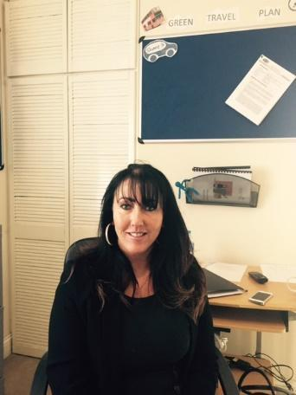
Diane Jones (DJ)
Chief Executive Officer
Diane.jones@hennessygroup.co.uk
Address: Rickleton 1B
Bowes business park
Lambton estate
Chester le street
DH3 4AN

Tel: 07868485180

Experience of CEO:
Diane has over 25 years’ experience in the field of care and support in Children and Adult Services. She has previously been the Registered Manager of 4 children’s services. Before joining the Hennessy Group, Diane was the Head of Children’s Services, Director of Operations, and the Responsible Individual for 17 services across the country which specialised in challenging behaviour and complex needs, physical disability and learning disabilities, mental health, autism and sexualised behaviour. She was also Regional Director and Responsible Individual for Adult Services and oversaw 42 services which included Residential and Supported Living. Diane has spent a large amount of time supporting other companies at director level to turn failing regions around.
Qualifications:
NVQ Level 4
Registered Managers Award Level 4
ILM Level 4 Management
D32 and 33 Assessors Award (Upgrade to A1 and A2)
Professional Qualification in Person Centred Counselling and Transactional Analysis

Chris Goundry (CG)
Chief Operations Officer and responsible individual

Email: chris.goundry@hennessygroup.co.uk
Address:
Rickleton 1B
Bowes business park
Lambton estate
Chester le street
DH3 4AN
Tel: 07715200411
Date of Joining Hennessy Group: 9th June 2016
Experience:
Chris is the Chief Operating Officer for the Hennessy Group. Chris has been promoted through the company from a support worker to COO, working in every position in between. Chris is responsible for the oversight of each of the services we offer and is the Responsible Individual for four of these services.
Chris has previous experience of working with adults and young people with learning disabilities and challenging behaviour and gained valuable experience as a Senior Custody Officer in a custodial setting.
Chris has worked in Children’s services for over 5 years, 4 of which have been at senior level supporting children with autism, learning disabilities and physical disabilities as well as children with SEBD needs. Chris is passionate about providing positive outcomes and experiences for the children we are fortunate enough to support, cascading this enthusiasm and passion through the services he oversees.
Qualifications:
NVQ Care Level 3
Level 5 in leadership and management
Currently undertaking MBA
Level 2 Handling of Medications
Level 2 Autism Awareness.
Beech Lodge Leadership Team
Manager Beech Lodge- Sarah Smith
Experience:
Sarah has a family of her own and has 8 years experience of working with children and young people. Sarah began working in a primary school supporting young people with additional needs and supporting SEN children within the classroom. Sarah has also volunteered as a mentor and independent visitor role within a children's charity while undertaking her qualifications. Sarah began working in residential care after acquiring a foundation degree working with children and young people and a degree in child youth and community studies. Sarah firstly came to the Hennessy Group working in a solo supported living setting for complex needs and then moved to Beech lodge residential home. After 2 years at Beech Lodge, Sarah has progressed to the position of Manager. Sarah is currently undertaking her level 5 in management and leadership and looking forward to her professional development within the Hennessy Group.

Qualifications: BTEC National diploma in Health and Social care (Level 3) 2004,
Foundation degree in working with children and young people (level 4-5) 2018,
Degree of Bachelor of Arts in youth childhood and community studies (Level 6) 2019,
Awareness of childhood sexual exploitation including consent, intelligence sharing and image sharing. The children’s society 2018,
Level 2 in understanding the safe handling of medication in health and social care 2020,
Moving and handling in the workplace 2020,
MAPA 2021,
Safeguarding face to face (LA) Jan 2020
First Aid 2019 (2 day)
Safer Recruitment training 2021
Deputy Manager- RH
Experience: R is a qualified support worker with over 8 years’ experience, he has excellent knowledge of Looked After children procedures including education and challenging behaviours. Before becoming a support worker R has worked with lots of young people who have behavioural challenges, learning difficulties and children who are autistic within youth settings. R was a support worker and has worked hard to get the deputy role with many transferable skills that will benefit the children at Beech Lodge. “I am looking forward to working as Deputy Manager at Beech Lodge” and progressing further with my own development.
Qualifications:
Level 3 in children and young people,
Level 3 in youth work,
First aid and medically trained,
PI trained,
Medication training

Acting Deputy Manager DM

Experience: D has a large family and has always been involved in the care of her nephews and other family members, through these years she has always wanted to be involved in the care sector and look after vulnerable children in residential care. Although D did not pursue this career until late, she is a natural support worker and is amazing with the children in the home. D always provides exciting activities and experiential learning and will listen to the voice of the child and ensure all professionals are aware of the child’s feelings and wishes.
Qualification: Currently undertaking level 3 and due to complete in March 2022,
MAPA Nov 2021,
Medication training September 2020,
Safeguarding Face to Face January 2020.
Supervision training.
Future within the Service: D would like to go on to become a Deputy manager.

Beech Lodge Staff Team
At Beech Lodge, we currently have a staff team of 17 Support Workers, including 6 Bank Support workers. 1 Manager, 1 Deputy and 1 Acting Deputy.
The staff levels are of course dependent on the care needs of the children and young people who live at Beech Lodge at any given time. Our staffing levels are well planned to take account of the differing needs of children at any given time. These will be in accordance with staffing requirements as set out in placement plans, risk assessments and contracts with placing authorities. Specific experience and qualifications of staff in post are set out within this document. We recognise that our young people should have appropriate role models both male and female. Our young people may also attend School where they will have a diverse range of staff working with them along with regular contact with their family members.
We recognise that our children and young people have diverse needs, and their staffing establishment and skill mix has been developed to accommodate our children/young people’s needs and preferences. Where any future admissions are made to the home that involves either gender, management will ensure the gender mix is appropriately balanced.
All appointments are conditional on receipt of the following satisfactory checks:
- Disclosure and Barring Service at the appropriate level, which includes checks of the Protection of Children Act List (POCA) and Protection of Vulnerable Adults List (POVA)
- Occupational Health Check (where necessary)
- At least two references, preferably one from a current employer and, where possible a statement from each referee as to their opinion of the person’s suitability to work with children. All references are verbally verified with referees.
- Checks on any breaks in employment history.
- Identity Checks.
- Checks of any required and relevant qualifications.
- Checks to confirm the right to work in the UK; and
- Where the person has lived outside of the UK, further checks are considered appropriate.

The whole process is carried out in line with Hennessy Group Equal Opportunities and Recruitment and Selection Policies.

Manager: SS
Deputy Manager : RH
Acting Deputy Manager DM
Support workers: NR,KS,GL,SB,GH,MTL,MA,AJ,KM,LC
Bank workers: LR,JW,AC, KW,AU, LH

Staff member: NR
Start date: July 2019
Experience: N has worked within the child sector for the last 5 years working within youth work and residential care. N has three young children, and she has recently worked on placement with vulnerable adults during her university course. N came to the Hennessy group as a support worker developed through her personal development plan as team leader and then to acting deputy role. N is currently completing her MA in social work and will be going on a LA placement for young children in March 2021. N is a care leaver herself and due to this she is aware of feelings and emotions during the care period and gives sound and positive advice to the young people.
Qualifications: MA Masters currently undertaking 2021 in social care, medication level 3 2020, MAPA 2020, all online training courses, First Aid 2019, Mental health 2019, fire training 2019
Future within the Service: N would like to stay within the Hennessy group at Beech Lodge even when she is qualified as a social worker as she enjoys working with the young people in residential care.

Staff member: AU- Bank Worker
Start date: October 2020.
Experience: A has worked within a range of nursery and primary settings working with children and young people to provide activities through teaching and learning. Anna also during this time supported families and vulnerable children. Anna then moved careers still working with families and young people but to experience the working with families and young mothers within a mother and baby unit, Anna enjoyed this work although it was hard work it was rewarding unfortunately the home closed and Anna enjoying working with vulnerable children, she decided not to go back into education but to take her career further working with looked after children and families in residential care.
Qualification: Health and safety Social Care (2014-2015), BA in early years childhood development and learning (level 6) 2016-2019) Graded care 2020 safeguarding face to face 2020, CSE training February 2021, First aid
Future within the Service: Anna has a wealth of knowledge and would like to progress further at Beech Lodge or within the Hennessy group.

Staff member: AJ -Support Worker
Start date: September 2020.
Experience: AJ has a lot of experience with children and young people with LD. AJ has experience with working with LD young people in an equine setting and has qualification to teach YP through equine therapy. AJ has worked in LD settings supporting individual young people in solo placements to ensure the care and quality has been delivered to each individual child.
Qualification: First aid Qualification, MAPA training and A has just started her level 3 in children and young people this is due to finish in January 2022. A has completed all of her online training.
Future within the Service: A would like to move to a new service in the future with Hennessy Group as a support worker in the new setting in the middle 2021 within the equine service.

Staff member: GL – Support Worker
Start date: October 2020
Experience: G is a care leaver, and she has experienced this throughout her life, G is proud of the way she has coped with all difficulties she has faced throughout her life, she has qualified throughout school and worked hard to achieve this. Georgia has gone to college and then on to university to study law. G has always wanted to work with children and provide a voice for them in care.
Qualifications: G has started her level 3 and she is due to end this in January 2022
Future within the Service: Georgia would like to become a key worker and team leader and work her way through the sections of the job role in the future.

Staff member: LR- Bank worker
Experience: L has no experience in the care sector but has always wanted to work with children and young people in care. Her dream job was to work with LAC children in residential care but never thought that she was able to do this. When she got the opportunity to do this L came to Beech and has worked so hard to achieve her dream. L works well with all young people and she would like to specialise in an area of therapy that she would like to teach. L has her own cake making business and she is keen to teach all the young people to cook which she is already achieving.
Qualification: Working towards her level three, completed all online training
Future within the Service: L would like to become a team leader and a key worker within the service.

Staff member: MTL- support worker
Experience: M has a lot of experience with the development of children M has her own children and she has also experience of caring for others. M has a very caring nature and has always wanted to care for children in the childcare setting especially residential care. M has a real way of working with the young people. She is very consistent in her care and how she listens to each individual child. M is completing her level 3/4 she has completed all online work. CSE and safeguarding is booked for early 2021
Qualification: M is currently working towards her level 3/4 qualification in children and young people in residential care.
Future within the Service: M would like to become a team leader and a key worker in the future of her career.

Staff member: LC- Support worker
Experience: L has worked in the care sector for over 20 years caring for the elderly and the adult LD sector, he has experience in bespoke care planning, behaviour management and risks. L has a full care background and wants to move from LD care to children’s care in residential.
Qualifications: First Aid, PI training, level 3 health care, level 3 in direct care.
Future within the Service: L would like to become part of the management team and also be a trainer of a specialised topic of care plans within the care sector.

Staff member: AC- Bank worker
Experience: A has a wealth of knowledge within the children care sector A has always wanted to become a social worker. A works at Beech Lodge as a support worker. She can identify the needs of the children in our care and present this in care planning and behaviour management.
A has worked as support worker since August 2020, her skills and effectiveness on children’s lives is noticeable and she believes that every child does matter and every child should be listened to at all times.
Qualifications: Business studies (c,) English literature (c), Fine Art (c), MAPA, BA in English studies 1st class hons, creative writing 2019, sign language level 1 and 2 2018-2019, MA social work- present day, online training
Future within the Service: A is qualifying as a social worker and has come to Beech Lodge for the experience of working with young people in care. A likes the role so much that she would like to carry on when qualified eventually as bank staff to keep working face to face with children and young people.

Staff member: GH
Experience: G has a lot of experience with family members and younger family members growing up and caring for them for the last 10 years. G loves to be around young people and she can communicate well and provide a voice for the young people to be heard. G can provide experiential learning activities for the young people and she is always going on an adventure. G can provide structure to the day and also be consistent with behaviours.
Qualifications. MAPA November 2020, online training, G has enrolled at started her level 3/4 with Derwentside college, first aid, County lines and she is also booked on safeguarding for the new year
Future within the Service: G would like to become a team leader and a key worker within the service.

Staff member:
Experience:
Qualifications:
Future within the Service

Staff member:
Experience:
Qualifications:
Future within the Service:

Staff member:
Experience:
Qualifications:
Future within the Service:

Staff member:
Experience:
Qualifications:
Future within the Service:

Staff member:
Experience:
Qualifications:
Future within the Service:
Staff member:
Experience:
Qualifications:
Future within the Service:

Training
We are committed to ensuring that our staff team have been given the necessary skills to meet the individual needs of our young people through an extensive programme of in-house and external training. This is not only about competencies of staff but is also concerned with having positive values and attitudes towards their work. We all share a commitment to our core principles which all training is based upon. Staff training needs are also identified through the on-going process of statutory obligations and the internal process of supervision, team meetings and appraisals. The admission of a child/young person with specific care needs might highlight the necessity for additional training as required, for example: Epilepsy awareness and diabetes management.
Staff of the Hennessy Group work towards providing a service in which children and young people are encouraged to develop through the mediums of opportunity and support. All staff complete a comprehensive induction when joining and must complete a probationary period that is monitored by the Registered Manager through the supervisions and mentoring process.

All staff undertakes the following training (this is not an exhaustive list):
Course Title
Introduction to The Hennessy Group
Emergency First Aid at Work
Health and Safety
Manual Handling
Fire Safety
Food Hygiene
Infection Control
Safe Handling of Medicines Certificate
Positive Behaviour Support Planning
Mental Health Awareness
Learning Disabilities and Communication
Safeguarding of Children
Whistle Blowing and Child Protection
Physical Intervention and Breakaways
Sensory
Epilepsy
Child specific interventions.
Level 3 Children and Young People’s Workforce Diploma / Level 3 Diploma for Residential Childcare (From 05/01/2015)
Level 5 Children and young people Diploma residential management/advanced practice in childcare.

We are also hoping to develop a management programme for existing and aspiring managers who are provided with a coach or mentor to support them through the programme. This will support our strategic succession planning:
Management Course Title
Supervision and Appraisal
Managing Finance
Introduction to Children’s Act and Regulations
CPD Registered Managers Workbook
CPD Team Leader Workbook
How to Manage a Team
Coaching and Mentoring
Leadership and Management Development Programme
Transition to independence
Designated Child Protection
Child Protection Conferences
Adult Protection and MAPPA (where appropriate)
Mental Capacity and Deprivation of Liberty and Safeguards (where appropriate
Level 5 Leadership and Management in Health and Social Care / Level 5 Diploma in Leadership and Management for Residential Childcare (From 05/01/2015)

We also provide in-house training so that new staff can shadow more experienced staff. We have experienced staff members who can work alongside new staff or staff who wish to develop their understanding and skill level further. This has proved beneficial as it has increased the competencies, attitudes and confidences which the young people benefit from.
All staff will be given a personal development plan which sets out training needs and opportunities.
This has been proven positive as these last four months we have trained staff from another service within Hennessy Group, and they have successfully moved to the new service trained and ready to open.
Arrangements for Supervision
Beech Lodge is fully committed to meeting supervision standards as set out in Regulation 33 (4b) of the Children’s Homes Regulations 2015.
We will ensure that all staff receive 1:1 professional supervision, group or observational supervisions, and appraisal in line with Company Policy and Children’s Homes Regulations 2015. The purpose of supervision is to create a forum in which staff can be held accountable for their work, receive advice and support on work-based practice, and allow an opportunity to explore personal and professional development. Additional supervision will be provided as required or requested. We believe that it is essential to ensure best practice is promoted and achieved through staff development and education. Beech Lodge aims to encourage and maintain high motivation and morale amongst individuals and the whole staff team. The company has a robust policy on staff supervision and records held by the Registered Manager.
Performance frameworks are also embedded into each staff member’s supervision, to ensure a high standard of service is provided. We also ensure at Beech Lodge that there are daily handovers, and regular staff meetings to keep the staff up to date with the young people’s development or to share information regarding the reviews of young people, company developments etc. We recognise the value in a joined-up supervision system that provides the opportunity of bottom up and top-down communication. We also expect high supervisory standards from our management team therefore the Registered Manager and Deputy Managers receive training on managing teams and supervision and appraisal.
The Registered Manager also receives a formal monthly supervision with the Area manager where a discussion will take place about young people’s welfare, planning, review, monitoring and evaluation of placement plans and practices.

Our Organisational & Beech Lodge Structure
PH
Director

DJ
Chief Executive Officer

CG
Chief Operations Manager

Residential Home Manager
SS

Deputy Manager

RH

Support Workers
NR, JD,GL,AC,GH,MTL,LR,AJ,KM,CW,LC

Admissions
Admission to the home is carefully planned and organised, both for the child/young person moving in and for other young people in residence. Once we have received a letter from the Local Authority requesting permission for an assessment, we work together with the child/young person, their family, social worker, and any other professionals who are able to provide information. Assessments prior to admission provide invaluable holistic, person centred information which enables us to make an informed decision. We also request an updated copy of the child’s Local Authority Placement Plan and Annual Statement of Education from the social worker and Individual Education Plan, this information will provide us with the educational and care needs information required so that we know exactly what the child/young person’s needs are and how to support them consistently and appropriately to their preferences. Before any child/young person or their family visit the Registered Manager will assess information, which includes potential and actual risks relevant to the specific needs of the individual. This information will be considered alongside the knowledge of any child/young person already residing. Physical aspects of the home, staffing levels, skills of the staff etc. will also be considered.
The assessment team is normally composed of the Chief Executive Officer, Area Manager, Registered Manager, Deputy Managers, support workers, auxiliary staff, Teacher and Therapist from outside agencies will be utilised where possible. We will work together to consider the most appropriate placement and complete a compatibility risk assessment.
We will endeavour to state from the outset any additional resources necessary to meet individual needs. Similarly, professionals and family will be made aware of the general philosophy of the home and its relationship to the rights and needs of the individual. If a trial period is felt to be appropriate, then the home must be aware of its timescale to meet the specific needs of the other children/young people and their reactions may also be closely monitored.
Emergency/accelerated admissions to the home will be considered if there is suitable space in the home to accommodate the child/young person and the placement appears appropriate in terms of compatibility, meeting needs etc. An initial assessment would be completed, and risks considered prior to agreement and accommodation.
We will write to the Local Authority outlining the service that can be offered to the child/young person. Once this has been approved, we work alongside the child/young person, their family and any other professional to develop a person-centred passport prior to admission. We also provide the child/young person with an accessible format of the Children’s Guide and we provide families and social workers with a copy of the parent’s guide and the homes Statement of Purpose where requested.
Children, young people and families are also offered the opportunity to take part in social activities, e.g. having a meal with the other children/young people or attending an activity. This is helpful to develop social relationships and build familiarity and predictability. Some children/young people may have difficulty with this so discussion will take place to ensure the right transition is taken for each individual person.
On admission the child/young person will be registered with the local GP and a health check will be completed. The child/young person will also be registered with the local Dentist and Optician. Where distance permits children and young people and their families may prefer to maintain existing relationships with their own GP and Beech Lodge will support such choices.
In order to ensure that we are providing the right care, and our aims are in line with the needs of the individual young people, we will draw together a placement plan prior to admission wherever possible. These plans will look at the needs of the child/young person and how they are to be met. This plan will be looked at during the placement stay and will be reviewed at each statutory review, one month, three months and six months into placement.
Children and young people will have the opportunity of a key worker who will be suitably chosen to reflect the child/young person’s abilities and preferences. The key worker will become the link person between School and with the family. Sometimes the child/young person or the family might just want to ask practical questions which the key worker can offer advice and reassurance. The child/young person will be given the choice of their key worker at Beech Lodge. The Registered Manager ensures that all staff are trained and aware of their duties in operating key worker responsibilities.

Arrangements for Quality-of-Care Reviews
In addition to monitoring and inspection from statutory bodies, Beech Lodge has a Regulation 44 External Visitor that monitors the running of the home in line with relevant legislation and good practice. Reports are regularly forwarded to the COO , CEO and the Registered Manager. The home is supported to develop their own personal development and action plan from the report outcome and findings.

In addition to spending time with young people, staff and management, a comprehensive checklist enables a thorough insight of how the home is functioning. The home is audited against a range of criteria including how children and young people are effectively safeguarded and how the conduct of the home promotes children’s and young people’s well-being.

An action log for improvement or development is provided together with details of timescales for action required and who is responsible for this. The Registered Manager monitors the home’s provision through monthly checks.

Care Planning and Reviewing
Upon admission, each child/young person will have a Placement Plan, which sets out clearly the assessed needs of the child/young person and how these will be met on a day-to-day basis. The plan will identify 5 key areas to work towards each month.
The Plan includes the key elements of the L.A.C. system, health, education, physical and emotional needs. Safeguarding and promoting welfare, cultural, religious language, racial needs, and leisure needs. Also, contact arrangements with family, friends, and significant others.
The child/young person’s needs and how best they are being met will be monitored by the child/young person’s key worker. The key worker is responsible for maintenance of the Plan and co-ordinating the guidance, advice, and support for the child/young person.
The Registered Manager regularly seeks the views of children and young people, parents (where appropriate), social workers and teachers and considers in initiating and making changes to the plan.
Children and young people are encouraged to participate in meetings designed especially for them; minutes are taken of their views, opinions, and ideas. These meetings: held monthly or when requested, are tailor made to consider the age range and level of understanding, they have an open agenda and cover all aspects of daily life within the residential home. All children and young people receive a copy of these minutes on their working files, with copies also provided to the multi-disciplinary team.
The child/young person will be encouraged to participate as far as is practicable in the review process however staff will support and encourage the children and young people who wish to make a less formal “one-to-one” approach with staff and the placement plan is an evolving plan that is discussed during these events.
All children and young people are made aware of the context of their overall plans and Placement Plan according to their level of understanding and support received by the Therapy Team where appropriate.
Placement plans are reviewed under a multidisciplinary team approach including:
- Child/Young person
- Registered Manager
- Key workers
- Family
- Education staff
- Therapy staff
- Social Worker
- SENCO

Child Protection

Our children and young people have the right to feel safe in their home and we are committed to ensuring that this is achieved. We do this in many ways:

- All staff have Enhanced DBS checks with full references prior to commencing employment.
- All visitors to the home are vetted before entering.
- Security is maintained within the property.
- The home meets environmental health standards.
- All staff receive safeguarding training which is refreshed every two years.
- Designated child protection officer poster available for all children, staff, parents and Local Authority representatives

The safety and well-being of the children and young people is paramount and is underpinned in all care provided within the home. This is fully supported in the Hennessy Group policy of safeguarding children where its procedures clearly are a key to keeping children safe.

All children and young people have individual risk assessments which are regularly reviewed and monitored. We are careful to ensure that these risk assessments do not infringe the rights of the child/young person and allow them to take an element of risk to grow and learn.

Staff are familiar with and adhere to child protection protocol and will be prompt in raising a child protection concern. They are familiar with and will refer to:

- Hennessy Group Safeguarding Policy
- Local Safeguarding Children Policy
- Children’s Homes Regulations 2015
- Hennessy Group Representations, Complaints and Compliments Policy

A hard copy of the above policies is readily available to staff and can be located within the office.

Safeguarding vulnerable children

Safeguarding children and young people is part of statutory induction training for all new staff to become familiar with and gain an understanding on child protection issues and protocol.

All staff will attend appropriate inter-agency training in Safeguarding and complete the LSCB e-learning training course.

Beech Lodge has regular unannounced inspections, undertaken by Chris Goundry, C.O.O.

These focus on staff’s knowledge around safeguarding as well as inspecting key documentation, such as accident/injury logs, and incident recording logs, to ensure that safeguarding is maintained within the service. An action plan is provided following each inspection of areas where progress is required, and this is followed up within 2 weeks of the actions made where necessary.

The named person and Designated Safeguarding Officer responsible for Child Protection at Beech Lodge is the Registered Manager. The Designated Safeguarding Officer within Hennessy Group is Diane Jones, Chief Executive Officer.

All parents and the Local Authority have access to our policy and procedure. This is in the general office of the home and can be requested at any time.

Anti-Bullying
Bullying is a persistent and personal abuse of power towards an individual. Bullying is defined as the unjustified, unprovoked and repeated display of aggressive, verbal or physical behaviour on the part of one individual or group to torment, inflict pain or humiliate, to the extent that the victims lose the power of will to defend.
Bullying is recognised as a serious problem that can affect a person’s mental and physical health and well-being. Bullying and any other form of intimidation is not acceptable. Internet bullying will be monitored by all staff ensuring that children and young people access appropriate safe sites. Each child/young person will have a risk assessment on the use of computers. Staff use many forms of alternative and augmented communication to help children and young people to divulge their feelings including things such as feeling bullied. Staff are also observant and alert to any patterns of behaviour that may indicate a child/young person is bullying or being bullied. The child/young person’s Positive Behaviour Support Plan/risk assessment will address aspects of behaviour that may be causing harm or distress to another child/young person.
Any form of intimidation that increases the risk of significant harm to a child/young person will be dealt with accordingly. The home has a zero-tolerance policy towards any form of bullying of children and young people by staff or others and has a robust anti-bullying policy to support this. Any instances of such behaviour will be investigated, responded to and outcomes monitored.
How we protect our children and young people:
- Teaching all children how to socialise and respect people particularly their dignity and privacy.

- Children’s Guide is in accessible format informing them of what bullying is and how to respond to it or make a complaint.

- Advocate and key worker support are available to all children and young people.

- Detailed Placement Plans/Positive Behaviour Support Plans and risk assessments for children and young people.

- Children’s/Young people’s meetings so that they have an opportunity to air their feelings.

- High level of support and supervision.

- Indicators of Well-being which helps to identify the subtle signs of bullying.

Missing from Care
At Beech Lodge we ensure that all children and young people are supervised both during the day and at night according to their assessment needs. If a child/young person has been known to abscond, a Missing Person’s Risk Assessment is created along with a recent photograph to assess the risk of absconding/going missing and provide a history of outcomes of past experiences of absconding. The Registered Manager will put into place all reasonable measures to prevent a child/young person from absconding. These procedures may include behavioural and/or therapeutic approaches to change the child/young person’s behaviour. Any such measures will be used as agreed in the child/young person’s Placement Plan. In the event of a child/young person regularly absconding a copy of the missing from care risk assessment and photograph would be shared with the local police
In the event a child/young person does go missing the police are notified immediately whilst staff conduct a localised search based on all known information and knowledge of the child/young person. The safety of the children and young people is paramount.
If the child/young person wants to speak to an independent advocate, then this can be arranged. Parents and professionals would be kept fully informed of any action taken to prevent reoccurrence. At Beech Lodge we have a comprehensive Missing from Care policy which is linked to the Safeguarding Children’s Missing from Care Policy and the local Police’s Missing Children and Young People Protocol

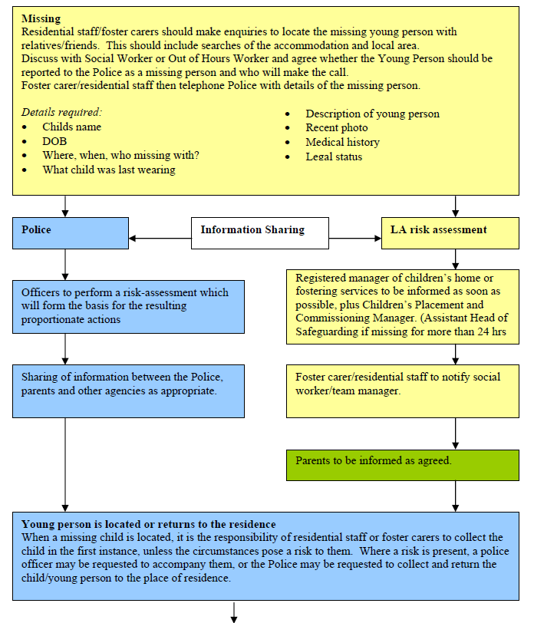

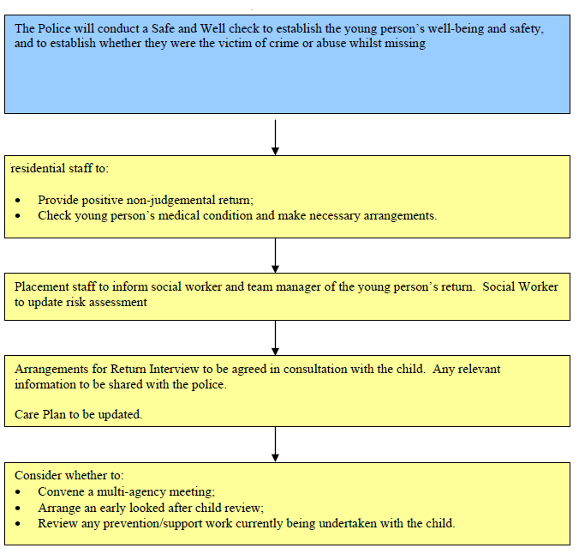

Fire Precautions
The home operates robust fire and emergency procedures.
The home has a fire policy which is rigorously applied. An appropriately qualified external agent services equipment on a regular basis.
Fire equipment and alarms are tested at regular intervals and tests are recorded in the fire logbook, testing takes place in line with the fire safety policy and legislation and staff and service users take place in regular evacuations as required and we actively support children and young people in understanding fire safety. We do this through talking about fire safety and through fire drill simulations. Records are kept and include children’s and young people’s comments.
All exits are clearly marked and with emergency windows and fire equipment in place that is checked regularly.
The team receives regular fire training from a qualified consultant and in-house instruction takes place as part of the induction process for new staff and regular thereafter.
We also participate in night-time simulation drills to raise staff awareness on fire safety. We also have an evacuation plan which highlights the procedure for staff to follow in the event of a day or night-time fire and accommodation required for the children and young people in the event that the building is unsafe.
The staff team will carry out weekly checks on all fire equipment, record and report any actions required to their line manager. All our staff have been trained in first aid so that there is a first aider on duty at any one time.
Health and medical emergencies are also planned for within the general running of the home. An ambulance will be called by the home in the event of any accident or injury requiring attention. A staff member will accompany the child/young person to hospital and remain with them as required. Night cover will be provided if it is felt that this would be in the best interests of the child/young person or at the request of the placing authority.
Other emergencies such as gas or water leaks or electrical failures, will receive immediate attention from appropriate external agencies, the home has a Business Continuity Plan which can be found in the office.
Fire precautions and emergency procedures are inspected during monthly statutory Regulation 44 visits and during the Registered Managers Regulation 45 reporting. The Registered Manager also ensures that portable appliance testing (PAT) is carried out on a yearly basis. The boilers are serviced annually to ensure that they are safe for use.
Therapeutic Input into the Home
The changing needs of a child or young person can make it difficult to make predictions about the on-going and future needs of the individual. Hennessy Group sees this as part of the on-going review system and accepts that the home may no longer be suitable for the changing needs of the individual. This can include an increase in independence and development.
Emergency incidents notwithstanding, any decisions or changes will be made through multidisciplinary reviews and would only happen if agreed that it is in the best interests of the child or young person, or where a failure to act is likely to put the home in breach of registration requirements.

Staff attend regular training which enables them to implement therapeutic strategies and approaches effectively.

Staff Acknowledgement
I confirm I have read the contents of the Statement of Purpose.
I confirm I will carry out all instructions as detailed in this document.
I can confirm I know this document is kept within the office Should Ofsted request me to locate the Statement of Purpose during an inspection I can do this immediately.
I am aware that the Statement of Purpose is a document that all Children’s Residential Homes must have as stated in Regulation 16 of the Children’s Homes Regulations 2015 which instructs who the Statement of Purpose should be available to. Schedule 1 of the Children’s Homes Regulations sets out a detailed list of criteria which is the minimum contents contained in the Statement of Purpose.
I agree to follow the guidelines in the Statement of Purpose.
Name | Signature | Date

Review Date: | October 2021 or as and when required
Version: | 9
Date Sent to Ofsted: | AUG 2021
Date Sent to Social Workers (all young people): | When requested
Date Sent to Parents (all young people): | At time of admission or as requested

Contact Details

Beech Lodge

Email: managerbeechlodge@hennessygroup.co.uk
01642 555320

Rickleton 1B
Bowes Business park
Lambton estate
Chester le street
DH3 4AN

